JURNAL EKONOMI PEMBANGUNAN: KAJIAN MASALAH EKONOMI DAN PEMBANGUNAN
ISSN 1411-6081, E-ISSN 2460-9331
(http://journals.ums.ac.id/index.php/JEP/index)

COPYRIGHT TRANSFER AGREEMENT FORM

Name of Principal Authors : Panji Kusuma Prasetyanto, SE., M.Ec.Dev..
Address of Principal Authors : Prawit RT.04 RW.02 Nusukan Banjarsari, Surakarta
Tel : 085641401115 |  | Fax :
E-mail : panjikusuma@untidar.ac.id
Author(s) Name : | Nuwun Priyono, Siti Arifah,  Eva Wulandari, and  Panji Kusuma Prasetyanto
Manuscript Title : | The Determinants of Level of Society Welfare Within Fiscal Decentralization Framework In Regional Autonomy Era
 |  |  |  | 13 March 2020

- I/We submit to the Jurnal Ekonomi Pembangunan: Kajian Masalah Ekonomi dan Pembangunan for the above manuscript. I/We certify that the work reported here has not been published before and contains no materials the publication of which would violate any copyright or other personal or proprietary right of any person or entity.
- I/We hereby agree to transfer to Lembaga Pengembangan Publikasi Ilmiah [Publication Office], Muhammadiyah University of Surakarta the copyright of the above - named manuscript. I/We reserve the following: (1) All proprietary rights other than copyright such as patent rights. (2) The right to use all or part of this article in future works of our own such as in books and lectures.

Panji Kusuma Prasetyanto, SE., M.Ec.Dev.
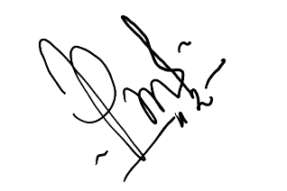

13 March 2020
(When there is more than one author, only one signature will suffice.)

