Table 1. Cognitive Ability of Girls and Boys.
Group Statistics
 | Gender | N | Mean | Std. Deviation | Std. Error Mean
CognitiveAspects | Girl | 20 | 3,5000 | ,45883 | ,10260
 | Boy | 20 | 3,4000 | ,47573 | ,10638

Independent Samples Test
 |  | Levene's Test for Equality of Variances |  | t-test for Equality of Means
 |  | F | Sig. | t | df | Sig. (2-tailed) | Mean Difference | Std. Error Difference | 95% Confidence Interval of the Difference
 |  |  |  |  |  |  |  |  | Lower | Upper
CognitiveAspects | Equal variances assumed | ,495 | ,486 | ,677 | 38 | ,503 | ,10000 | ,14779 | -,19919 | ,39919
 | Equal variances not assumed |  |  | ,677 | 37,950 | ,503 | ,10000 | ,14779 | -,19920 | ,39920
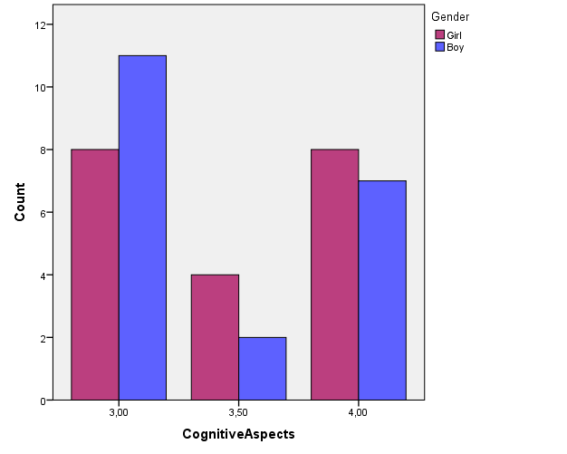

Figure 1. Comparison Diagram of Cognitive Ability of Boys and Girls

Table 2. Analyze Children Ability
Model Summary
Model | R | R Square | Adjusted R Square | Std. Error of the Estimate
1 | ,670ª | ,449 | ,404 | ,39107
a. Predictors: (Constant), DeconstructionAbility, DifferentiationAbility, OrganizeAbility
Table 3. ANOVA Ability to Children Analyze
ANOVAª
Model |  | Sum of Squares | Df | Mean Square | F | Sig.
1 | Regression | 4,494 | 3 | 1,498 | 9,796 | ,000^{b}
 | Residual | 5,506 | 36 | ,153
 | Total | 10,000 | 39
a. Dependent Variable: Gender
b. Predictors: (Constant), DeconstructionAbility, DifferentiationAbility, OrganizeAbility

Table 4. Coefficients Ability to Children Analyze

Coefficientsª
Model |  | Unstandardized Coefficients |  | Standardized Coefficients | t | Sig.
 |  | B | Std. Error | Beta
1 | (Constant) | 5,535 | ,782 |  | 7,080 | ,000
 | DifferentiationAbility | ,045 | ,166 | ,038 | ,274 | ,786
 | OrganizeAbility | -,642 | ,197 | -,453 | -3,265 | ,002
 | DeconstructionAbility | -,541 | ,189 | -,386 | -2,864 | ,007
a. Dependent Variable: Gender

