LAMPIRAN F
ANALISIS DATA

F-1 Deskriptif Data
F-2 Uji Normalitas
F-3 Uji Linieritas
F-4 Uji Homogenitas
F-5 Uji Hipotesis

F-1 Deskriptif Data
Descriptive Statistics
 | N | Mean | Std. Deviation | Minimum | Maximum
Efikasi_Diri | 193 | 80.24 | 13.291 | 35 | 112
CDDQ | 193 | 64.97 | 23.936 | 3 | 142

F-2 Uji Normalitas
One-Sample Kolmogorov-Smirnov Test
 |  | Efikasi_Diri | CDDQ
N |  | 193 | 193
Normal Parameters^{a,b} | Mean | 80.24 | 64.97
 | Std. Deviation | 13.291 | 23.936
Most Extreme Differences | Absolute | .038 | .057
 | Positive | .031 | .057
 | Negative | -.038 | -.041
Kolmogorov-Smirnov Z |  | .529 | .791
Asymp. Sig. (2-tailed) |  | .942 | .559
a. Test distribution is Normal.
b. Calculated from data.

F-3 Uji Linieritas
Model Summary
R | R Square | Adjusted R Square | Std. Error of the Estimate
.528 | .278 | .275 | 20.385
The independent variable is Efikasi_Diri.

ANOVA
 | Sum of Squares | df | Mean Square | F | Sig.
Regression | 30629.797 | 1 | 30629.797 | 73.708 | .000
Residual | 79371.074 | 191 | 415.555
Total | 110000.870 | 192
The independent variable is Efikasi_Diri.

Coefficients
 | Unstandardized Coefficients |  | Standardized Coefficients | t | Sig.
 | B | Std. Error | Beta
Efikasi_Diri | -.950 | .111 | -.528 | -8.585 | .000
(Constant) | 141.229 | 9.002 |  | 15.688 | .000

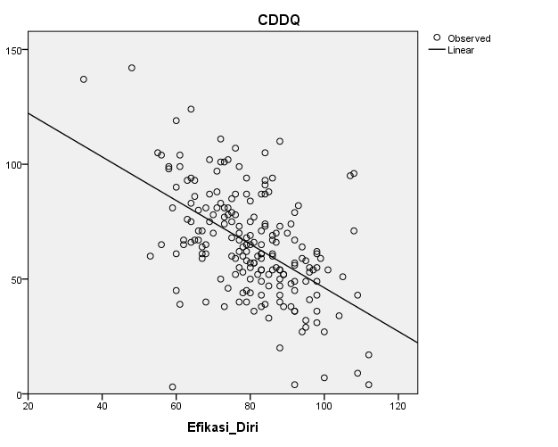

F-5 Uji Hipotesis

- Uji Hipotesis Pertama
Correlations
 |  | Efikasi_Diri | CDDQ
Efikasi_Diri | Pearson Correlation | 1 | -.528**
 | Sig. (1-tailed) |  | .000
 | Sum of Squares and Cross-products | 33917.554 | -32231.782
 | Covariance | 176.654 | -167.874
 | N | 193 | 193
CDDQ | Pearson Correlation | -.528** | 1
 | Sig. (1-tailed) | .000
 | Sum of Squares and Cross-products | -32231.782 | 110000.870
 | Covariance | -167.874 | 572.921
 | N | 193 | 193
**. Correlation is significant at the 0.01 level (1-tailed).

