ANALYSIS AND IMPROVEMENT OF ASSEMBLY LINE
A CASE STUDY AT AUTOMOBILE REAR-AXLE ASSEMBLY LINE-A PT. ZYX

[authors]

Abstrak: Makalah ini menjelaskan kegiatan peningkatan produktivitas PT ZYX pada lini-A perakitan bagi poros belakang kendaraan roda empat, menggunakan metodologi garis penyeimbang (line balancing). Empat metode perakitan garis penyeimbang dipelajari, yaitu, Peringkat Positional Weight (RPW), Pendekatan Region, J-Wagon dan garis kelompok menyeimbangkan aturan berdasarkan Kaizen. Pemilihan metode yang paling cocok dibuat berdasarkan kriteria kinerja yang digunakan sesuai balancing. Dengan kegiatan perbaikan tersebut, metode garis balancing terbaik ditemukan menjadi metode Kaizen yang berhasil mengurangi total waktu siklus, jumlah workstation, dan jumlah operator. Untuk memverifikasi metode garis penyeimbang, simulasi diusulkan menggunakan Software Tecnomatix. Dua jenis model simulasi kejadian discrit yang dikembangkan dan ditunjukkan bahwa kinerja waktu proses dari sistem yang diusulkan lebih baik dari sistem yang ada.
Kata kunci: Perakitan garis penyeimbang, produktivitas, kaizen, simulasi kejadian diskrit

Abstract: This paper describes improvement activities of PT ZYX in automobile rear axle assembly line-A, using a line balancing methodology. Four assembly balancing methods are studied, namely, Ranked Positional Weight (RPW), Region Approach, J-Wagon and group line balancing rules based on Kaizen. Selection of the most suitable method is made based on the performance criteria used in line balancing. With these improvement activities, the best line balancing method was found to be a method of Kaizen that managed to reduce the total cycle time, the number of workstations, and the number of operators. To verify the line balancing method, a discrete event simulation is proposed using Tecnomatix Software. Two types of simulation models are designed and showed that the process time performance of the proposed system is better than the existing system.
Keywords: Assembly line balancing, productivity, kaizen, discrete event simulation

INTRODUCTION
PT ZYX is located at West Java. The company manufactures and assembles rear-axle parts of automotive components (refer Figure 1, a rear axle of a vehicle is used as an illustration, the original picture could not be shown). By its operations, this company focuses to improve productivity at Line-A assembly line. They are 17 workstations with 17 operators in a line. Based on their perception, balancing the line can be done either by reducing the amount of required manufacturing time to produce finish product or by reducing the number of workstation by combining some sequence of operations. By performing this, the lead time of the product delivery expected to be significantly improved.
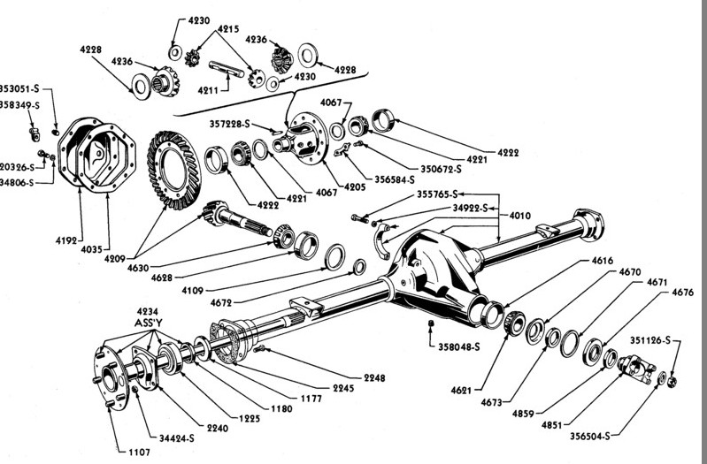Figure 1: An illustration of A Rear Axle of A Truck (source: http://www.vanpeltsales.com/)
The problem of assembly line balancing consists of determining the set of tasks to be performed for every station in a way that the operation time does not exceed the cycle time (Salveson, 1955). The objective of assembly line balancing is to divide the workload of an assembly line among different individual workstation and determine which tasks should be performed at each workstation. According to Konully (2013), assembly line balancing steps is following: (1) list the sequential relationships among tasks and then draw a precedence diagram, (2) calculate the required workstation cycle time, (3) calculate the theoretical minimum number of workstations, (4) choose a primary rule that will determine how tasks are to be assigned to workstations, (5) assign each task one at a time, until the sum of task times is equal to the workstation cycle time, (6) repeat step (5) for the remaining workstation until all the tasks have been assigned to workstation, and (7) evaluate the efficiency of the line balance. These works may involve in applying three heuristic algorithms, namely, Ranked Positional Weight (RPW), Region Approach, and J-Wagon to select the best methodology for rear axle assembly line-A. This three heuristic methods is based on following assumption to perform the analysis, namely, (a) all activities is movable without any constraint of equipment and resources, (b) all activities is movable with constraint consideration either for equipment or resources.
Instead of three heuristics method above, Kaizen method which has been adapted by PT ZYX is also being used to evaluate the productivity of Line-A above. After implementing those 4 methods (included RPW, Region Approach and J-Wagon), the success of the implementation will be simulated using Discrete Event Simulation (DES) method. The following paragraph discusses the methods above further and overview of DES (Larasari, 2015).

Ranked Positional Weight (RPW)
This method is focused on local restrictions based on the precedence diagram. Each work station grouped according to the presence or absence of a predecessor and sequence similarity. Each iteration process is done based on precedence diagram where only each work station adjacent and which allows in terms of sequence and cycle time will be combined. So the emphasis is immediacy and reach areas between work stations.

Regional Approach (RA)
Region Approach is a heuristic method that puts elements of the work at the work station is based on the position of the precedence diagram. Elements located earlier in the diagram is placed first on the first work station.

J-Wagon
This heuristic method prioritizes number of elements are most dependent work, in which elements of the work will be prioritized in advance to be placed in the work stations and followed by the other elements of work that has a number of elements depend less work. If there are two elements of work that has the same weight, the element with greater processing time will be prioritized in advance.

Kaizen
Waste always exists, and no matter how good the process is right now, it can always be better. This commitment to continuous improvement is known as Kaizen (Lean Manufacturing, 2015). Kaizen aims for improvement in productivity, effectiveness, safety, and waste reduction. PT. ZYX has its own strategy for Kaizen (see Figure 2). It is required to analyse the current condition of an assembly line.
The approach proceeds with the following steps :
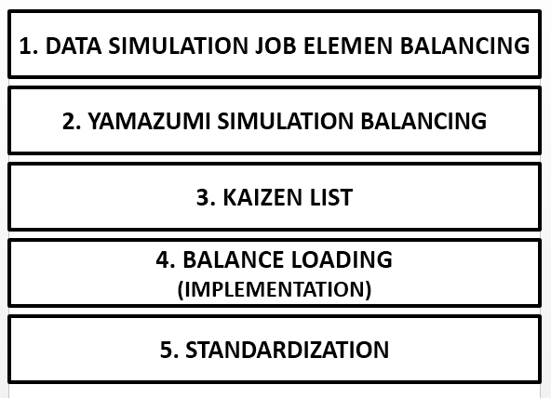Figure 2: Kaizen Strategy by PT ZYX
PT ZYX develop rules based on Kaizen in resolving line balancing problem. There are 5 balancing rules discussed hereunder.

No | Rule
1 | Job balancing elements (parts) by assembly the sequence (Pn) must exist before (Pn+1)  Table 1. Example of rule 1.  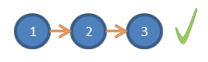  The balancing results that do not violate the order assy :  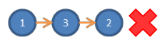  The balancing result that violate the order assy :
  No. | Job Element | Rules
  1 | Installing Oil Deflector | P2
  2 | Installing Gasket | P3
  3 | Installing DC | P4
2 | Job balancing elements based on elements that require special machines (pokayoke)  Examples of elements of the job that requires special elements:  P2(x) : The second element of the work order and require special machines  Table 2. Example of rule 2.
  No | Job Element | Rules | Special Machine Type
  1 | Torque (QL) Drain Plug | P2(x) | Torque pokayoke machine
  2 | Nut DC Tightening | P3(x) | Tightening pokayoke machine
3 | Job balancing elements that are considerating similar part in the element, so that these elements can be splited into several element of the workload  Example of job element that have similar parts:  Table 3. Example of rule 3.
  No. | Job Element | Rules
  1 | Installing Oil Seal | P2
  2 | Installing Brake | P3
4 | Job balancing element that considers the work can be done in several post (do not follow the order)  Fpn-pm : these elements can be done anywhere from sequence n to sequence m  Fp2-p6 : these elements can be done anywhere on the order of 2 to the order of 7  Example of elements of work that can be done in several posts:  Table 4. Example of rule 4.  Result the right job element balancing  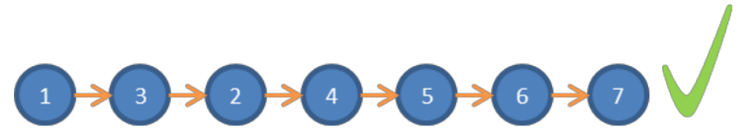  Result the wrong job element balancing  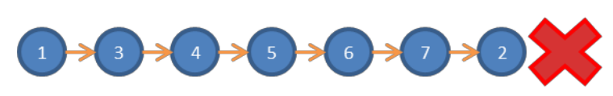
  No. | Job Element | Rules
  1 | Installing Oil Deflector | P2
  2 | Installing Drain Plug | Fp2-p7
  3 | Installing Gasket | P3
  4 | Installing DC | P4
  5 | Installing Brake | P5
  6 | Installing Nut Brake | P6
  7 | Installing Drum Brake | P7
5 | HPn → handling part required so that when the balance loading will follow the work elements in the order (Rule 1)  H → handling/work element parts that can be removed immediately eliminated when on-balance loading
Example of job elements HPn & H :

Table 5. Hpn elements
No. | Job Element | Rules
1 | Taking Oil Deflector | HP1
2 | Taking DC | HP2

Table 5. H elements
No. | Job Element | Rules
1 | Moving Drum Brake | HP1
2 | Push Chutter Housing | HP2

Discrete Event Simulation
Discrete Event Simulation (DES) is an effective decision support tool (Babulak & Wang, 2008). Discrete event simulation is used to imitate a real process in order to see how the process can be affected by different conditions and test some ideas without risking the real process. Tecnomatix Plant Simulation software (Bangsow, 2016) enables the simulation, visualization, analysis, and optimization of production systems and logistics processes. Through this work, Tecnomatix Plant Simulation is used to visualize the result of existing situation and proposed results.

COLLECTING DATA
Existing Layout of Rear Axle Assembly Line-A
The operations take place in rear axle assembly line-A. There are 17 workstations with 17 operators run the process. Figure 2 shows the existing layout.

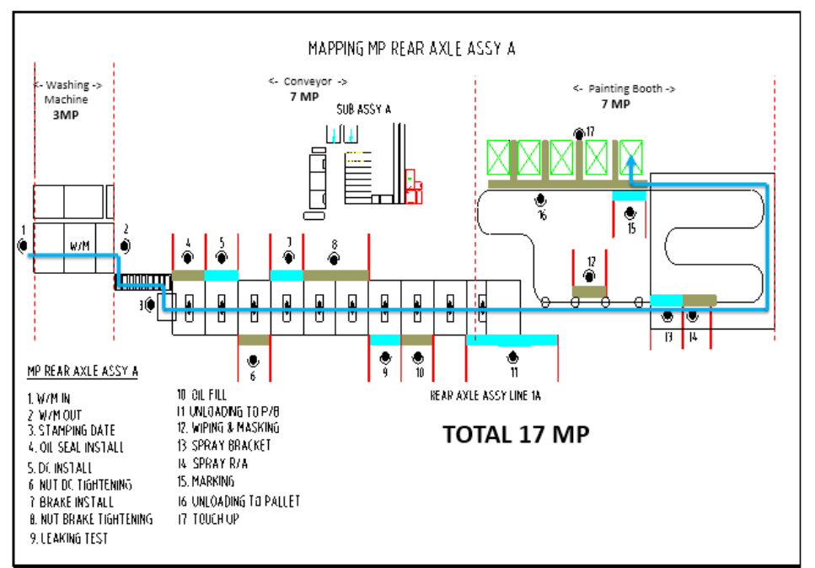Figure 3: Existing Layout. The 'black dot' shows human operator (MP = Man Power)
Figure 3 shows human operator at each workstation, following the assembly sequence shown by the 'blue' line from the section of 'washing machine', 'conveyor', and 'painting booth'.

Yamazumi Chart (Cycle Time vs. Takt Time)

Table 7 and Figure 4 show cycle time (CT) and takt time (TT) in second, of each operator.
Table 7. Cycle Time and Takt Time
 | MP1 | MP2 | MP3 | MP4 | MP5 | MP6 | MP7 | MP8 | MP9 | MP10 | MP11 | MP12 | MP13 | MP14 | MP15 | MP16 | MP17
CT(sec) | 46 | 57 | 52 | 57 | 48 | 59 | 58 | 59 | 60 | 53 | 55 | 58 | 53 | 58 | 55 | 43 | 57
TT(sec) | 60 | 60 | 60 | 60 | 60 | 60 | 60 | 60 | 60 | 60 | 60 | 60 | 60 | 60 | 60 | 60 | 60
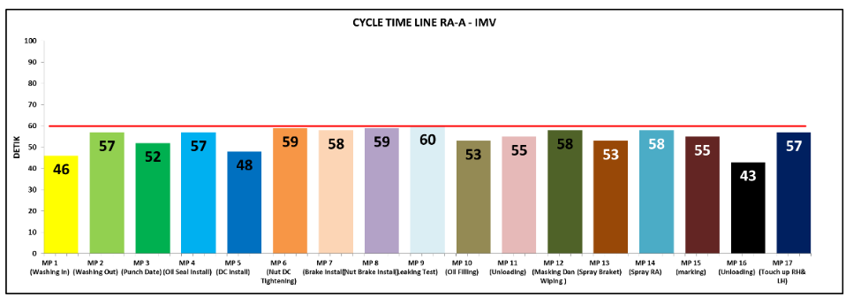Figure 4: Yamazumi Chart

Amount of WorkStation
The amount of workstations can be calculated using Eq.1 as follows,
… (1)
where :
= number of workstation,
= cycle time, in seconds,
= takt time, in seconds.
Based from Eq.1, the number of workstations in rear axle assembly line-A is 15.48, and it is round-down to 15 workstations.

RESULT AND DISCUSSION

Existing System Performance
Analysis of the current system is performed by observing the condition of rear-axle assembly line-A at specific period of time. The observed line is the process of assembling the IMV-models. In the production system implemented by the company when the observations were made, it appears that the workload is less balanced between operations, resulting in less optimal line efficiency of each operation. The process of assembling in rear axle assembly line-A is divided into 17 workstations.
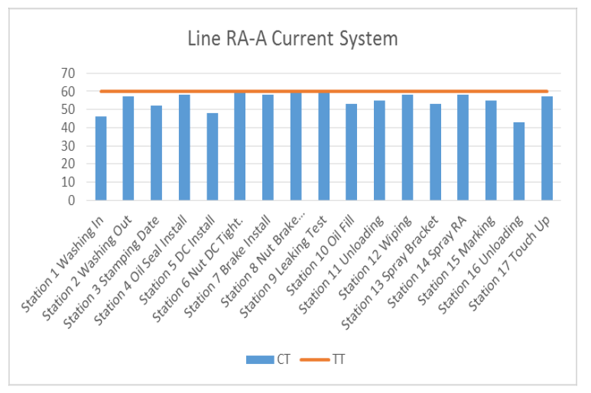Figure 5: Line RA-A of current system; CT = Cycle Time in sec, TT = Takt Time in sec. (Larasari 2015)
Using heuristic methods above, with assumption that all activities is moveable without any constraint of equipment. Table 8 shows the result of performance evaluated.

Table 8. Performance Evaluation.
Method | Line Eff. (%) | Idle Time (s) | Balance Delay (s) | Smoothness Index (%) | Productivity (pcs/mh)
Current | 91 | 91 | 8.9 | 29.61 | 1.06
The following paragraph shows the use of three methods evaluation to the 1st assumption

Performance Evaluation to The 1st Assumption
The performance comparison using three heuristics method is shown by following table.
Table 9. Performance Comparison of Three Heuristics Method
Methods | Line Efficiency (%) | Idle Time (s) | Balance Delay (%) | Smoothness Index (%) | Productivity (pcs/mh)
RPW | 97 | 31 | 3.2 | 25.33 | 1.21
Region Approach | 97 | 31 | 3.2 | 25.33 | 1.21
J-Wagon | 97 | 31 | 3.2 | 32.49 | 1.21
From Table 9, it is shown that the proposed improvement to balance the line results in line efficiency, idle time, balance delay, and productivity having the same result. However, the smoothness index shows which method is better. The smoothness index shows the average of differences between one workstation to another. The smaller the smoothness index, the better the performance of balancing the line. From Table 9, it can be concluded that the proposed method are Ranked Positional Weight (RPW) and Region Approach with smoothness index value of 25.33. Another result of the best performance line is the reduced number of workstation from 17 to 16, thus the number of operators reduced from 17 to 16, and the number of cycle time is remain the same as 929 seconds.

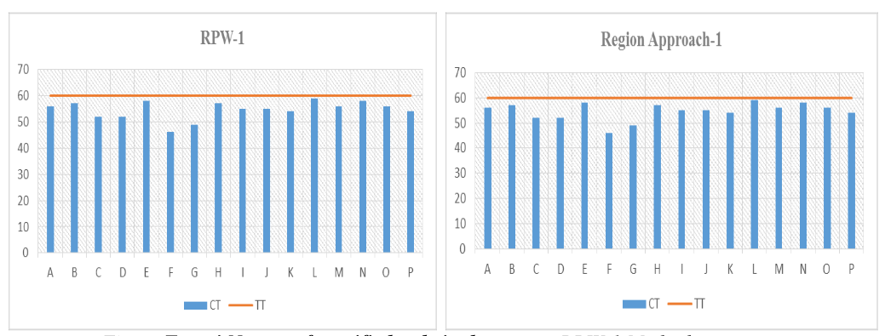Figure 6: RPW Method and Regional Approach Method of the 1st Assumption (Larasari 2015)
However, referring to the assumption, those methods above is not possible to be implemented. In order to get the best line balancing method, the second assumption will be used. Here is the calculation of the three heuristic methods with the second assumption, namely, all activities is moveable with any constraint or equipment.

Performance Evaluation based on The 2nd Assumption
The result of 2nd assumption applied by three heuristics method is following (refer to Table 10).

Table 10. Performance of Three Heuristic Methods of the 2nd Assumption
Methods | Line Efficiency (%) | Idle Time (s) | Balance Delay (%) | Smoothness Index (%) | Productivity (pcs/mh)
RPW | 91 | 86 | 8.9 | 26.68 | 1.13
Region Approach | 91 | 86 | 8.9 | 26.68 | 1.13
J-Wagon | 91 | 86 | 8.9 | 26.87 | 1.13

From Table 9, it can be seen that all the proposed improvement line balancing methods which results in line efficiency, idle time, balance delay, and productivity has the same result. With similar results in nearly all the above factors, the value of the smoothness index that determines which method is better.
This value indicates the level of smoothness of a balance line. The smaller the smoothness index value, the better the performance of the balance of the line. It can be concluded that the proposed method could be the method of Ranked Positional Weight
(RPW) and Region Approach with smoothness index value of 26.68. Another result of the best performance line is the reduced number of workstations from 17 workstations to 16 workstations, the number of operators reduced from 17 to 16 man power, and the number of cycle time reduced from 929 to 874 second.
As a result from three heuristic line balancing methods, RPW and Region Approach are the best methodology. There are 16 stations with 16 operators (man power) in RPW and Region Approach Method. It can be concluded, that the results of the proposed method is the reduction of one station and one operator (see Figure 7).
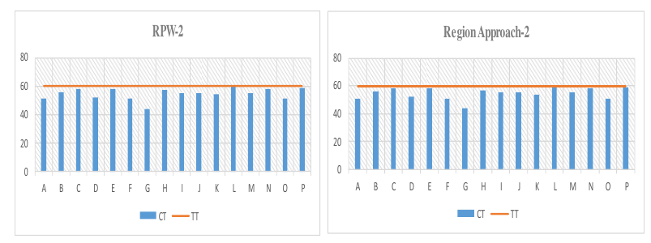
Figure 7: RPW Method and Regional Approach Method of the 2nd Assumption (Larasari 2015)
Those methods above are possible to be implemented based on the assumption. A new internal company approach, namely, line balancing based on the Group rules using Kaizen will be discussed hereunder.

Performance Line Balancing Method Based on ZYX Group Rules using Kaizen
Based on the rules made by OMDD (Operations Management Development Division) of ZYX, the Table 11 shows the rules.

Table 11. Example of Station 1: Washing In
ST | No. | Work Element (Station 1: Washing In) | Te | Rule | CT
1 | 1 | Take one Kanban and put in poly box | 2 | H | 46
1 | 2 | Take the housing of the trolley with chute mechanic | 4 | HPn | 46
1 | 3 | Place housing in the stand housing | 3 | HPn | 46
1 | 4 | Setting up an empty box for a small part drum brake | 5 | H | 46
1 | 5 | Take a small box part | 3 | H | 46
1 | 6 | Take a drum brake on the trolley | 4 | HP1 | 46
1 | 7 | Put a drum brake in the area stand W/M | 5 | HP1 | 46
1 | 8 | Do wiping on the surface of the housing | 14 | P1 | 46
1 | 9 | Push housing in booth W/M | 3 | HP1 | 46
1 | 10 | Return to the starting position | 3 | H | 46
All the rules has been applied for each work element. There are some work elements that was eliminated after the balancing rule applied so that the total cycle time is reduced (see station 2, station 3, and station 11). There are also work elements being moved to antoher work station based on balancng rule that resulted in a reduction of two workstations, namely workstation 3 and workstation 11.

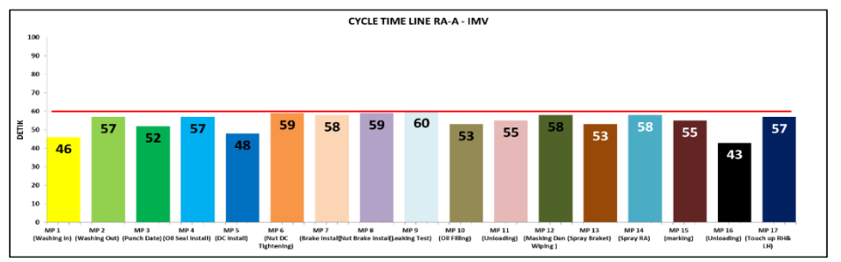
Figure 8: Yamazumi Current
[FIGURE]
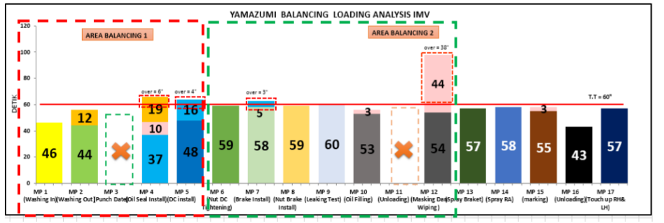
Figure 9: Yamazumi Simulation Balancing (Larasari 2015)

Figure 8 and Figure 9 show the cycle time with the takt time of each operator before and after simulation balancing. It can be seen that the distribution of work elements that have been applied by balancing rule resulted in reduction of two workstations, namely, station 3 and station 11. There are 2 balancing area (see Figure ...). The purpose of making 2 balancing area is to simplyfy the distribution of work element which has cycle time that exceeds the takt time, for example: station 3, 4, 7 and 11.

Kaizen List
Kaizen focuses on costant elimination of “muda” (waste). Any non-value adding activities are considered waste. To eliminate waste, it is iportant to understand exactly what waste is and where it exists. Therefore, it is required to define the area balancing, item problem, Kaizen idea, Kaizen point, Kaizen criteria, and analyse the condition before and after Kaizen.

Table 12. Kaizen-1
Station & Area Balancing | No. Element | Item Problem | Kaizen idea | Kaizen point | Kaizen Criteria
11 & 2 | 93 | The process of model input quantity to the database shop floor is done with manual input | The process of model input quantity to database replaced by using barcode scanning | Barcode sticker will be taped to the back of each Kanban. Position barcode scanning is located near to the operator when unloading | Reduce NVW OP unloading/IMV
Table 12 shows the idea to reduce the NVW (Non-Valuable Work) by replacing manual operator using boarcode scanner for the process of model input quantity to the database. As a result, the time required for scanning is reduced 2 seconds.

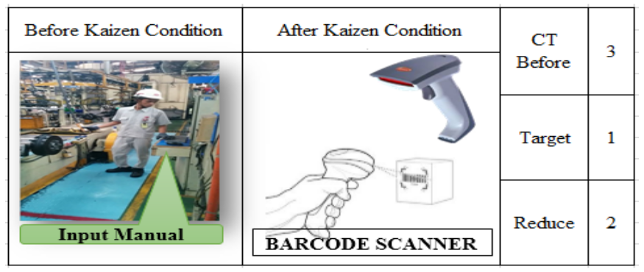
Figure 10: Kaizen
Kaizen Results
The final result after Kaizen is a reduction of two workstations, namely station 3 (stamping date) and the station 11 (unloading to painting) and the numver of work stations now are 15 stations with 15 operators.

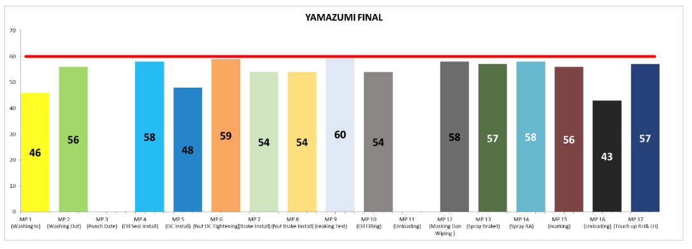
Figure 11: Yamazumi Final
Figure 12 and Figure 13 show the comparison of the total cycle time and total number of main power (operator) in the current system with the system after Kaizen. It can be seen at Figure .. that the cycle time is reduced from 929 seconds to 818 seconds after the Kaizen, so the total cycle time is reduced 111 seconds.

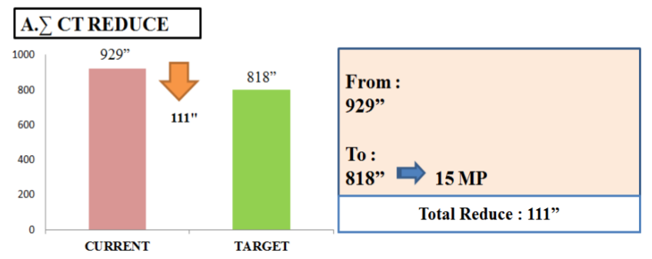
Figure 12: Total Cycle Time Comparison, Current vs. After Kaizen

As well as the number of man power reduced from 17 operators to 15 operators after Kaizen (see Figure 13). The three shift are applied at PT ZYX, thus the total number of man power (operator) reduced is 6 man power/line/day. The number of operators after Kaizen is in accordance with the ideal number of operators that have been calculated (refer to eq. ...).

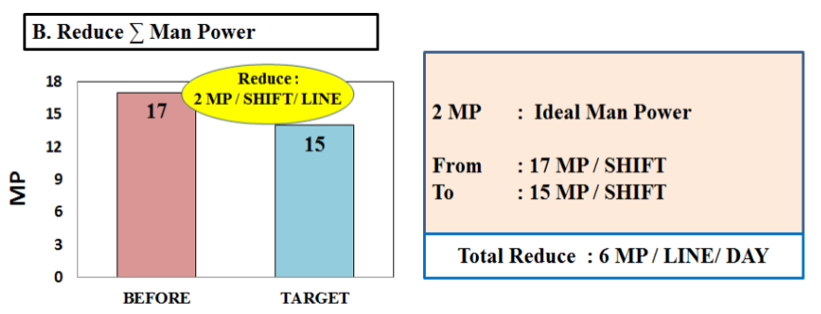
Figure 13: Total Man Power Comparison, Current vs. After Kaizen

Performance Evaluation of ZYX Group Rules using Kaizen
The result shows that the calculations with line balancing method based on ZYX group rules with cycle time 60 seconds has an efficiency line (LE) 91%, a total of 82 seconds of idel time, balance delay 9.1%, smoothness index of 28.28, and the productivity of 1.21 which can be seen at Table 13.

Table 13. Perfomance of ZYX Group Method
Method | Line Efficiency (%) | Idle Time (s) | Balance Delay (%) | Smoothness Index (%) | Productivity (pcs/mh)
ZYX Kaizen | 91 | 82 | 9.1 | 28.28 | 1.21

Simulation
The next part of this work is to propose improvements of the assembly line using simulation (discrete event systems), which consists of conceptual model, verification and validation of the model. The simulation is prepared using Tecnomatix Plant Simulation software. The simulation study began with examining the whole assembly.

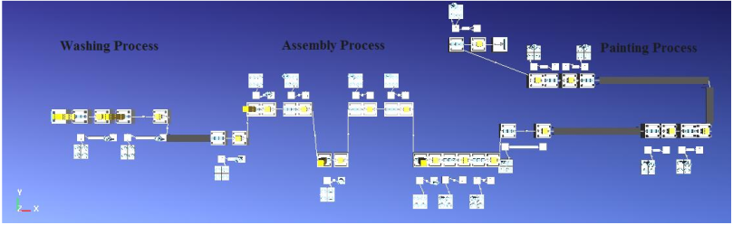Figure 14: A general overview of current system (using Tecnomatix Plant Simulation) (Larasari 2015)

Figure 14 shows the overview of layout of assembly lline for current system. Rear axle assembly line-A is divided into 17 stations with 17 operators and it consists of three main processes; washing, assembly, and painting processes (see Figure 15).

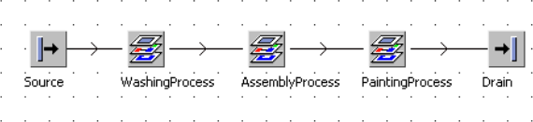Figure 15: Three Main Frames (Washing, Assembly, and Painting Processes) of Assembly Line (Larasari 2015)
Two types of simulation models were designed. First is the existing assembly line and second, is the ZYX group methodology. Figure 16 shows the conceptual model of existing assembly line with 17 stations and 17 operators. Figure 17 shows the conceptual model of ZYX group method with 15 stations and 15 operators.

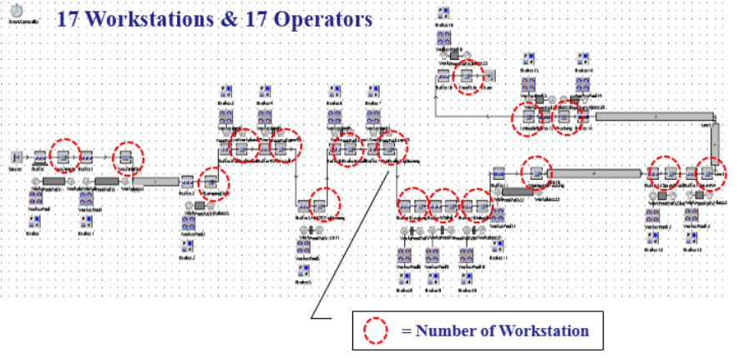Figure 16: Conceptual Model of Existing Assembly Line (Larasari 2015)

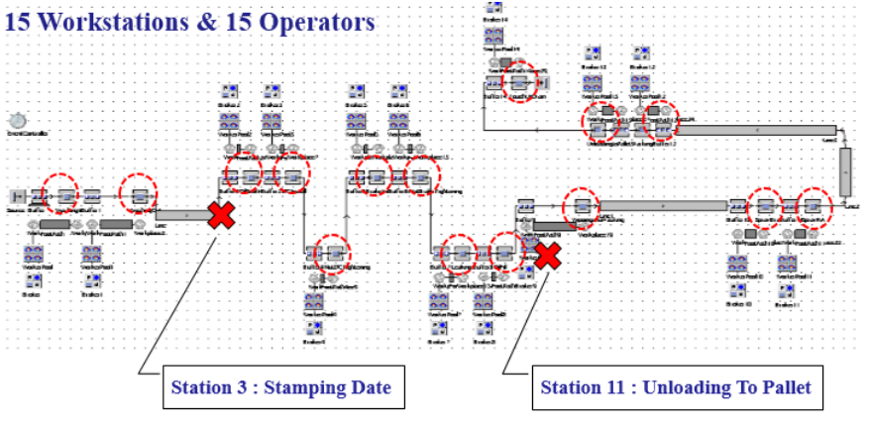Figure 17: Conceptual Model of Proposed System (Larasari 2015)

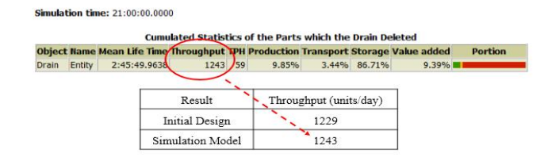Figure 18: Throughput Result from Simulation

From Figure 18, there is a slight difference between the simulation model and initial design. In throughput percentage, the simulation model shows that the production line can meet 101% of forecast demand.

Conclusion
- There are two assumptions have been used within the usage of the three heuristic methods. Based on the first assumption, the best method is Ranked Positional Weight (RPW) and Region Approach. From Table 14, it is shown that the smoothness index is 25.33 %. The workload differences is lower between a station and another, while the others parameters shown similar but still better than the existing condition. However, RPW and Region Approach are not possible to be implemented. Thus, the second assumption will be used.
- Based on the second assumption, the best method is still RPW and Region Approach, since the smoothness index is 26.68%.
- A new approach proposed, using ZYX group rules based on Kaizen. The Kaizen performance result is not significantly different from the current system performance. However, this method managed to reduce the number of work stations from 17 to 15 workstations. Therefore, it reduces the number of operator from 17 to 15, and the number of cycle time is also reduce from 929 to 818 seconds.

Table 14. Comparison of Methods based on Its Parameter (Larasari 2015)
 |  |  | Assumption 1 |  |  | Assumption 2
No | Parameter | Current | RPW | Region Approach | J-Wagon | RPW | Region Approach | J-Wagon | Kaizen
1 | Lean Efficiency (%) | 91 | 97 | 97 | 97 | 91 | 91 | 91 | 91
2 | Idle Time (s) | 91 | 31 | 31 | 31 | 86 | 86 | 86 | 82
3 | Balance Delay (%) | 8.92 | 3.22 | 3.22 | 3.22 | 8.95 | 8.95 | 8.95 | 9.11
4 | Smoothness Index (%) | 29.61 | 25.33 | 25.33 | 32.49 | 26.68 | 26.68 | 26.87 | 28.28
5 | Productivity (pcs/man-hour) | 1.06 | 1.21 | 1.21 | 1.21 | 1.13 | 1.13 | 1.13 | 1.21
6 | Cycle Time (s) | 929 | 929 | 929 | 929 | 874 | 874 | 874 | 818
7 | No. of workstation | 17 | 16 | 16 | 16 | 16 | 16 | 16 | 15
8 | No. of operator | 17 | 16 | 16 | 16 | 16 | 16 | 16 | 15

Recommendation
- Focusing on calculation of time for each workstation because it will affect the workstation layout changes. It is also required to consider cost, that might effecting the selection of better method above.
- A factor that might influencing productivity is to consider the usage of operator energy. For this, ergonomic and human factor aspect need to be further analyzed.
- It is advisable to reduce manual work with additional automation tools, this may affect the reduction of standard time and increase productivity. However, the business process would be greatly reconsidered.

References
--, Yamazumi Workload Charts, Applied Computer Services, Inc., [online] http://www.acsco.com/Yamazumi.htm
Arunkumar, Y, Patil, R, Mohankumar, Discrete Event Simulation for Increasing Productivity in Digital Manufacturing, International Journal of Engineering Research and Development, Vol. 1, Issue 10, pp.36-40
Babulak, E. and Wang, M., 2008, Discrete Event Simulation: state-of-the-art, International Journal of Online Engineering, Vol.4, Issue 2, pp.60-63, [online] http://researchgate.net
El-Namrouty, K.A., and AbuShaaban, M.S., 2013, Seven wastes elimination targeted by lean manufacturing case study ”gaza strip manufacturing firms”, International Journal of Economics, Finance and Management Sciences, Vol.1, Issues 2, pp.68-80, [online] http://www.sciencepublishinggroup.com/j/ijefm
Bangsow, S., Tecnomatix Plant Simulation: modeling and programming by means of examples, Springer, 2016
Ghutukade, S.T., Sawant, S.M., “Use of Ranked Position Weighted Method for Assembly Line Balancing”, Int. Journal of Advanced Engineering Research and Studies, II/IV, July-Sept., 2013
Hegelson, B.W. & Bernie, D.P., “Assembly Line Balancing Using the Ranked Positional Weight Techniques”, Journal of Industrial Engineering, 12, pp 394-398, 1955
Salveson, M.E., “The Assembly Line Balancing Problem”, The Journal of Industrial Engineering, Vol. 6, No. 3, 1955, pp. 18-25.
Hamza, R.M.A. and Al-Manaa, J.Y., 2013. “Selection of Balancing Method for Manual Assembly Line of Two Stages Gearbox”. Global Perspectives on Engineering Management,
Larasari, P.A, “Improving Productivity in Rear Axle Assembly Line-A and Factory Simulation”, Bachelor Thesis, Department of Industrial Engineering, Faculty of Engineering & Information Technology, Swiss German University, Tangerang, 2015

