LESSON PLAN

Subjects : Mathematics
Class : IV
Time allocation : 2 x 35 minutes
Theme : Always Save Energy

Core Competencies (KI)
- Embracing and practicing the religion they profess.
- Honest, disciplined, responsible, courteous, caring, and confident in interacting with family, friends, teachers, and neighbours
- Understanding factual knowledge by observing (listening, seeing, reading) and asking questions based on genuine curiosity about himself, God's creatures and their activities, and the objects they encounter at home and at school.
- Presenting factual knowledge in clear and logical language, in aesthetic works, in movements that reflect healthy children, and in actions that reflect the behaviour of children of faith and noble character.

Basic Competencies and Indicators
- Mathematics
Basic competencies
3.3 Explain and perform estimation of the sum, difference, product, and quotient of two positive integers and/or two fractions.
4.3 Solve problems of estimating the sum, differences, product, and quotient of positive integers and/or two fractions.

Indicators of Competence Achievement
3.3.1 Explain and perform estimation of the sum of two positive fractions.
4.3.1 Solve problems of estimating the sum of two positive fractions.

Learning objectives
- Through the context of biogas, the students are able to estimate the value of a fraction with simple fractions that are easier to remember.
- Through the biogas context, students are able to estimate the results of the sum of two fractions by estimation.

Learning materials
- Estimating the value of a fraction with other fraction that is easier to remember
- Estimate the sum of of two fractions

Learning Approaches, Models and Methods
- Approach: Saitifik
- Model: Cooperative
- Methods: Exploration, Discussion, as well as Question and Answer

Media, Tools, and Learning Resources
Media : videos, student worksheets, calculator fx-991ID PLUS, flipchart / A3 paper
Tools : books and stationery, OHP., Slides.
Learning Resources: student books and teacher books.

Steps of Learning Activities
Phase | Description of Activity | Time Allocation
Introduction | The teacher distributes the Preliminary Activity Worksheet and calculator to each student. Students work on the worksheet accompanied by the teacher.  Next, the teacher shows the following illustration in front of the class. Students recall about fraction material, especially simple fractions and their sum, for example, ½ + ½, 1 + ½, and so on. For example, the teacher can use problems that involve the addition of simple fractions in the context of everyday life, for example, as follows.  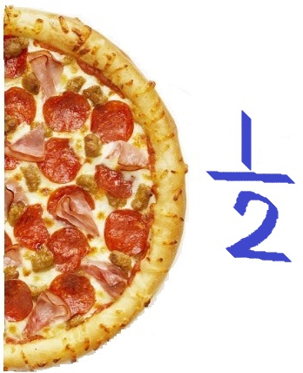  = …  +    = …  -  1 | 15 minutes
Core Activities | Entering this phase, students put aside their calculators first.  Students observe in front of the class, the process of making biogas shown by the teacher (video).  The teacher shows the tools and materials needed in making biogas, one of which is a tube or barrel.  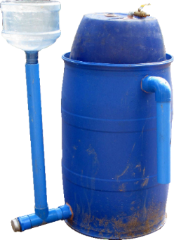  Students listen to the problems explained by the teacher in front of the class.  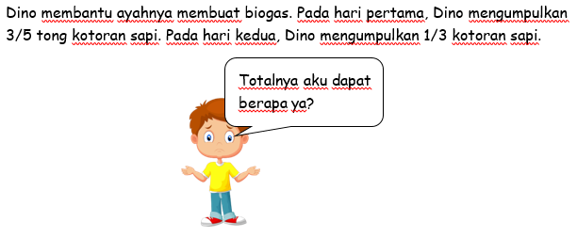  Translation: Dino helps his father make biogas. In the first day, Dino collect $\frac{3}{5}$ barrel of cow dung. In the second day, he collect $\frac{1}{3}$ barrel of cow dung.  Students discuss the problem in their groups. Some students may spontaneously mention their answers, as well as describing how they were solved and the difficulties they face.  The teacher can explore students' answers by bringing them to the context of Mathematics, for example, "What mathematical operations can be used to solve the problem?"  The teacher distributes Worksheet part 1 to the students. With the guidance of the teacher, students work on questions no. 1 to no. 6. Students estimate the contents of barrels, shade them according to estimates, then add up the two contents and fill in the Worksheet.  After the question no. 1 to no. 6 is completed, students present the results. As a tool for student presentations, the teacher sticks a picture like the one described below, to the whiteboard.  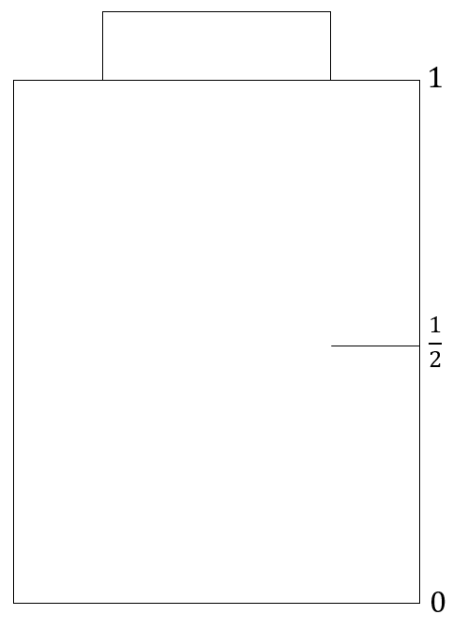  $$\frac{1}{3}$$  $$\frac{3}{5}$$  =  +  Group representatives come to the front of the class to shade the picture of the first and second barrels. With the help of the teacher, students deduce the total amount of cow dung by adding up the contents of the first barrel and the contents of the second barrel.  In question no. 7, the teacher invites students to use the calculator.  In the part that uses a calculator, the teacher guides students to do it step by step while introducing calculator functions, especially the a and ER keys in typing in the fractions.  Students estimate fraction results by determining equivalent fractions using a calculator. After finishing the problem, students present their results again.  The teacher guides students to compare the results obtained through estimations, with the results obtained with a calculator. It is expected that students can observe that the results obtained by estimation (if done correctly) are not too different from the exact results obtained with a calculator.  The teacher can emphasize as follows,  Was it easier not to add ½ and ½? The results are not too different from using a calculator, right? So if you find a difficult fraction and have no calculator, what to do?  Together, and with the guidance of the teacher, students conclude their findings, namely that the sum of two fractions can be calculated through estimation using simple fractions with the closest value.
Closing | As an assessment, the students work on the Worksheet part 2.  The teacher reviews the activities that have been done and reflect on the learning activities that have just been carried out by answering questions.  • What did you learn today?  • Which parts do you understand well?  • Which parts you don't understand well.  • What was your follow-up so you understood more?  • What attitudes you can adopt in your daily life.  • Inform the next learning material. | 15 minutes

