ACTIVTIES OF THE EXPERIMENTAL AND CONTROL GROUP

Day | Experimental | Control
1 | Pre test | Pre test
2 | Introduce the rubric  Topic: (Apply the differentiation rules in computing the derivative of an algebraic functions)  Group Activity guided by the rubric | Discussion  Topic: (Apply the differentiation rules in computing the derivative of an algebraic functions)
3 | Lecture with rubric  Topic: (Apply the differentiation rules in computing the derivative of an exponential functions)  Pair Activity with a use of the rubric | Discussion  Topic: (Apply the differentiation rules in computing the derivative of an exponential functions)
4 | Lecture with rubric  Topic: (Apply the differentiation rules in computing the derivative of an logarithmic functions)  Pair Activity with a use of the rubric | Discussion  Topic: (Apply the differentiation rules in computing the derivative of an logarithmic functions)
5 | Utilization of rubric  Topic: (Solve optimization problems)  Individual Activity with utilization of the rubric | Discussion  Topic: (Solve optimization problems)
6 | Utilization of rubric  Topic: (Solve rectilinear motion problems)  Individual Activity with utilization of the rubric | Discussion  Topic: (Solve rectilinear motion problems)
7 | Utilization of rubric  Topic: (Solve situational problems involving related rates)  Individual Activity with utilization of the rubric | Discussion  Topic: (Solve situational problems involving related rates)
8 | Seatwork with rubric  More practice with all the topics discussed though seatwork with the use of rubric | Seatwork  More practice with all the topics discussed though seatwork
9 | Seatwork with rubric  More practice with all the topics discussed though seatwork with the use of rubric | Seatwork  More practice with all the topics discussed though seatwork
10 | Post test | Post test

APPENDIX H
RESEARCH INSTRUMENT
(For Validation and Pilot Test)

Instruction: Mark (X) on your answer sheet that corresponds to the letter of your answer.

1. Suppose that the height of a skydiver t seconds after jumping from an airplane is given by $f\left(t\right)=640-20t-{16t}^{2}$ feet. Find the person’s acceleration at time t.
a. ${32 ft/s}^{2}$ | b. ${-32 ft/s}^{2}$ | c. ${-42 ft/s}^{2}$ | d. ${12 ft/s}^{2}$
2. A body is moving along a horizontal line according to the formula $s= t^{3}-{3t}^{2}$ where s ft. is the distance of the particle from the origin at time t (in seconds). What is the instantaneous velocity of the particle when t=3?
a. 0 ft/sec | b. 3 ft/sec | c. 6 ft/sec | d. 9 ft/sec
3. Jane is sipping juice from a 1 in. by 3 in. by 6 in. tetra pack at the rate of ${0.5 in}^{3}/sec$. How fast is the height of juice in the pack decreasing?
a. $2 in/sec$ | b. $\frac{2}{3} in/sec$ | c. 9 $in/sec$ | d. $\frac{1}{6} in/sec$

For numbers 4-5.
Determine the dimensions (radius and height) of the right circular cylinder of greatest volume that can be inscribed in a right circular cone of radius 6 cm and height 9 cm.
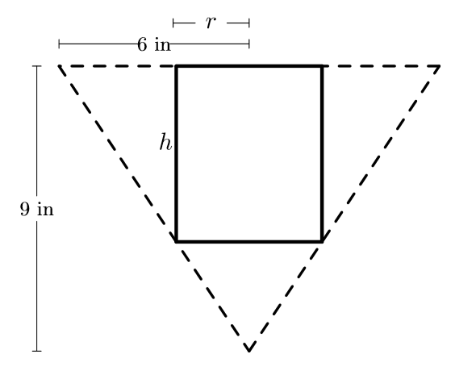

4. What is the value of the radius?
a. $2 cm$ | b. $3 cm$ | c. $4 cm$ | d. $5 cm$
5. What is the value of the height?
a. $2 cm$ | b. $3 cm$ | c. $4 cm$ | d. $5 cm$

6. Find the rate of change of the area of a circle per second with respect to its radius (r=5 cm).
a. 5 $π {cm}^{2}/s$ | b. 10 $π {cm}^{2}/s$ | c. $15 π {cm}^{2}/s$ | d. 25 $π {cm}^{2}/s$
7. The volume of a cube is increasing at a rate of 9 cubic centimeters per second. How fast is the surface area increasing when the length of an edge is 10 centimeters?
a. $3.6 π {cm}^{2}/s$ | b. $1.11 π {cm}^{2}/s$ | c. $3.6 π {cm}^{2}/s$ | d. $3.6 π {cm}^{2}/s$

8. A stone is dropped into a quiet lake and waves move in circles at a speed of 4 cm per second. At the instant, when the radius of the circular wave is 10 cm, how fast is the enclosed area increasing?
a. 20 $π {cm}^{2}/s$ | b. 40 $π {cm}^{2}/s$ | c. 60$π {cm}^{2}/s$ | d. $80 π {cm}^{2}/s$

9. The total cost C(x) in pesos, associated with the production of x units of an item is given by
$$C \left(x\right)= 0.005 x^{3}-0.02 x^{2}+30x+5000$$

Find the marginal cost when 3 units are produced, where by marginal cost we mean the instantaneous rate of change of total cost at any level of output.
a. $Php 15.75$ | b. $Php 25.67$ | c. $Php 30.02$ | d. $Php 89. 96$

For numbers 10-11:
The length of x of a rectangle is decreasing at the rate of 3 cm/minute and the width y is increasing at the rate of 2 cm/minute. When x = 10 cm and y = 6 cm, find the rates of change of _________?

10. the perimeter
a. $16 cm/min$ | b. $2 cm/min$ | c. $-2 cm/min$ | d. $-16 cm/min$

11. the area of the rectangle
a. $60 {cm}^{2}/min$ | b. $2 {cm}^{2}/min$ | c. $-2 {cm}^{2}/min$ | d. $-60 {cm}^{2}/min$

For numbers 12-16:
The position of a car is given by $s\left(t\right)= {2t}^{2}-16 t+35$ (s in meters, t time in sec)
12. Find v(t)
a. ${2t}^{2}-16 t+35$ | b. $4t-16$ | c. ${2t}^{2}-16 t$ | d. $4t-16+35$

13. Where does the car start?
a. $35 m$ | b. $30 m$ | c. $25 m$ | d. $20 m$

14. When does the car come to a stop?
a. $4 sec.$ | b. $8 sec.$ | c. $12 sec.$ | d. $16 sec.$

15. When it stops, where is it at this time?
a. $1 m$ | b. $2 m$ | c. $3 m$ | d. $4 m$

16. What does the ___ car after it stops?
a. moves to the left | b. moves to the right | c. cannot be identified | d. no motion

For numbers 17-19.
An object falling from a roof has after t seconds a heights h measured in feet given by
$$h=100- {16t}^{2}$$

17. Find the velocity.
a. $32t ft/sec$ | b. $-32t ft/sec$ | c. $42t ft/sec$ | d. $-42t ft/sec$

18. Find the acceleration.
a. ${32 ft/s}^{2}$ | b. ${-32 ft/s}^{2}$ | c. ${42 ft/s}^{2}$ | d. ${-42 ft/s}^{2}$

19. How fast is the object travelling when it hits the ground?
a. It is travelling with a velocity of 40 f/sec downward.
b. It is travelling with a velocity of 60 f/sec downward.
c. It is travelling with a velocity of 80 f/sec downward.
d. It is travelling with a velocity of 100 f/sec downward.

20. Find the rate of change of the area of a circle with respect to the radius.
a. $πr$ | b. $4πr$ | c. $3πr$ | d. $2πr$

21. Find the rate of change of the volume of a cylinder with respect to r if h = 10m.
a. $40πr$ | b. $35πr$ | c. $25πr$ | d. $20πr$

22. Find the rate of change of the volume of a sphere with respect to its radius r.
a. $2πr^{2}$ | b. $4πr^{2}$ | c. $8πr^{2}$ | d. $πr^{2}$

23. Of all the rectangles of area 100, which has the smallest perimeter?
a. 1 x 1 square | b. 2 x 2 square | c. 5 x 5 square | d. 10 x 10 square
24. The sum of two positive numbers is 60. How can we choose them so as to maximize their product?
a. 30 and 30 | b. 40 and 20 | c. 45 and 15 | d. 50 and 10

25. A rectangular box is to be made from a piece of cardboard 24 cm long and 9 cm wide by cutting out identical squares from the four corners and turning up the sides. Find the volume of the largest rectangular box that can be formed.
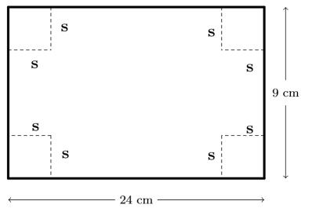

a. ${66 cm}^{3}$ | b. ${132 cm}^{3}$ | c. ${200 cm}^{3}$ | d. ${220 cm}^{3}$

APPENDIX I
TABLE OF SPECIFICATION
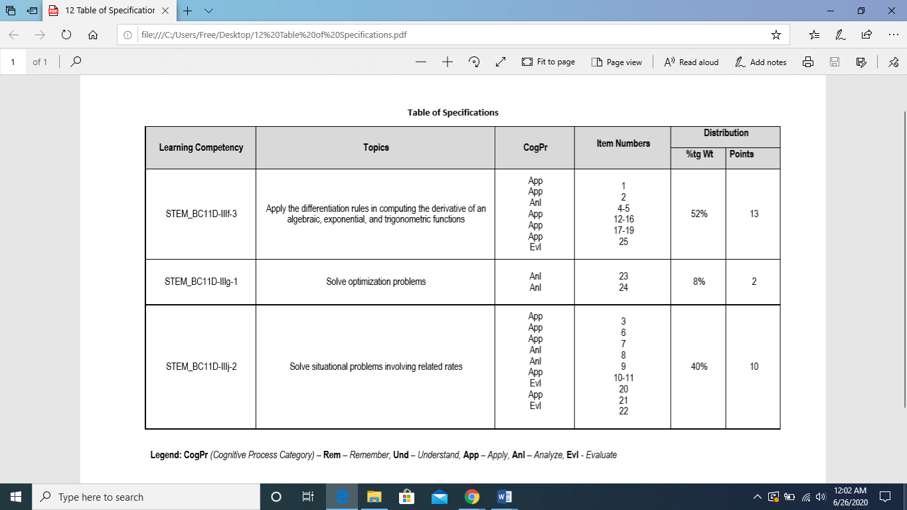
APPENDIX J
RESEARCH INSTRUMENT
(Pre-test/ Post-test)

Application of Derivatives

Instruction: Mark (X) on your answer sheet that corresponds to the letter of your answer.

1. Suppose that the height of a skydiver t seconds after jumping from an airplane is given by
$f\left(t\right)=640-20t-{16t}^{2}$ feet. Find the person’s acceleration at time t.
a. ${12 ft/s}^{2}$ | b. ${-32 ft/s}^{2}$ | c. ${-42 ft/s}^{2}$ | d. ${32 ft/s}^{2}$
2. A body is moving along a horizontal line according to the formula $s= t^{3}-{3t}^{2}$ where s ft. is the distance of the particle from the origin at time t (in seconds). What is the instantaneous velocity of the particle when t=3?
a. 0 ft/s | b. 3 ft/s | c. 6 ft/s | d. 9 ft/s
3. Jane is sipping juice from a 1 in. by 3 in. by 6 in. tetra pack at the rate of ${0.5 in}^{3}/sec$. How fast is the height of juice in the pack decreasing?
a. $\frac{1}{6} in/s$ | b. $\frac{2}{3} in/s$ | c. 2 $in/s$ | d. 9 $in/s$

For numbers 4-5.
Determine the dimensions (radius and height) of the right circular cylinder of greatest volume that can be inscribed in a right circular cone of radius 6 cm and height 9 cm.

4. What is the value of the radius?
a. $2 cm$ | b. $3 cm$ | c. $4 cm$ | d. $5 cm$

5. What is the value of the height?
a. $2 cm$ | b. $3 cm$ | c. $4 cm$ | d. $5 cm$

6. Find the rate of change of the area of a circle per second with respect to its radius at r= 5 cm.
a. 5 $π {cm}^{2}/s$ | b. 10 $π {cm}^{2}/s$ | c. $15 π {cm}^{2}/s$ | d. 25 $π {cm}^{2}/s$
7. The volume of a cube is increasing at a rate of 9 cubic centimeters per second. How fast is the surface area increasing when the length of an edge is 10 centimeters?
a. $3.6 π {cm}^{2}/s$ | b. $1.11 π {cm}^{2}/s$ | c. $3.6 π {cm}^{2}/s$ | d. $3.6 π {cm}^{2}/s$

8. A stone is dropped into a quiet lake and waves move in circles at a speed of 4 cm per second. At the instant, when the radius of the circular wave is 10 cm, how fast is the enclosed area increasing?
a. 20 $π {cm}^{2}/s$ | b. 40 $π {cm}^{2}/s$ | c. 60$π {cm}^{2}/s$ | d. $80 π {cm}^{2}/s$

9. The total cost C(x) in pesos, associated with the production of x units of an item is given by
$$C \left(x\right)= 0.005 x^{3}-0.02 x^{2}+30x+5000$$
Find the marginal cost when 3 units are produced, where the marginal cost is the instantaneous rate of change of total cost at any level of output.
a. $Php 15.75$ | b. $Php 25.67$ | c. $Php 30.02$ | d. $Php 89. 96$

For numbers 10-11:
The length of x of a rectangle is decreasing at the rate of 3 cm/minute and the width y is increasing at the rate of 2 cm/minute. When x = 10 cm and y = 6 cm, find the rates of change of _________?

10. the perimeter
a. $16 cm/min$ | b. $2 cm/min$ | c. $-2 cm/min$ | d. $-16 cm/min$

11. the area of the rectangle
a. $60 {cm}^{2}/min$ | b. $2 {cm}^{2}/min$ | c. $-2 {cm}^{2}/min$ | d. $-60 {cm}^{2}/min$

For numbers 12-16:
The position of a car is given by $s\left(t\right)= {2t}^{2}-16 t+35$ (s in meters, t time in sec)

12. Find v(t)
a. ${2t}^{2}-16 t+35$ | b. $4t-16$ | c. ${2t}^{2}-16 t$ | d. $4t-16+35$

13. Where does the car start?
a. $35 m$ | b. $30 m$ | c. $25 m$ | d. $20 m$

14. When does the car come to a stop?
a. $4 sec.$ | b. $8 sec.$ | c. $12 sec.$ | d. $16 sec.$

15. When it stops, where is it at this time?
a. $1 m$ | b. $2 m$ | c. $3 m$ | d. $4 m$

16. What happens to the car after it stops?
a. moves to the left | b. moves to the right | c. cannot be identified | d. no motion

For numbers 17-19.
An object falling from a roof has after t seconds a heights h measured in feet given by
$$h=100- {16t}^{2}$$

17. Find the velocity.
a. $32t ft/s$ | b. $-32t ft/s$ | c. $42t ft/s$ | d. $-42t ft/s$

18. Find the acceleration.
a. ${32 ft/s}^{2}$ | b. ${-32 ft/s}^{2}$ | c. ${42 ft/s}^{2}$ | d. ${-42 ft/s}^{2}$

19. At what velocity Is the object travelling when it hits the ground?
a. $-40 ft/s$ | b. $-60 ft/s$ | c. $-80 ft/s$ | d. $-100 ft/s$

20. Find the rate of change of the area of a circle with respect to the radius.
a. $πr$ | b. $4πr$ | c. $3πr$ | d. $2πr$

21. Find the rate of change of the volume of a cylinder with respect to r if h = 10m.
a. $40πr$ | b. $35πr$ | c. $25πr$ | d. $20πr$

22. Find the rate of change of the volume of a sphere with respect to its radius r.
a. $2πr^{2}$ | b. $4πr^{2}$ | c. $8πr^{2}$ | d. $πr^{2}$

23. Water runs into a conical tank at the rate of$9 {ft}^{3}/min$. The tank stands point down and has a height of 10 ft and a base of radius 5 ft. How fast is the water level rising when the water is 6 ft. deep?
a. $0.32 ft/min$ | b. $0.50 ft/min$ | c. $0.15 ft/min$ | d. $0.74 ft/min$

24. The sum of two positive numbers is 60. How can we choose them so as to maximize their product?
a. 30 and 30 | b. 40 and 20 | c. 45 and 15 | d. 50 and 10

25. A rectangular box is to be made from a piece of cardboard 24 cm long and 9 cm wide by cutting out identical squares from the four corners and turning up the sides. Find the volume of the largest rectangular box that can be formed.

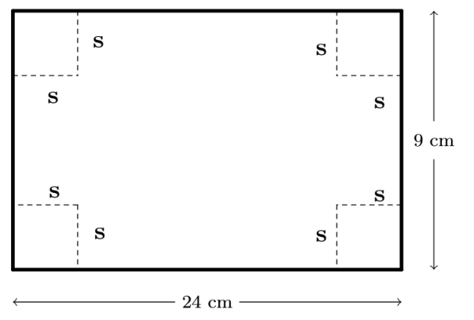

a. ${66 cm}^{3}$ | b. ${132 cm}^{3}$ | c. ${200 cm}^{3}$ | d. ${220 cm}^{3}$

APPENDIX K
RELIABILITY TEST

Scale: ALL VARIABLES

Case Processing Summary
 |  | N | %
Cases | Valid | 43 | 97.7
Cases | Excludedª | 1 | 2.3
Cases | Total | 44 | 100.0
a. Listwise deletion based on all variables in the procedure.

Reliability Statistics

Cronbach's Alpha | Cronbach’s Alpha Based on Standardized Items | N of Items
.857 | .856 | 25

APPENDIX L
RUBRIC
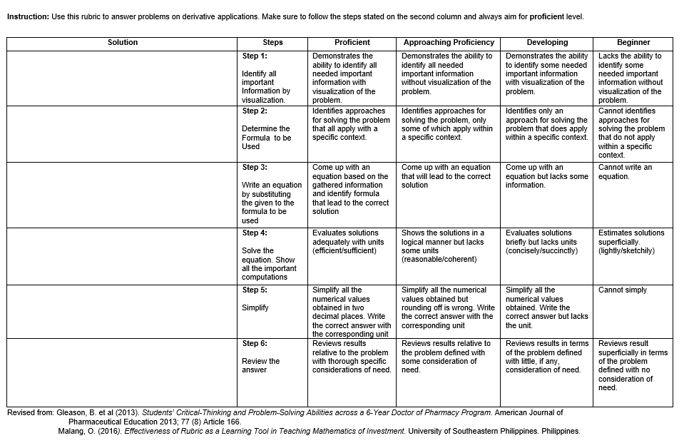

APPENDIX M
Statistical Computations

The Pretest Means Scores and Posttest Mean Scores of the Control and the Experimental Group

Case Processing Summary
 | Cases
 | Included |  | Excluded |  | Total
 | N | Percent | N | Percent | N | Percent
PretestOverall * Groups | 96 | 100.0% | 0 | 0.0% | 96 | 100.0%
PosttestOverall * Groups | 96 | 100.0% | 0 | 0.0% | 96 | 100.0%

Report
Groups |  | PretestOverall | PosttestOverall
Experimental | Mean | 8.45 | 15.41
Experimental | N | 49 | 49
Experimental | Std. Deviation | 2.558 | 3.840
Control | Mean | 9.32 | 13.06
Control | N | 47 | 47
Control | Std. Deviation | 2.979 | 3.226
Total | Mean | 8.87 | 14.26
Total | N | 96 | 96
Total | Std. Deviation | 2.792 | 3.725

Significance of Difference between Pretest Mean Scores of Control and Experimental Group and Significance of Difference between Posttest Mean Scores of Control and Experimental Group

Group Statistics
 | Groups | N | Mean | Std. Deviation | Std. Error Mean
PretestOverall | Experimental | 49 | 8.45 | 2.558 | .365
PretestOverall | Control | 47 | 9.32 | 2.979 | .435
PosttestOverall | Experimental | 49 | 15.41 | 3.840 | .549
PosttestOverall | Control | 47 | 13.06 | 3.226 | .471

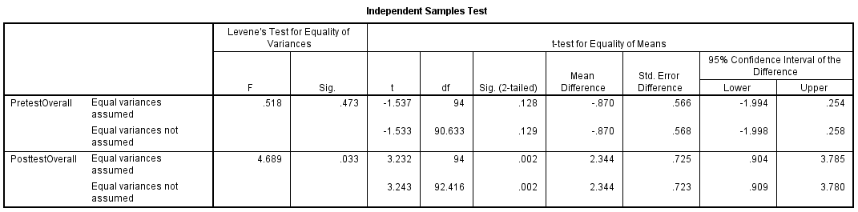

Significance of Difference between Pretest and Posttest Mean Score of the Control Group and Significance of Difference between Pretest and Posttest Mean Score of the Experimental Group

Paired Samples Statistics
 |  | Mean | N | Std. Deviation | Std. Error Mean
Pair 1 | PretestExperimental | 8.4490 | 49 | 2.55817 | .36545
Pair 1 | PosttestExperimental | 15.4082 | 49 | 3.84013 | .54859
Pair 2 | PretestControl | 9.3191 | 47 | 2.97896 | .43453
Pair 2 | PosttestContol | 13.0638 | 47 | 3.22628 | .47060

Paired Samples Correlations
 |  | N | Correlation | Sig.
Pair 1 | PretestExperimental & PosttestExperimental | 49 | .216 | .135
Pair 2 | PretestControl & PosttestContol | 47 | .100 | .505

Paired Samples Test
 |  | Paired Differences |  |  |  |  | t | df | Sig. (2-tailed)
 |  | Mean | Std. Deviation | Std. Error Mean | 95% Confidence Interval of the Difference |  | t | df | Sig. (2-tailed)
 |  |  |  |  | Lower | Upper | t | df | Sig. (2-tailed)
Pair 1 | PretestExperimental - PosttestExperimental | -6.95918 | 4.12795 | .58971 | -8.14487 | -5.77350 | -11.801 | 48 | .000
Pair 2 | PretestControl - PosttestContol | -3.74468 | 4.16751 | .60789 | -4.96831 | -2.52105 | -6.160 | 46 | .000

Mean Gain Scores of Experimental and Control Group

Case Processing Summary
 | Cases
 | Included |  | Excluded |  | Total
 | N | Percent | N | Percent | N | Percent
MeanGainSocres * Groups | 96 | 100.0% | 0 | 0.0% | 96 | 100.0%

Report
MeanGainSocres
Groups | Mean | N | Std. Deviation
Experimental | 6.9592 | 49 | 4.12795
Control | 3.7447 | 47 | 4.16751
Total | 5.3854 | 96 | 4.43044

Descriptive Statistics
 | N | Minimum | Maximum | Mean | Std. Deviation
ControlMeanGain | 47 | -8.00 | 13.00 | 3.7447 | 4.16751
ExperimentalMeanGain | 49 | -2.00 | 16.00 | 6.9592 | 4.12795
Valid N (listwise) | 47

Significance of Difference between Mean Gain Scores of Experimental and Control Group

Paired Samples Statistics
 |  | Mean | N | Std. Deviation | Std. Error Mean
Pair 1 | ExperimentalMeanGain | 6.7660 | 47 | 4.03901 | .58915
Pair 1 | ControlMeanGain | 3.7447 | 47 | 4.16751 | .60789

Paired Samples Correlations
 |  | N | Correlation | Sig.
Pair 1 | ExperimentalMeanGain & ControlMeanGain | 47 | .127 | .396

Paired Samples Test
 |  | Paired Differences |  |  |  |  | t | df | Sig. (2-tailed)
 |  | Mean | Std. Deviation | Std. Error Mean | 95% Confidence Interval of the Difference |  | t | df | Sig. (2-tailed)
 |  |  |  |  | Lower | Upper | t | df | Sig. (2-tailed)
Pair 1 | ExperimentalMeanGain - ControlMeanGain | 3.02128 | 5.42334 | .79107 | 1.42893 | 4.61363 | 3.819 | 46 | .000

APPENDIX N
Turnitin Result



