ANALYZE ABILITY OF EARLY CHILDHOOD BASED ON GENDER
Salsabila Hasiana Tanjung¹, Suparno²

^{1,2}Yogyakarta State University

ABSTRACT
The experimental design in this study has a particular interest in making conclusions made about gender differences in the ability to analyze children aged 5 years in the perspective of Taxonomic Bloom. The problem in this research is represented by the sample of research subjects by using items that have been loaded instrument. Test reliability and heterogeneity of variance can be randomly drawn conclusions from the scores of women and men on the instrument used. The results showed a statistically significant effect size difference difference (.01 Mean) in favor of women. The magnitude of gender differences in the impact of learning outcomes, however, differs substantially throughout the specific product domain graphically.

KEY WORDS  gender, cognitive and analyze ability.  CORRESPONDING AUTHOR:  email: suparno_plb@uny.ac.id  Manuscript submitted May 28, 2019; accepted Junes 18, 2019.  Copyright: ©2019 This is an open access article under the terms of the Creative Commons Attribution License, which permits unrestricted use, distribution, and reproduction in any medium, provided the original author and source are credited. | ECRJ (Early Chilhood Research Journal)  ISSN Numbers: Print, 2655-6448; Online, 2655-9315  ADDRESS  Website: http://journals.ums.ac.id/index.php/ecrj  Address: Pendidikan Guru PAUD  Universitas Muhammadiyah Surakarta  A. Yani Street No. 1, Pabelan, Kartasura, Surakarta, Indonesia  Telp. +62-271-717417 ext.  Email: ecrj@ums.ac.id

INTRODUCTION
The problem in this study is to see how different the ability to analyze boys and girls. It is seen or researched in situations of the child's learning process when the child performs cognitive aspect activities for one semester. The research process has resulted in a fair and valid assessment that allows researchers to understand the differences that are found, the difference between boys and girls, and the reasons underlying them have differences in analytical skills. Boys are more inclined to think logically [1], nevertheless in doing girls' schooling activities more closely and their memory memory is better [2] The child's ability to analyze is important in the conduct of each child's activities. Having good analytical thinking skills from an early age will help the child in various aspects of life of further development. Thinking analysis is a reflective form of thinking by emphasizing the idea of what to believe and do to make the right decision. The category analyzing, evaluating, and creating is an abstract concept that belongs to a higher level and not all preschoolers can understand it [3]. Therefore in this study, researchers only limit the ability to analyze only. This research is important because it can see how different the ability to analyze boys with girls at the age of five to six years. By knowing the differences in the ability to analyze across gender, teachers or parents can be better prepared to adapt the right way and learning activities for the child. The ability to analyze is a high-level thinking level, because it encourages the learning performance of learners [4] thus affecting how the child's learning outcomes. Ability to analyze becomes one of the capital for children to be able to complete the tasks that children have, both in life learning and in daily life. The learning process that uses a learning system that emphasizes interaction tends to produce students who have good learning outcomes [5].
In the research implementation, there was a gap in the learning process used, because in this study researchers and teachers used the same treatment for each gender of children and more dominant in the number of research, so researchers took the number of girls according to the needs of research. The diversity in every half of the population and the large number of variables affecting the subject adds considerable complexity to the research process. I consider here some experimental design problems that are essential for gender study differences because the nature of the results depends, in large part, on the way the research is done. The steps taken in the process of research that is, children and teachers do learning activities as usual. Learning content covers cognitive, linguistic and motor aspects. Researchers see the process of each child and the child's learning outcomes in the cognitive aspect. In the bloom taxonomy, analytical ability has sub aspects of differentiation, organizing and deconstruction capabilities [6]. Therefore, researchers assess the results of child learning based on three sub-aspects. Limitations in this study that researchers only discuss aspects of the ability to analyze children only from aspects of High Order Thinking Skills (HOTS). So for the ability to evaluate and create not reviewed in this research.

Analyze Ability
The category of cognitive process dimension is intended to provide a set of categorization for the cognitive processes of learners included in the objectives. The cognitive process dimension according to Bloom's Taxonomy Revision consists of 6 categories: remember, understand, apply, analyze, evaluate, and create [7]. Categories range from the most common cognitive processes found in this purpose, relating to remember, through understand and apply, for the less frequent ones of learning, evaluate, and create. Remember means taking back relevant knowledge from long-term memory. Analyze is the breakdown of matter into its constituent parts and determines how the parts are related to each other as well as the overall structure or purpose.
In the six categories of cognitive process dimensions, the objectives (targets) to be conducted in this study is limited to the category of analytical ability. This is based on the consideration that the cognitive abilities of children have stages that must be considered and not all categories of cognitive process dimensions are measured because it is adapted to the stage of child development to perform high-order thinking skills. Higher order thinking skill is a cognitive ability that is empirically based on bloom taxonomy learning theory, which is mechanistic, giving priority to process ability and higher thinking result. The thinking process included in the HOTS category is the ability to analyze, evaluate and create [8]. Children are given the condition so that children think more creative and critical behavior then appear based on the learning conditions provided in the learning process. Higher order thinking skills or HOTS is the ability or cognitive skills of children in thinking at a high level that helps children the opportunity to be skilled in thinking more creative and critical.
Ability to analyze is one of the cognitive abilities that are in the fourth level on the theory of Bloom. Analyzing involves the process of classifying the material and determining how the relationship between parts with each part with its overall structure. Children who have the ability to analyze will facilitate their life when children become adults [9]. The ability to help the child to take any action and support changes in the child's behavior for the better. Without the foundation of the ability to analyze children early on well, then the child will have difficulty to understand whether the child is doing right or wrong and can change the behavior of children when he grew up later. The process analyzing categories include cognitive processes in differentiating, organizing and attributing. Analyze includes learning to determine relevant pieces of information (differentiating), determining ways to organize the pieces of information (organizing) and determining the purpose behind the information (attribute). Analyze as an extension of the child's ability to understand and as the foundation of the child to be able to evaluate and create. The ability to analyze what children have early on will greatly assist the child's literacy skills [10]. The child's ability to analyze will help the child in sentence, number, and symbol related issues. The ability to analyze will make it easier for the child to manage the words that the child should speak while speaking, since the child has static or arranged speech skills [11]. So the ability to analyze the child will facilitate the child in readiness to read and count. In the ability to analyze children are able to distinguish between conditions, linking conclusions with supporting statements, distinguishing relevant material, and linking ideas. These things will facilitate the child in the learning process from an early age to the next stage because of the ability to analyze it [12]. Process categories understand, analyze and evaluate each other and are often used to perform cognitive tasks.
1) Differentiation
Differentiation is a child's ability to differentiate in analytical skills involving the process of sifting through the relevant or important parts of a structure. Differences occur when the child discriminates relevant and irrelevant information, important and unimportant. The process of differentiation is also different from comparing, because in comparing its form with relevant information while to distinguish that sort, focus and choose.
2) Organizing
Organizing involves the process of identifying situations and the process of recognizing how the elements form a coherent structure. Organizing is usually at the same time as the process of differentiation. The child first identifies relevant or important elements and then determines a structure formed from the elem. When organizing, the child is given a situation or problem, then the child can identify the relationship of these problems.

3) Deconstruction
Deconstruction is the ability of the child to attribute to occur when the child can determine the point of view, opinion, value, or purpose behind. Attributing involves the process of deconstruction, in which the child determines his own actions from his point of view. Children will behave based on the results of his analysis which then formed in the form of value or understanding of children in accordance with the process of analysis that has been done children.

Gender
Gender is a set of characteristics that are bound to and distinguish masculinity and femininity. Such characteristics may include gender (male, female, or intersex), gender-based (social structure such as gender role), or gender identity. [13] Some cultures have specific gender roles that are different from "men" and "women" collectively referred to as the third gender such as the Bissu group in Bugis society in Sulawesi and the hijras of South Asia. New Zealand sexologist John Money sparked a difference in the use of gender biological and gender terms as a role in 1955. Prior to that, the word "gender" was rarely used to mention anything other than grammatical gender in linguistics [14]. The word gender comes from the French language Mid gendre which in turn comes from the Latin word genus which means "type" or "type". The related modern French word is genre (as in the sexuel genre). The Oxford English Dictionary of the first edition of 1900 mentions that the initial meaning of gender as "kind" is unusual. The word gender is still widely used, especially in linguistics, for grammatical gender (masculine, feminine, and neutral nouns).
The word gender is still widely used as a substitute for sex or sex (as a category of biology), although there are some who try to maintain the distinction between the two. The American Heritage Dictionary uses the following two sentences to illustrate the difference between the two terms while pointing out that the differences between them are in principle useful but not widely used and varying usage in various contexts. The definition is still used today for some contexts such as in social science [15].
Some knowledge about gender one of them is branch of social science that is study of gender. Neurology and neurology also discuss some issues about gender. Gender studies generally discuss gender as a social construct while the sciences in the natural sciences deal with the biological differences between men and women that can influence gender development in humans. Both approaches contribute to investigating the extent to which biological differences influence the formation of gender identity in a person. Social identity is a common identification of a society of people or a social category that constitutes a common culture among its members [16]. According to social identity theory [17] an important component of self-concept derives from membership in social groups and categories. It is shown in the group process as well as in how intergroup relationships have a significant influence on one's perceptions and behaviors. The group then provides its members with a definition of who they are and how they should behave in their social environment [18].
Taken together, developmental gender literature shows that boys and girls enter preschool years with very similar levels of cognitive and pre-academic skills, but with some potentially larger differences in language, social, emotional and behavioral domains. In preschool classroom settings, these differences are thought to lead to differences in child-teacher relationship quality as well as how children spend their time, especially during unstructured children's play. In particular, girls are described as having a closer and less conflicting relationship with their teacher than boys [19]. In addition, women were also depicted more involved in cognitive stimulation of classroom activities and imaginary verbal mediated and prosocial play, rather than boys, especially during free self-play [20]. If teachers are instructional content channels and serve important scaffolding roles in children's learning [21], then girls proximity to their teachers provides a basis for stating that girls tend to learn early academic skills from analytical skills rather than boys. Perhaps the same hypothesis also applies to the impact on girls' behavior. Again, better women's self-regulatory skills and closer relationships with their teachers can mean that they are very likely attending their teacher's efforts to develop their social and behavioral skills, and they may be better able to meet the expectations of their teacher's behavior, thereby creating a positive interaction of materials further fuel prosocial behavior and self-regulation. In particular, this developmental explanation is consistent with the observation [22] that "skills" during the childhood.

RESEARCH METHODS
Data
This research is the data of children learning outcomes on the cognitive aspects in terms of ability to analyze it. The data in this study were taken from 20 boys and 20 girls by the age of five. Kindergarten used is a school located in Deli Serdang district located in North Sumatra. The data used is the data of children's learning outcomes during one semester by seeing the average value of achievement with Likert scale then from each learning outcomes of children assessed ability to analyze with differentiation, organize and deconstruction aspect. All data obtained will be obtained by using an appeal or t test and data regression test.

Methodology
To understand whether the ability to analyze with different gender in five-year-olds, we do quantitative method that uses the results of studies on each data that has been obtained by using comparative data for boys and girls. This methodology tends to see how it is compared so that it uses the t test in its methodology. Results from individual reports are used to estimate average effect sizes across the results of the child's analytical skills. In addition, test whether the average effect size is different from the characteristics of analytical skills, in this case the gender of the participants. After defining interest issues, takes place in the following steps, described below: (1) literature search, (2) data evaluation, 3) Interviews with teachers and (4) data analysis.
Table 1. Cognitive Ability of Girls and Boys
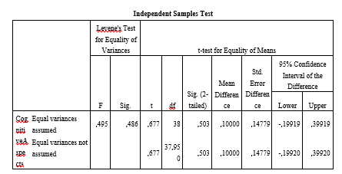
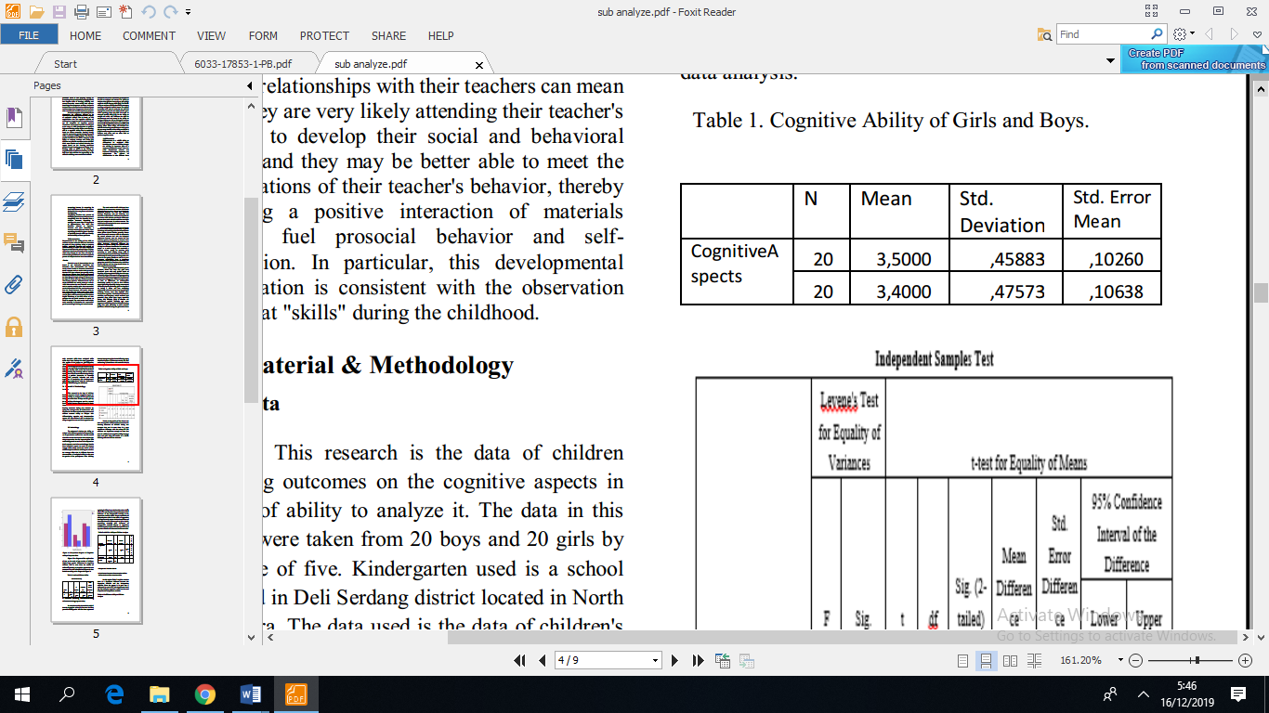

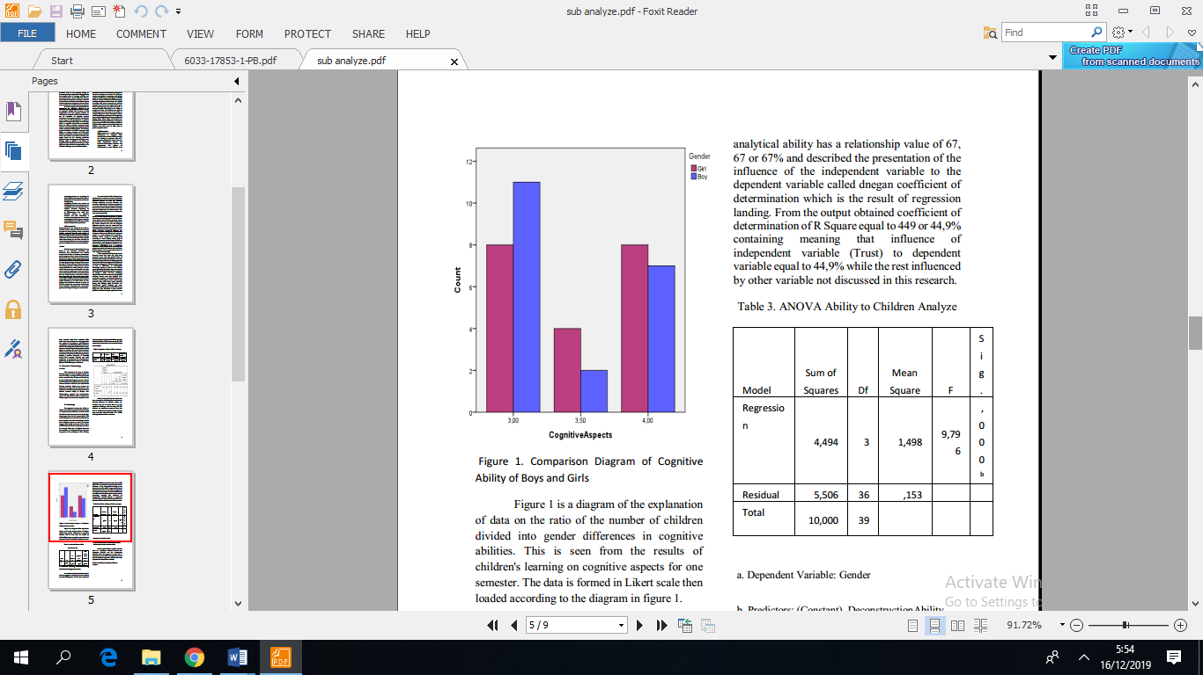
Based on the results of the data to see how the cognitive abilities of boys based on the learning outcomes of children during one semester that can be seen there is a very significant difference with the value, 67. The numbers are significant enough to state that there is a difference in cognitive ability between boys and girls using the results of a child's learning outcomes for one semester.

Figure 1 is a diagram of the explanation of data on the ratio of the number of children divided into gender differences in cognitive abilities. This is seen from the results of children's learning on cognitive aspects for one semester. The data is formed in Likert scale then loaded according to the diagram in figure 1.

Table 2. Analyze Children Ability


a. Predictors: (Constant), Deconstruction Ability, Differentiation Ability, Organize Ability.

In accordance with the results in table 2 that the regression value (R) between the five-year-old child's gender with the three aspects of analytical ability has a relationship value of 67, 67 or 67% and described the presentation of the influence of the independent variable to the dependent variable called dnegan coefficient of determination which is the result of regression landing. From the output obtained coefficient of determination of R Square equal to 449 or 44,9% containing meaning that influence of independent variable (Trust) to dependent variable equal to 44,9% while the rest influenced by other variable not discussed in this research.

Table 3. ANOVA Ability to Children Analyze
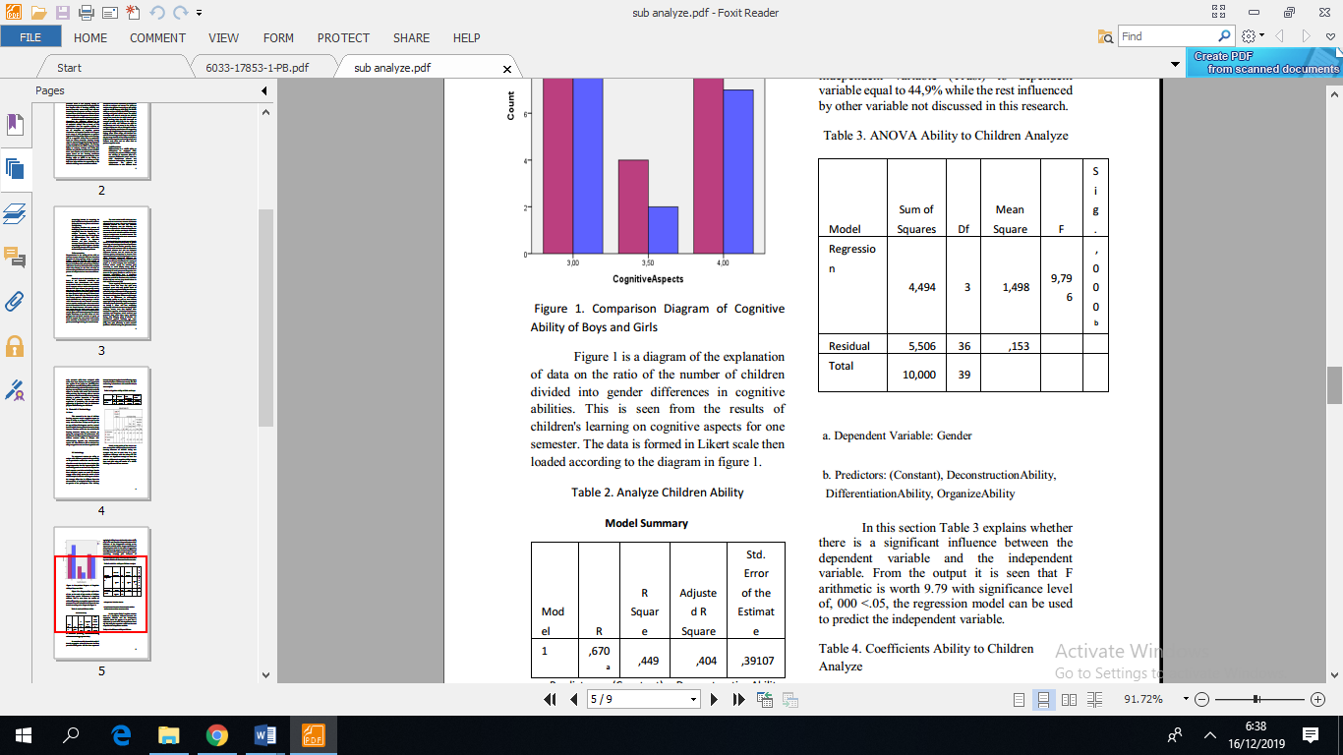

a. Dependent Variable: Gender
b. Predictors: (Constant), Deconstruction Ability, Differentiation Ability, Organize Ability

In this section Table 3 explains whether there is a significant influence between the dependent variable and the independent variable. From the output it is seen that F arithmetic is worth 9.79 with significance level of, 000 <.05, the regression model can be used to predict the independent variable.

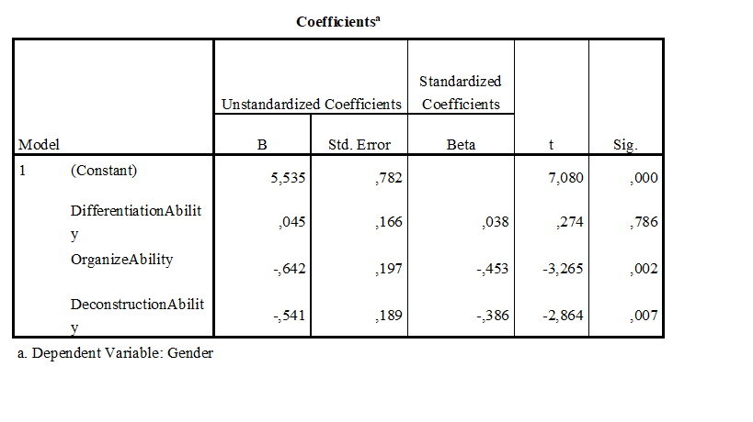
Table 4. Coefficients Ability to Children Analyze.
In table 4, in column B at Constant value is 5,535. With regression equation:
Y = a + bX or 5,535 + bX
The constant of 5,535 states that if there is no Trust value at the output then the value of participation is the value of the outpunt of the constant.
RESULTS AND DISCUSSION
Based The cognitive abilities between girls and boys have significant differences. The results of a simple multi-level regression model using the size of the results of all domains, where the term intercept represents the mean effect size for girls and the coefficients on the variables for boys measured the difference in effect size for males compared with women on the cognitive abilities of children who then reviewed the ability to analyze it by looking at three aspects. The results showed a statistically significant effect size difference difference (.01 Mean) in favor of women. The magnitude of gender differences in the impact of learning outcomes, however, differs substantially throughout the specific product domain graphically. Gender differences seem to have little greater impact on cognitive outcomes and analytical abilities on the achievement of girls than for boys' outcomes. The gender differences in these results are statistically significant, but again, they are small and we interpret them as not substantively meaningful. Since we can not reject the hypothesis on the ability to analyze and gender impacts on cognitive outcomes and achievements are similar, we combine these two sets of results in subsequent analyzes. So although there is a significant difference but the great influence between the ability mengenalisis five-year-old children with the existence of gender differences did not happen very large influence.
This analysis for early childhood education programs is the first to see and study whether boys and girls have different cognitive abilities and analytical skills. This question is important from the science of development and gender equality perspective. For cognitive and achievement outcomes, both sexes differ in ability by about one-tenth of the mean value, in all these outcomes. Among the few studies that incorporate the behavior and outcomes of mental health programs generally do not affect these outcomes for both boys or girls. However, although similar programs affect the achievement and cognitive skills as well as the ability to analyze them.
Gender differences in the ability to analyze on cognitive and substantive achievement outcomes are small (0.01 averages), suggesting early benefits of girls in skills in analyzing and behavior as well as proximity to their classroom teachers did not make them substantially more able to learn from group-based and initiated by the children's learning activities that are common in preschool activities. As explained in our introduction, it is also conceptually important to consider how the ability to analyze children between boys and girls. In the process of learning outcomes, girls are more tidy in the process so that there is a subjective side in the assessment even though boys have not much different cognitive abilities. Although the same trials [23] have been carried out before producing men more tendency.Another explanation for this small difference is that although women may be more involved with cognitive aspects and analytical skills, they may also be more involved in enriching the interaction in the learning environment. In all other domains, if there is a gender difference, girls are more dominant. This suggests that a clear explanation for the improvement of other school outcomes such as differential impact on the level of academic skills or reduction in problem behavior is unlikely to encourage children in the cognitive aspects of boys at other school levels.

CONCLUSION
In accordance with the data obtained and if the data has been done, it can be seen that there is a significant anatara learning results of cognitive aspects of girls with boys. Nevertheless, when statistical tests were performed by means of regression tests, there was no significant difference and influence between the ability to analyze between girls and boys. In this study did not discuss too much about what variables that cause no effect is too great between the ability to analyze boys with girls. Therefore, follow-up research is needed to complement the issues not covered in this study.
Acknowledgement. This research is fully supported by Yogyakarta State University and the teachers who help me in completing the data for the research completion process.

REFERENCES
Feingold, A. (1993). Cognitive gender differences: A developmental perspective. Sex Roles, 29(1-2), 91-112.
Stumpf, H., & Jackson, D. N. (1994). Gender-related differences in cognitive abilities: Evidence from a medical school admissions testing program. Personality and Individual Differences, 17(3), 335-344.
Mufson, Lisa & Strasser, J. (2014). Moving beyond who, what, when, where, and why; using bloom’s taxonomy questioning to extend preschools’ thinking. For the Preschool Professional, 9, 1-12.
Saido, G. M., Siraj, S., Nordin, A. B B., et al. (2015). Higher order thinking skills among secondary school students in science learning. The Malaysian Online Journal of Educational Science, 3, 13-20.
Druin, A. (2009). Mobile technology for children: Designing for interaction and learning. Morgan Kaufmann.
Anderson, Lorin W. Krathwohl,David R. (2001). A Taxonomy for Learning, Teaching, and Assessing : A Revision of Bloom’s Taxonomy of Educational Objectives. A Bridged Edition. Addison Wesley Longman : New York
Anderson, Lorin W. Krathwohl,David R. (2001). A Taxonomy for Learning, Teaching, and Assessing : A Revision of Bloom’s Taxonomy of Educational Objectives. A Bridged Edition. Addison Wesley Longman : New York
Assaly, Ibtihal R. Smadi, Oqlah M. (2015). Using Bloom’s Taxonomy to Evaluate the Cognitive Levels of Master Class Textbook’s Questions. Canadian Center of Science and Education. https://files.eric.ed.gov/fulltext/EJ1075241.pdf
Semrud-Clikeman, Margaret. (2007). Social Competence in Children. Springer : USA
L. Maria, Bernard. (2009). Current Management in Child Neurology. People’s Medical Publishing House : Shelton
J.Brainerd, Charles. Pressley,Michael. (1982). Verbal Process in Children : Progress in Cognitive Development Research. Springer-Verlag : Berlin.
Allal, Linda. Chanquoy, Lucile. Largy, Pierre. (2014). Revision Cognitive and Instructional Processes. Springer Science + Business Media : New York.
Haig, D. (2004). The inexorable rise of gender and the decline of sex: Social change in academic titles, 1945–2001. Archives of sexual behavior, 33(2), 87-96.
Pokorny, J. (1989). Indogermanisches etymologisches Wörterbuch. Bern: Francke.
Lindsey, L. L. (2015). Gender roles: A sociological perspective. Routledge.
Snow, D. A., & Oliver, P. E. (1995). Social movements and collective behavior: Social psychological dimensions and considerations. Sociological perspectives on social psychology, 571-99.
Tajfel, H. (Ed.). (2010). Social identity and intergroup relations. Cambridge University Press.
Terry, D. J., & Hogg, M. A. (1996). Group norms and the attitude-behavior relationship: A role for group identification. Personality and Social Psychology Bulletin, 22(8), 776-793.
Ewing, A. R., & Taylor, A. R. (2009). The role of child gender and ethnicity in teacher–child relationship quality and children's behavioral adjustment in preschool. Early Childhood Research Quarterly, 24(1), 92-105.
Goble, P., Martin, C. L., Hanish, L. D., & Fabes, R. A. (2012). Children’s gender-typed activity choices across preschool social contexts. Sex Roles, 67(7-8), 435-451.
Burchinal, M., Magnuson, K., Powell, D., & Hong, S. S. (2015). Early childcare and education. In
M. Bornstein, & T. Leventhal (Eds.), Handbook of child psychology and developmental science. Ecological settings and processes (Vol. 4) (pp. 223–267). Wiley: Hoboken, NJ.
Heckman, J. J. (2008). Schools, skills, and synapses. Economic inquiry, 46(3), 289-324.
Feingold, A. (1993). Cognitive gender differences: A developmental perspective. Sex Roles, 29(1-2), 91-112

