Caldera of Godean, Sleman, Yogyakarta:
An Volcanic Geomorphology Review

Hill. Gendoet Hartono¹, Adjat Sudradjat, Okki Verdiansyah
SekolahTinggiTeknologi NasionalYogyakarta
1Correspondingauthor (email: hilghartono@sttnas.ac.id)

Abstract
Godean area is located approximately 10 km westward from the Yogyakarta city. The existence of morphological Godean heights that surrounded by the plains became the focus of the study, especially the rocks from Godean heights utilized by the local community as a raw material for making tiles and red brick, while plains fro settlement and rice fields. On the other hand, the distribution of rocks and sediments in the western part of the plain morphology Godean boundary by the curved pattern of Kulon Progo river that flow eastward Godean heights surrounding morphology. The genesis of landscape and terrain of the Godean area affected by various factors, such as lithology, structure geology, and subaerial process. The purpose of this paper is to reveal the existence of Godean’s landscape. The method is consist of field visits, measurements of the morphological variables, rock sampling and laboratory analysis. The results of field mapping indicates that the altitude Godean be isolated, consisting of a hill with a steep slope (> 40 °), a height of +231 m., stream direction is relatively northeast - southwest which disembogue into K Progo in the west. Morphology elevation on Godean such as G. So (+173 m), G. Gede (+218 m), G. Wungkal (+187 m), G. Butak (+154 m) and G. Berjo (+ 175 m) were controled by lithology form of igneous rock which composed by porphyry andesite - microdiorite, pumice lapilli and quartz rich lapilli-tuff, and most of the igneous rocks have weathered and altered to clays, while the deposition from Merapi volcano forming the landscape with an altitude between +100 - +150 m. surrounding Godean heights. Sentolo formations exposed in Kembang, Bantul (± 5 km) south of the assessment with sediment beds N93ºE /12º, while distribution in the southwest and northeast relatively curved cover Godean highs. The results of the analysis provide an understanding that the Godean is a landscape remains of the volcanic caldera form, with various igneous rock type, volcaniclastics deposits and occurrences of hydrothermal alteration and mineralization. Further geophysical research needs to determine the configuration of igneous rocks under the earth's surface.
Keywords: Earthquake, Prediction, Southern Mountains,Yogyakarta, Stratigraphic.

INTRODUCTION
Godean is part of the Godean District, Sleman Regency, Yogyakarta (Figure 1), precisely in the southwestern city of Sleman and approximately 10 km western of the Yogyakarta city. In general, the name of Godean quite well known for the craft of making tiles and red brick which the raw materials locally produce, but the surrounding area is very fertile rice fields in the form. Geologically, the area of ​​hills isolated Godean, among others G. So (+173 m), G. Siwareng (+194 m), G. Gede (+218 m), G. Wungkal (+187 m), G. Ngampon ( +222 m), G. Gedang (+193 m), G. Patuk (+231 m), G. Butak (+154 m) and G. Berjo (+175 m) surrounded by plains. This isolated hills composed by igneous rocks breakthrough very hard withigneous rock type consist of andesite and diorite, as a part of the Old Andesite Formation, while the plains composed younger volcaniclastic from G. Merapi (van Bemmelen, 1949; Rahardjo, et al., 1977). This formation has been much research done on the fulfillment of Sandi Stratigrafi Indonesia, however, on the other hand, understanding the genesis of geomorphology to reveal the existence of the landscape in the landscape altitude plateau has not been much research done in a sustainable and integrated.
The geneticproblems involves some important aspects such as aspects of the source material, the process of the formation mechanism, age and environmental aspects of the establishment. The source aspects describes the origin of intrusion and volcanic rocks that build heights and plains Godean including associated forming process, and origin of time, while the environmental aspect refers to the formation like subsurface or subaerial. Genesis formation of landforms and landscapes Godean produce the highsand plains that surrounded became the main focus of this study.

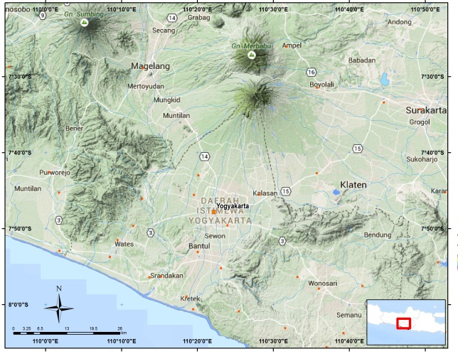

Figure 1.Location of research area.

Rahardjo, et. al., (1977) mentions that geology Godean hills part of the Kulonprogro Mountains. Mountains Kulonprogro body built by G. Gadjah old volcano, G. Idjo, and G. Menoreh otherwise known as Oblong Dome trending relatively northeastern - southwestern with a length of 32 km and a width of 15-20 km (Figure 2). Altitude area Godean, in general also an igneous body building, but has been deformed by weathering, alteration, intrusion and faulted. Possibility, those process forming the recent landscape.

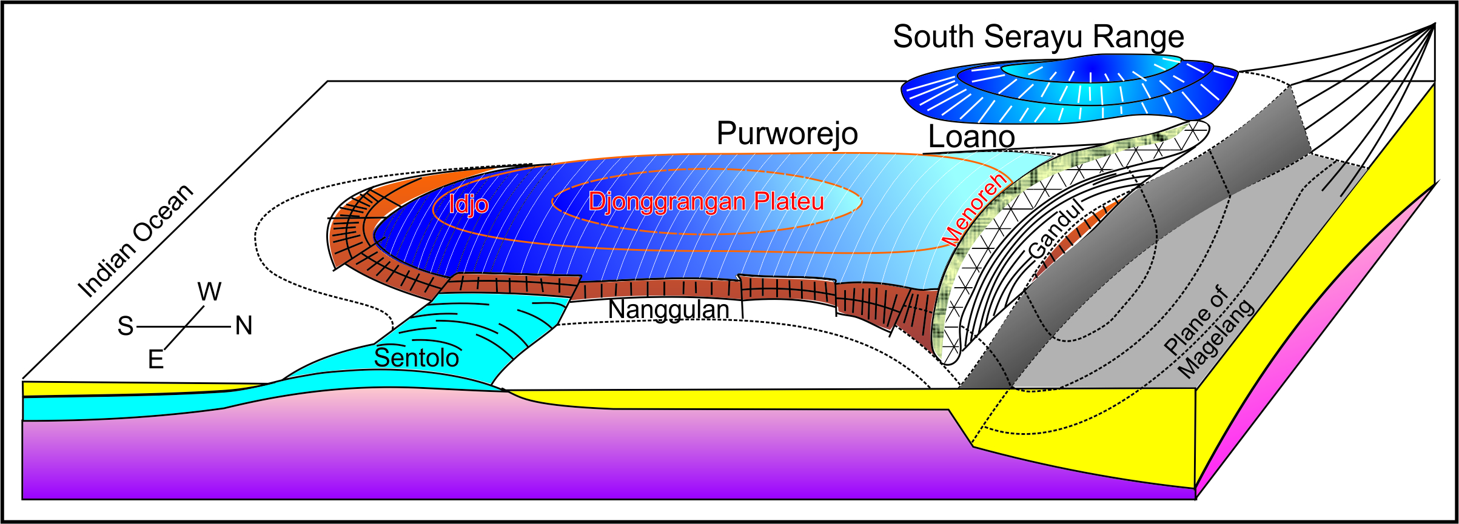

Figure 2. Oblong Domelandscape as relict of several ancient volcanosuch as Gadjah, Idjo, and Menoreh (modification from van Bemmelen, 1949).

Stratigraphyof Kulonprogo Mountain, beginning fromsilisiclastic sedimens of NanggulanFormationgroup (Tabel 1),which have member of Seputih member consist of marls in upper part, then conformabledepositof intercalation volcanics and coheren lava, others rock is shallow intrusion of Old Andesite Formation. Jonggrangan Formation dan Sentolo Formation interfingering and distribute in above Old Andesite Formation.
Lelono (2000) mentions that Nanggulan Formation Eosen age, this conclution base on palynomorphsfor lowland / rain forest and climate indicator, and Budiadi (2008) conclude the Kulonprogo Mountain landsape was controlled by geological structure, but in otherwise Hartono & Pambudi (2015) mentions that rocks that build Nanggulan Formation deposition in small basinal between two highs. Meanwhile, Sipatriot (2016) conclude that Godean was relict of ancient volcano, and Bronto, (1999) mentions about industrial mineral deposit in there, consist of clays that originate from weathering of igneous rocks.

Tabel 1. Stratigraphic column of Kulonprogo from several researcher.

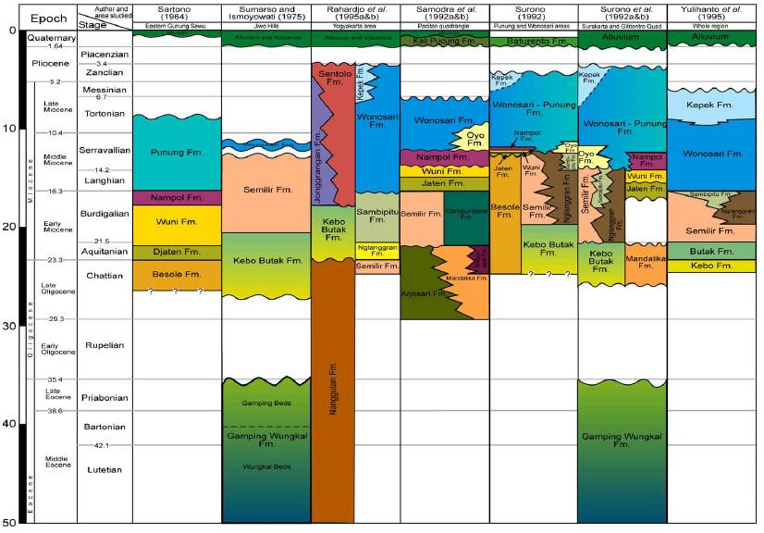

This research perhaps can solve the origins of highs landscape and the plains. This research can be first idea for possibility of hydrocarbon and economic mineral in this area.

METHOD
The applied method in this research is the study of geological surface that includes geological mapping, measurement aspects of geomorphology, structural geology and rock sampling. Geological mapping is done based on studies and literature critics, and only on a limited area Nanggulan heights and plains. In addition, the measurement element geological structure to determine its role in the formation of the landscape area of assessment, measurement aspects of geomorphology conducted to determine the slope, height difference, the pattern of drainage, stadia and the type of streams in the context of the character of the landscape and the process that accompanies it, while petrographic to understand capital mineral composition, texture and structure of precipitation, and the process of formation and depositional environment.

RESULT AND DISCUSSION
Surveys of the study show that the rocks making up the Godean hills composed of volcanic rocks and sub-volcanic rocks. Volcanic rocks generally form lapilli-tuff, lapilli-pumice, while the sub-volcanic rocks form a intrusion rock is composed of basalt, andesite, dacite and microdiorite (Figure 3). Lapilli tuff, tuff lapilli pumice and others volcanic rock originated from eruption activity, and where pumice indicate magma series is composed of acid and the massive eruption of volcanoes behave. On the other hand, the common intrusion igneous rock is composed of basalt, andesite and some rocks encountered many xenolith in igneous body that is composed of andesite porphyry - dacite. This shows the volcanic activity that occur repeatedly and some rocks that intruded into the rock to break through, as in the body dacite. This issue is important in the context of the paper that this process takes place in the body of magma or the magma chamber of a volcano body. Based on the variation of the composition of rocks exposed in the study area provides an explanation of the process of magma differentiation and lead to the behaviors that are Godean volcanic eruptions. Period destructive eruption this is probably contribute to the formation of a volcanic landscape in Godean. That is the type of eruption of volcanic eruptions produce landscapes openings vary in diameter by more than 2 km, characterized by the landscape perfectly circular and semi-circular shape resembles a crescent (half moon, horse shoe shape). On the other hand, the inside of the circular structure revealed a breakthrough rock, rock alteration, neck volcano (volcanic neck), and the lava dome. The rest of the landscape of volcanic eruptions outer sometimes still shows a symmetrical shape, steep rock – ramps of volcanic beds, and compiled by intercalation of pyroclastic and coherent lava rocks.

In petrography, igneous rocks that make up the Godean heights generally intermediate igneous rocks, consist of hornblende andesite and pyroclastic rocks, and acid rocksconsist of dacite. It refers to the abundance of quartz mineral reaches 5% - 30%, and rock shows pyroclastics texture withvolcanic glass in tuffs, pumice, while the textured porphyritic o intrusion rocks is aphanitic, with type of plagioclase mineral is andesine (An₄₄Ab₅₆) (Figure 4). Volcanic rocks consist of coherent lava and pyroclastic that make up the landscape Godean lies in part in the form of landscapes circular to semicircular (Figure 5), encountered rock that has undergone by alteration, while the landscape of the plains that surrounded compiled by material volcaniclastics produced by eruption of Mount Merapi activity is located ± 25 km to the north (Rahardjo, et al., 1977).

Learning from geomorphology of volcano indicate that the landscape was built by active volcano (intrusion, melt and eruption), where material and composition associated with magma and lava, also geological structure after that. Godean heights reflects the phenomenon, as shown in Figure 5A that height is located inside a circular structure with a diameter over 2 km, the distribution were covered by carbonate rock of Sentolo formation that shows the rocks layering tilt to south with the position N92°E / 12° (Figure 5B), while the southwestern and northwestern parts of the north - the distribution follows a circular structure.

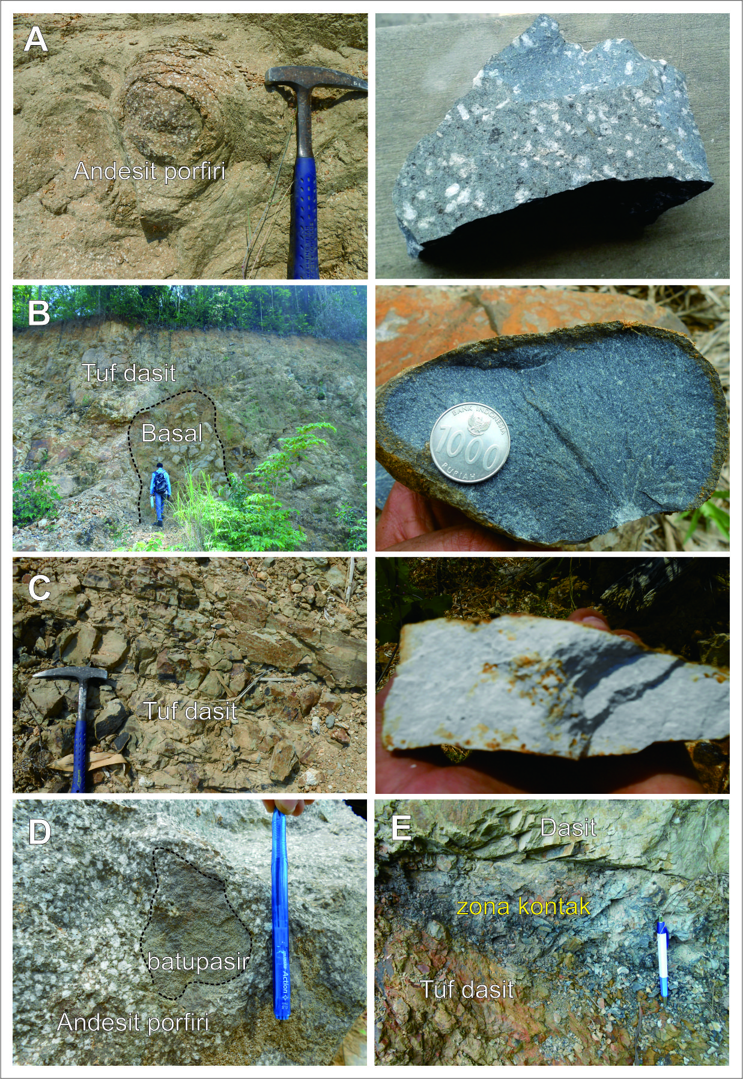

Figure 3. Various igneous rock type in Godean. (A) Spheroidal weathering of porphyryandesite; (B) Intrusive rockof basalt; (C) beding of Dacitic tuff; (D) Xenolithof sandstone in andesite ; (E)Contact zone (Sill) dasit with dacitic tuff. Notes: right side photo was handspecimen size (A, B, dan C)

The circular structure on the west side, followed by a curved shape of the Progo river is a reflection of the body architecture ancient volcano Godean. The curving river stream resistance may also be affected by volcanic rocks and may follow the structure of the fire mountain. In contrast to the eastern part undeveloped rivers and curved structures such as in the west. This is because the eastern part clastics material buried by volcanic origin Mount Merapi and river flow patterns evolve over sediment Merapi. Looked at the geological map (Figure 5A and 5B) that heights built on Godean separately and apparently unrelated. The explanation to this is the possibility of the faulted igneous body that becomes resistant fault zones and eroded, or prominent landscape is a dome in the surface (cryptodome), the body of a intrusion, or volcanic neck contained within the volcanic craters.

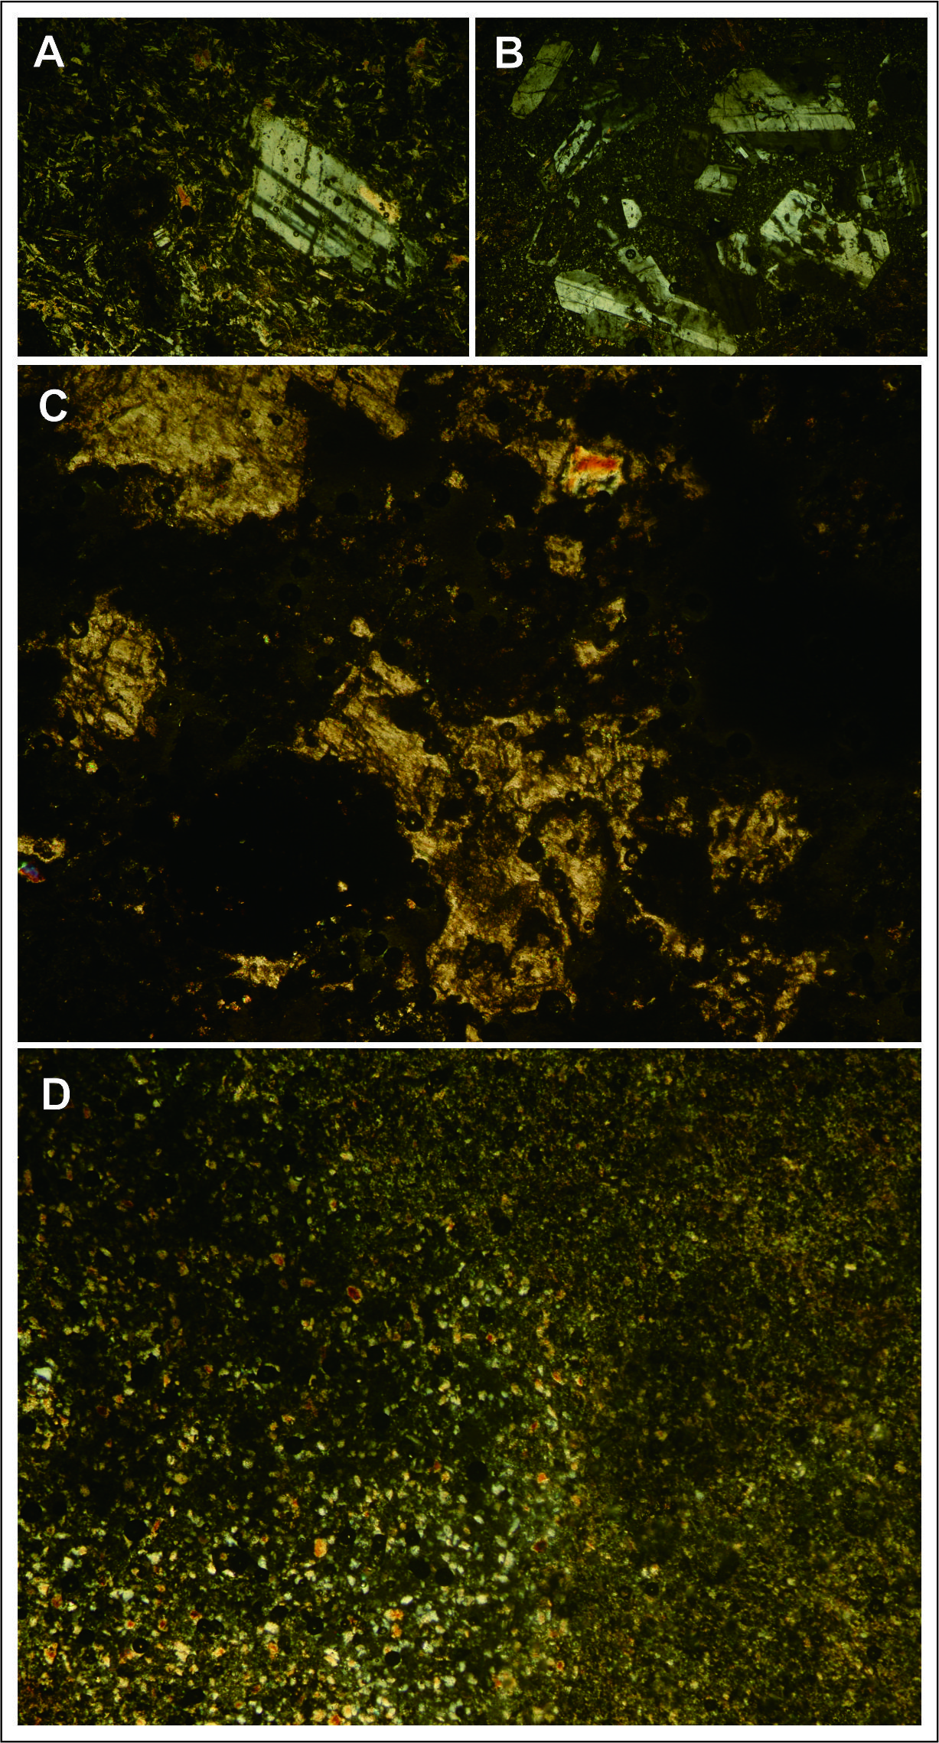

Figure 4. Photomicrograph of volcanic rocks that build Godean landscape (A) Porphyritic Andesite; (B) microdiorite; (C) Pumice; dan (D) Glass Tuff.

The oldest stratigraphy Godean compiled by Nanggulan Formation consisting of Eocene mudstone and sandstone, deposited thereon Old Andesite Formation composed of igneous rock, andesitic breccia and tuff. Igneous rock in the form of lava and intrusive rock (Rahardjo, et al., 1977). It confirms that Godean built by a group of volcanic rock from eruption process results and shallow intrusion. On the other hand, Sutanto, et al., (1994) shows the results absolute age dating from igneous shows the Old Andesite Formation age is 25.35 - 29.63 Ma old. This means that volcanic activity in Godean estimated lifetime with a volcano in the area of Kulon Progo, or possibly older when seen morphology and degree of weathering.
In Godean, there is also occurs hydrothermal alteration and mineralization in G. Wungkal that indicate of ancient volcanic activity, where we can assumption as geothermal system in ancient time. The occurrences of hydrothermal can adds confidence to interpretation that Godean product from volcanic process.
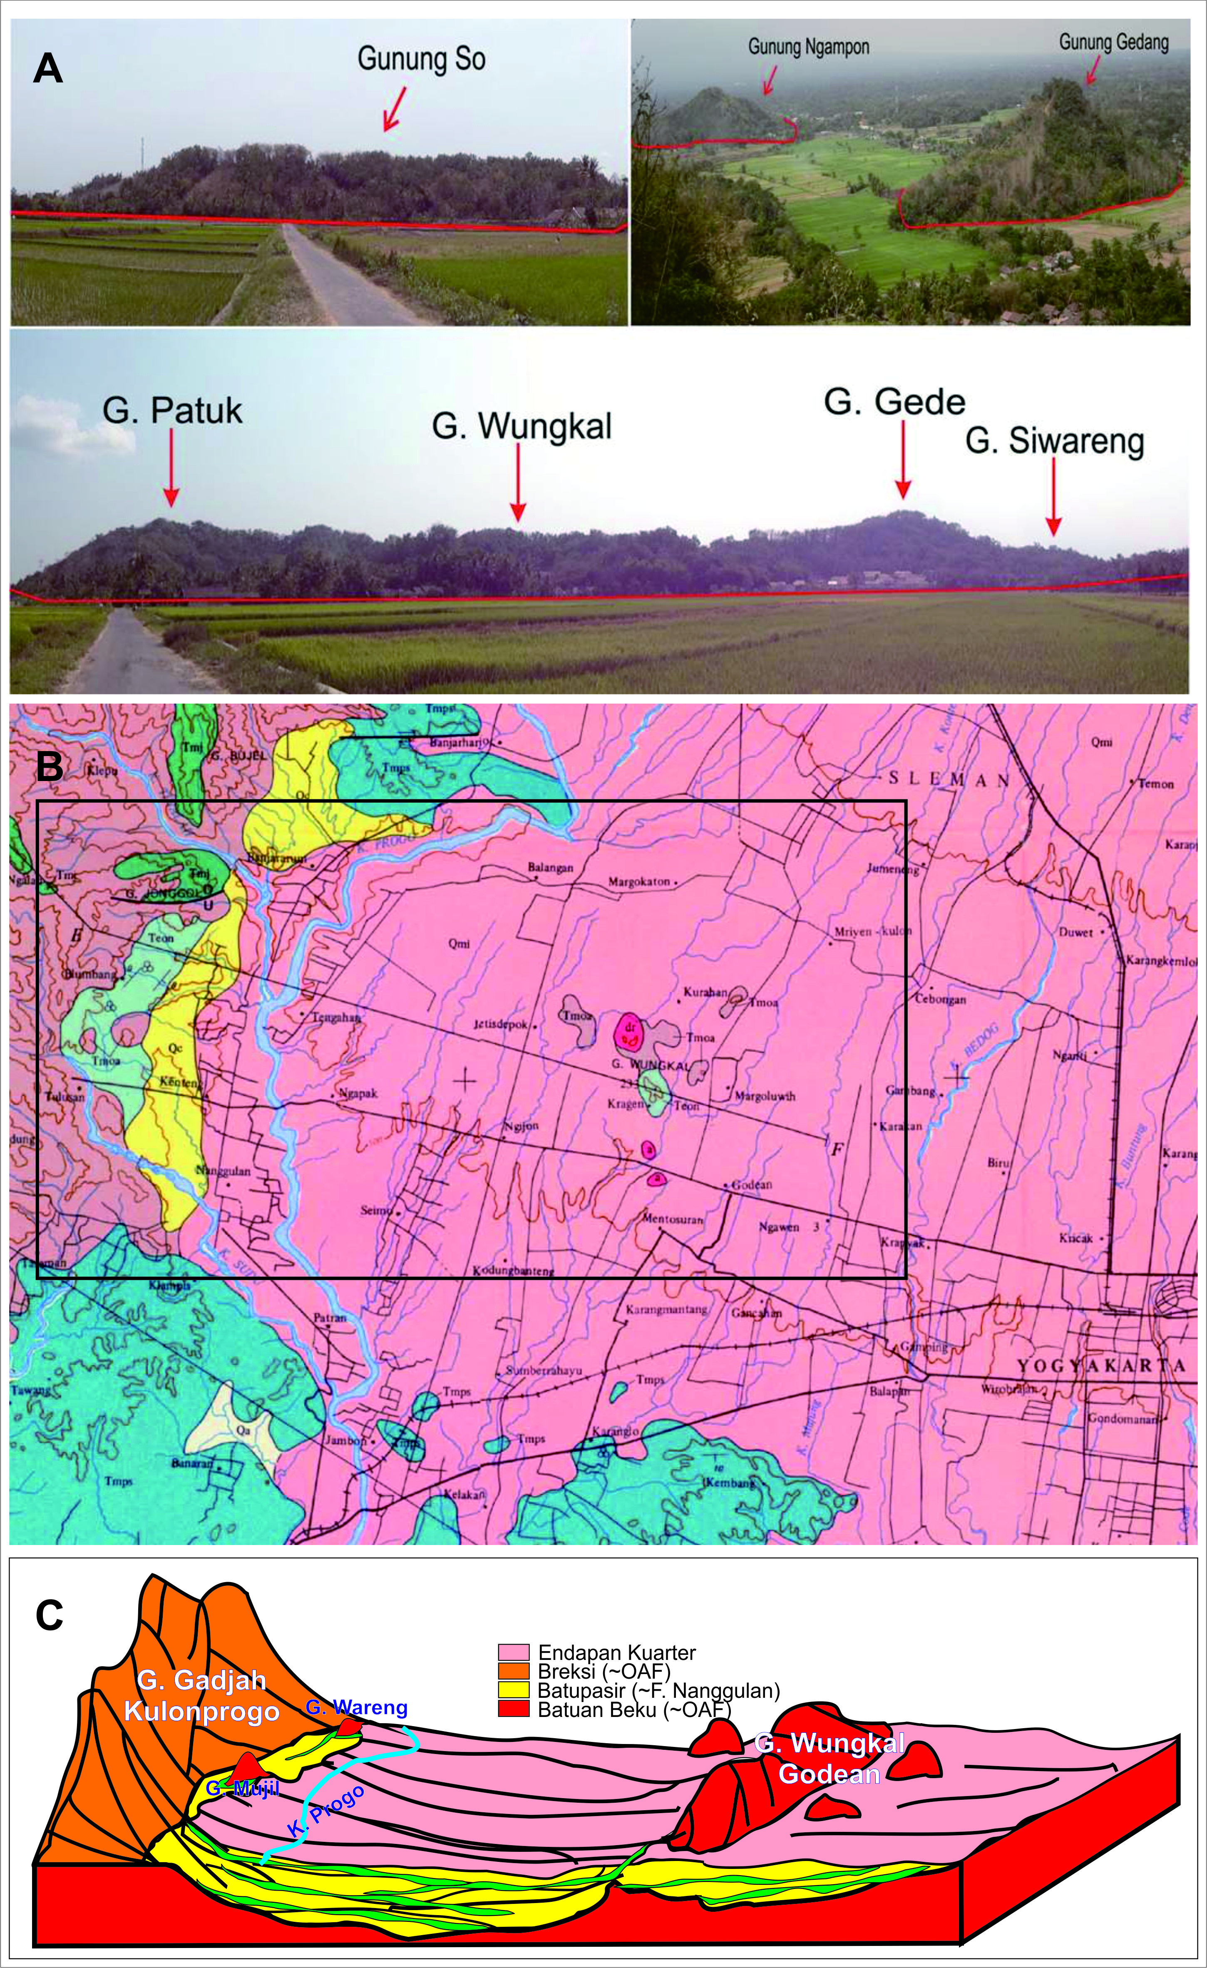

Figure 5. Morhology and landscape of Godean heightsthat compose of volcanics rock surrounded by fluvio-volcanics plain.(A)Morphology of hills height with tumors like morphology; (B) Geological map shows spread of lithologies (Rahardjo, dkk., 1977), and (C) Sketchof Godean Caldera with di G. Wungkal as central facies.

Figure 5C shows that Godean landscape as volcanic geomorphology created from volcanic eruption self-detructive process. This eruption association with Caldera eruption type, so its remain the caldera relict landscape form. In Genesis, the landscape of Godean relatively same with G. Gajahmungkur in Wonogiri – Central Java, whuch as as Caldera morphology (Hartono, 2010). One of the fact to prove the identification of hypothesis that we found pumice and dacitic tuff, as product of vig explosive associated with acidic magma. In otherside, opened circular and a half-circular landform have more 20 km in diameter, meanwhile in Godean area make 6km diameter. The opened structure, have weathered process and erosion, it caused only in west side that clearly observed for measured diameter.

The plains areas that are clastic material from G. Merapi is expected as early GGodeanbody which occupies the proximal facies, facies medial and distal facies. It is necessary to further study and prove that Godean asisolated volcanic cone between Kulonprogro Mountains height and Southern Mountains height.
Reconstruction of the lower plain areas of Godean has interpretedby Pertamina (2008 in Winardi, et al., 2013). Reconstruction explained that geophysical gravity measurements illustrate that under the rock mass altitude there Godean 2.49 g / cc to a depth of 2500 m is recorded as volcanic rock and shows its age 28.5 Ma. (Figure 6). Reconstruction model of the earth's surface and subsurface area has implications for the basin model in volcanic arc and the discovery of new natural resource location.

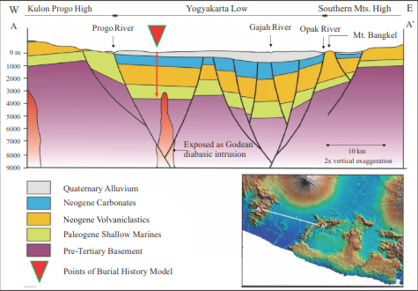

Figure6. Deposition stratified model as interpretation result of subsurface model from gravity data(Pertamina, 2008 dalam Winardi, dkk., 2013).

The volcano genetic perspective needed to understanding the basin characteristics has been put forward by Bronto, et al., (2006) and the model can be applied toassessment the relation and distribution of rocks formations in basin. It can used forestimatesedimentation between two highs or more, withthe depressionform as result from eruption that associated with caldera as in the study area.

CONCLUSION
The Godean height was volcanic landscape (geomorphology) that associated with caldera. Godean is composed by volcanic rock, consist of andesite - dacite, central part of caldera represented by G. Wungkal, and margin of crater reaching a 6000 mdiameter.

ACKNOWLEDGMENT
The author would like thank to STTNAS managementforresearch fundsandother committee who have helped the research and publication of this paper.

REFERENCES
Bronto, S., (1999). Petrologi dan Bahan Galian Industri di Daerah Godean Yogyakarta. Departemen Pendidikan dan Kebudayaan, Kantor Koordinasi Perguruan Tinggi Swasta Wilayah V Yogyakarta.
Bronto, S., Budiadi, Ev., dan Hartono, G.H., (2006). A New Perspective of Java Cenozoic Volcanic Arcs, Proceedings International Geosciences Conference and Exhibition, Jakarta.
Budiadi, Ev., (2008). Peranan Tektonik Dalam Mengontrol Geomorfologi Daerah Pegunungan Kulon Progo, Yogyakarta, Disertasi Doktor, UNPAD, Bandung, 204 hal.(Tidak dipublikasikan).
Hartono, G., (2010).Peran Paleovolkanisme dalam Tataan Produk Batuan Gunung Api Tersier di Gunung Gajahmungkur, Wonogiri, Jawa Tengah, Disertasi, UNPAD, Bandung, 335 h. (Tidak dipublikasikan).
Hartono, H.G. dan Pambudi, S., (2015). Gunung Api Purba Mujil, Kulonprogo, Yogyakarta: Suatu Bukti dan Pemikiran, Prosiding ReTII ke 10, STTNAS Yogyakarta.
Lelono, E.B. (2000).Palynological Study of the Eocene Nanggulan Formation, Central Java, Indonesia. Unpublished PhD Thesis.Dept. of Geology, Royal Holloway Univ. of London.
Rahardjo, W., Sukandarrumidi, & Rosidi, H.M.S. (1977). Peta Geologi Lembar Yogyakarta skala 1 : 100.000. Direktorat Geologi, Bandung.
Sipatriot, R. F., (2016).Geomorfologi Gunung Api Purba Godean, Kecamatan Godean, Kabupaten Sleman, provinsi DIY, Seminar Geologi, J. Teknik Geologi, STTNAS, Yogyakarta. Tidak terbit.
Sutanto, Soeria-Atmadja, R. C. Maury, & H. Bellon, (1994).Geochronology of Tertiary Volcanisme in Java, Kumpulan Makalah Seminar Geologi dan Geotektonik Pulau Jawa, Sejak Akhir Mesosoik hingga Kuarter, Jurusan Teknik Geologi, F. Teknik UGM, Yogyakarta, hal. 53-56.
Van Bemmelen, R. W., (1949).The Geology of Indonesia, Vol. 1A, The haque, Martinus Nijhoff, 732 hal.
Winardi, S., B. Toha, M. Imron, and D. H. Amijaya. (2013). The Potential of Eocene Shale of Nanggulan Formationas a Hydrocarbon Source Rock. Indonesian Journal of Geology, Vol. 8 No. 13-23.

