Mixed Pixel Estimation of Landsat Data Using LAPAN Surveillance Aircraft (LSA) Aerial Photo Data in Urban Area of Indramayu Regency, West Java
Nurwita Mustika Sari¹, Galdita Aruba Chulafak¹, Zylshal¹, Dony Kushardono¹

¹Remote Sensing Applications Center, Indonesian National Institute of Aeronautics and Space

E-mail: nurwita.mustika@lapan.go.id

ABSTRACT

Medium resolution satellite data such as Landsat is very potential for mixed pixel (mixel) to occur. Indonesian land use diverse especially urban areas makes high potential mixel in the first Landsat pixel size of 30 meters x 30 meters on the actual condition. Aircraft multispectral aerial photo data LAPAN Surveillance Aircraft (LSA) with a spatial resolution reached 58 cm can display objects in more detail in these sizes. The purpose of this research is to study mixel on Landsat data with multispectral data LSA as a complement Landsat data. The method proposed in this study is a visual interpretation with GEOBIA method for classification of land cover, and then test the validity of the sample to be used in research, and the use of such vegetation index NDVI to see the connection between vegetation index data of vegetation index LSA with Landsat data. The results showed that the regression equation obtained by regression between NDVI of Landsat data and NDVI of LSA with a significance of less than 0.05 is y = 0.732x - 0102 with a value of R² = 0.887. Through these results we can conclude that the NDVI values ​​on both the data related to one another.

Keyword: Mixed pixel, aerial remote sensing, Landsat, OBIA, NDVI.

- Introduction
Landsat imagery data is a popular data and has been widely used for various kinds of applications, including in a research by Sholihah et al. (2016) which found that the drought monitoring of agricultural land can be conducted by observing the vegetation health index (Vegetation Health Index/ VHI). Landsat 8 has been assessed by the user to look at the area of hydrothermal alteration copper mine. It used the existing TIR band and these data was able to do lithological mapping (Pour and Hashim, 2015). Integrated use of Landsat and LIDAR to map forest structure and biomass is done by Zald et al. (2016) in the area of Saskatchewan, Canada which gained moderate to high level of accuracy of its model (the value of R ² = 0.42 to 0.69). The use of remote sensing data with different resolutions, namely Landsat and Ikonos also be applied to determine soil erosion (Wang et al., 2011). The use of Landsat in the surface water monitoring in Australia has been done by Mueller et al. (2016) following the extreme floods in 2011 which used two decades data and developed standard algorithms on medium resolution satellite data for surface water. Landsat data is also used to evaluate changes in land use/ land cover along with the surface temperature pattern formed by the surface temperature is correlated with land use (Lv and Zhou, 2011). Landsat ortho has also been used to validate the model for mapping wetland area of Lampung province with level of accuracy reached 90.6% (Parsa et al., 2014).
The diversity of land cover occur in urban areas where the cities are areas with a high physical development of the region as the implications of increasing population (Widodo et al., 2015). The dynamics of rapid physical development of the city (Mikovits et al., 2014) affects traffic that one of the affected aspect is an urban road network density (Xing et al., 2013) which also adds the diversity of land cover in the city. Good urban planning in land use affect the quality of the city containing both the complexity of land use and of human activity on it to create a sustainable urban development (Vorontsova et Al., 2016).
The city is a region of land cover is very diverse as an example of Bandung on Green Open Space just have a diversity of land cover such as the area of trees, mixed garden, farm, bush/ shrub, open land and paddy fields (Narulita et al., 2016).
For that, study of mixed pixel (mixel) will be needed for further analysis. At Kuningan Regency, West Java the land cover changes causing narrow boundaries of land cover for the growth of residential area that is initially homogeneous consist of mixed garden or natural forests (Nasihin et al., 2016). Indonesia is a country with high prospective housing construction market with the regulation and affordability (Monkkonen, 2013).
On the other hand, the area of Indonesia with high diversity of land use/ land cover is tourism area including the Gili Matra island in Lombok, West Nusa Tenggara including land use/ land cover like shoal beach, sand beach, salty lake, mangrove area, mixed forest, plantation, bare areas, non built-up areas, settlements area, also tourism accomodation area. Land conversion into built-up area here occured very fast because of the major influence on the ease of access (Kurniawan et al., 2016).
Landsat data with a resolution of 30m which includes an area with high diversity of land cover has potential mixed pixel/ mixel which actually consist of several objects. Mixed pixel or mixel will be higher at imagery data with a coarse resolution (Danoedoro, 2009). Good ability of higher resolution imagery data to display objects in an imagery make the amount of pure pixels is more than low resolution imagery which tends to have a lot of mixed pixels (Hoyano and Komatsu, 1988).
The mixture in a pixel can occur in various forms including a boundary between two or more areas of the mapping unit, part of pixels in the form of a line, part of pixels in the form of an object, and intergrade or changes from one object to another object gradually (Fisher, 1997). The use of mixel to be a training data in classification is conducted by Foody and Mathur (2006) and obtained the overall accuracy of 92%. Referring to a research by Hoyano and Komatsu (1988) that divides pixels in several types, including pure pixels, mixel A and B. Mixel A is composed of several categories and does not have a separate section while mixel B is mixel containing several classes/ category and has a separate section.
The use of very high resolution remotely sensed data, for example WorldView-2 for detection of changes in land use like grazing with Landsat-8 as a previous condition data will obtain higher accuracy because the more specific changes will be detected while different objects in Landsat-8 scale are displayed in the same pixel (Tarantino et al. 2016). In other research using object-based method, the separation of objects conducted in three methods, first is based on Landsat TM and SPOT 5, second is only on SPOT 5 data and the last is only on Landsat TM. Of the three methods, the optimum segment result obtained is based on TM/ SPOT5 and only from SPOT5. By looking at the optimum result, it was concluded that the SPOT 5 data with higher resolution can improve the accuracy from 72.35% to 82.94%. With the increasing accuracy of the result, it is known that high-resolution data can be used to be a complement of Landsat data (Sun et al., 2014). Mixel study is important to measure the accuracy of satellite imagery.
Band on Tetracam multispectral camera used by LSA is able to detect vegetation well (Tetracam Inc., 2011). Aerial remote sensing using aerial vehicle called LSA (LAPAN Surveillance Aircraft) that carried a payload in the form of Tetracam camera with spatial resolution raching 58cm has been applied further to see the quality of a single object vegetation in urban areas with OBIA method and vegetation index (Nurwita and Dony, 2016) and reached accuracy of 88%. Besides vegetation, LSA multispectral data is capable to display objects clearly at the coastal region (Arifin et al., 2015). LSA multispectral data with a high resolution will be a complement of Landsat data which has lower resolution to see the estimation of mixed pixel occurred on Landsat.
Previous study of mixel divides this area into several types, but has not done stage to see the relationship of the spectral value between low resolution data with a higher resolution one. The purpose of this study is estimating mixel of Landsat data using LAPAN Surveillance Airfcraft multispectral data as complement.

2. Material and Methods
2.1. Material
The data used in this study is a multispectral image data acquired by the Center for Aviation Technology Space agency on September 19, 2014 includes the urban areas of Indramayu, West Java. The image data that has been acquired has been processed into mosaic and ortho correction by Remote Sensing Application Centre (Dony et al., 2014). Other data used is Landsat 8 acquired on September 22nd 2014 at the same area. The study area is located in urban area of Indramayu, West Java and its surrounding. Landsat data selected is the closest period to the acquisition of LSA data and has low cloud cover.

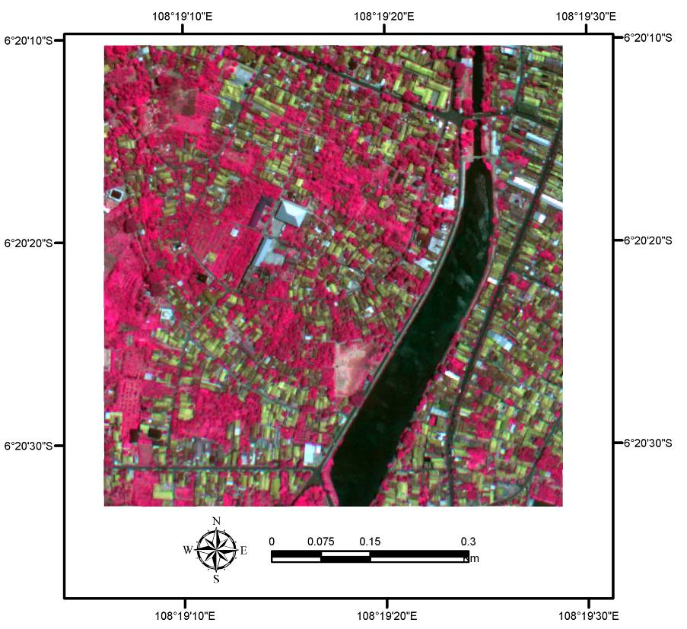
Figure 2-1 LAPAN Surveillance Aircraft (LSA) Data

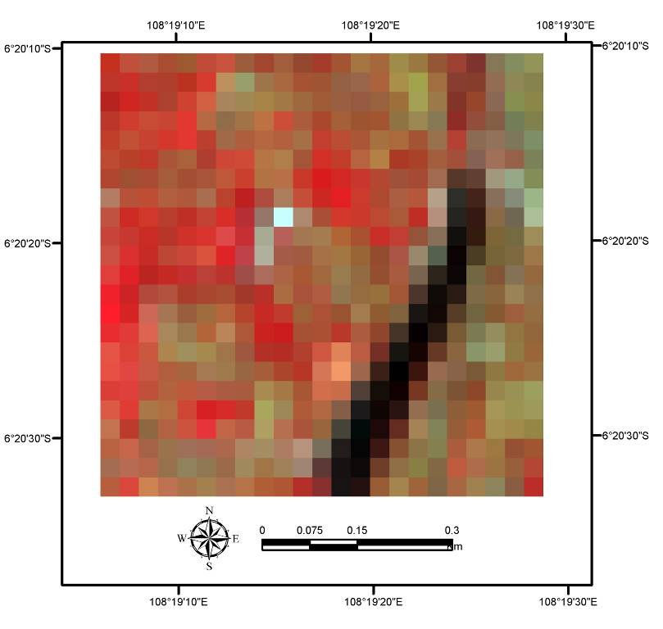
Figure 2-2 Landsat 8 data

2.2. Methods

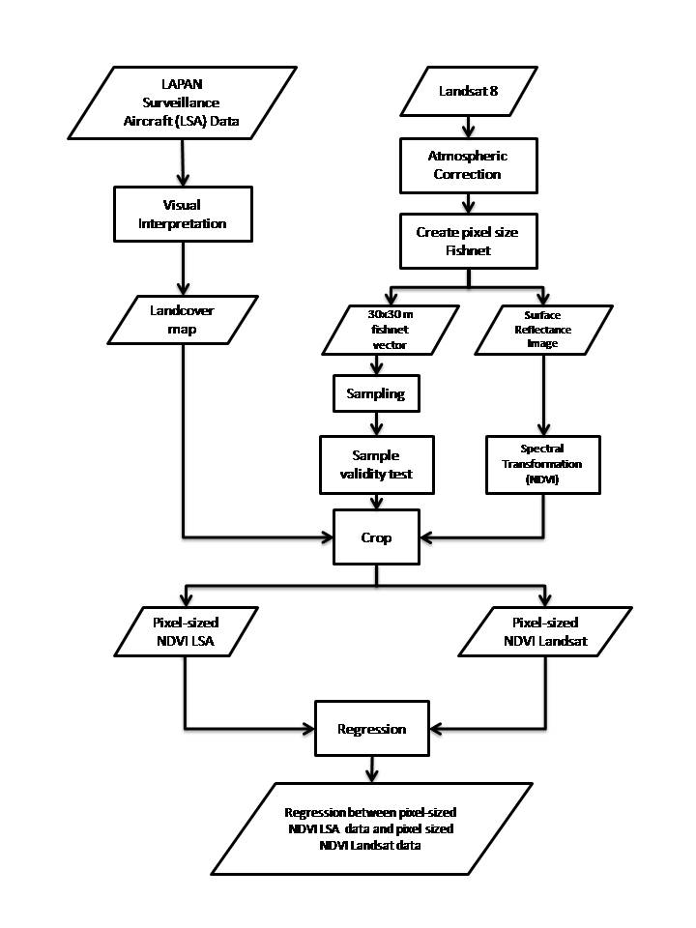

Figure 2-3 Flowchart

- Visual interpretation
Visual interpretation based on visual interpretation keys ontology is conducted in the research by Belgiu and Lampoltshammer (2013) which is carried out at LAPAN Surveillance Aircraft (LSA) data which has a very high resolution. Extraction process of objects used object-based classification method with multiresolution segmentation algorithm. After that the sampling was done with purposive sampling by selecting the chosen area.
- Construct fishnet
Fishnet construction is made in pixel-sized of Landsat data 30 meters x 30 meters. With this fishnet, process to create sample and analysis will be easier and more precision at the same place.
- Sampling
Sample selection was conducted by purposive sampling method that using specific criteria. Similar sampling method is done by specifying criteria for samples to be taken with the specific purpose. In several studies conducted by Smith et al. (2013) and Topp et al. (2004), sample criteria are very specific for sampling respondents. Besides in the study by Iryadi and Sadewo (2015), the chosen land surface area as samples based on certain criteria including vegetation cover, NDVI class and geomorphology unit. In this case the total of samples taken is 35.
- Validity assessment of the sample
Validity assessment of sample was conducted at 35 samples selected to normality test. The main variable in this test is the extent of vegetation cover. Normality test was conducted using the Shapiro-Wilk test because the sample size is less than 50 (Shapiro and Wilk, 1965).
- Transformation to NDVI values
Landsat data and LSA data transformation process to the NDVI value is conducted using a formula that uses the NDVI value NIR band and Red band value in its calculations and is one of the most common vegetation index used (Mokarram et al., 2016).

Theoretically if NDVI value approaches value of 1, the existing vegetation in that area is greener and denser, as if approaches a value of 0, it means that the vegetation is dry or not green whereas if NDVI value is between 0 and -1 then it is not the type of vegetation land cover, and the index can be used to detect changes in land cover (Haque and Basak, 2017).
f) Regression between NDVI of Landsat data and the NDVI of LSA data
Regression was conducted to see the relationship between vegetation index of Landsat data and vegetation index of LSA data

- Result and Discussion
Visual interpretation on LSA data is performed after the object is segmented into 797 objects. Classification is performed by dividing the object into 3 classes: water, development area and vegetation as seen at Figure 3.1.

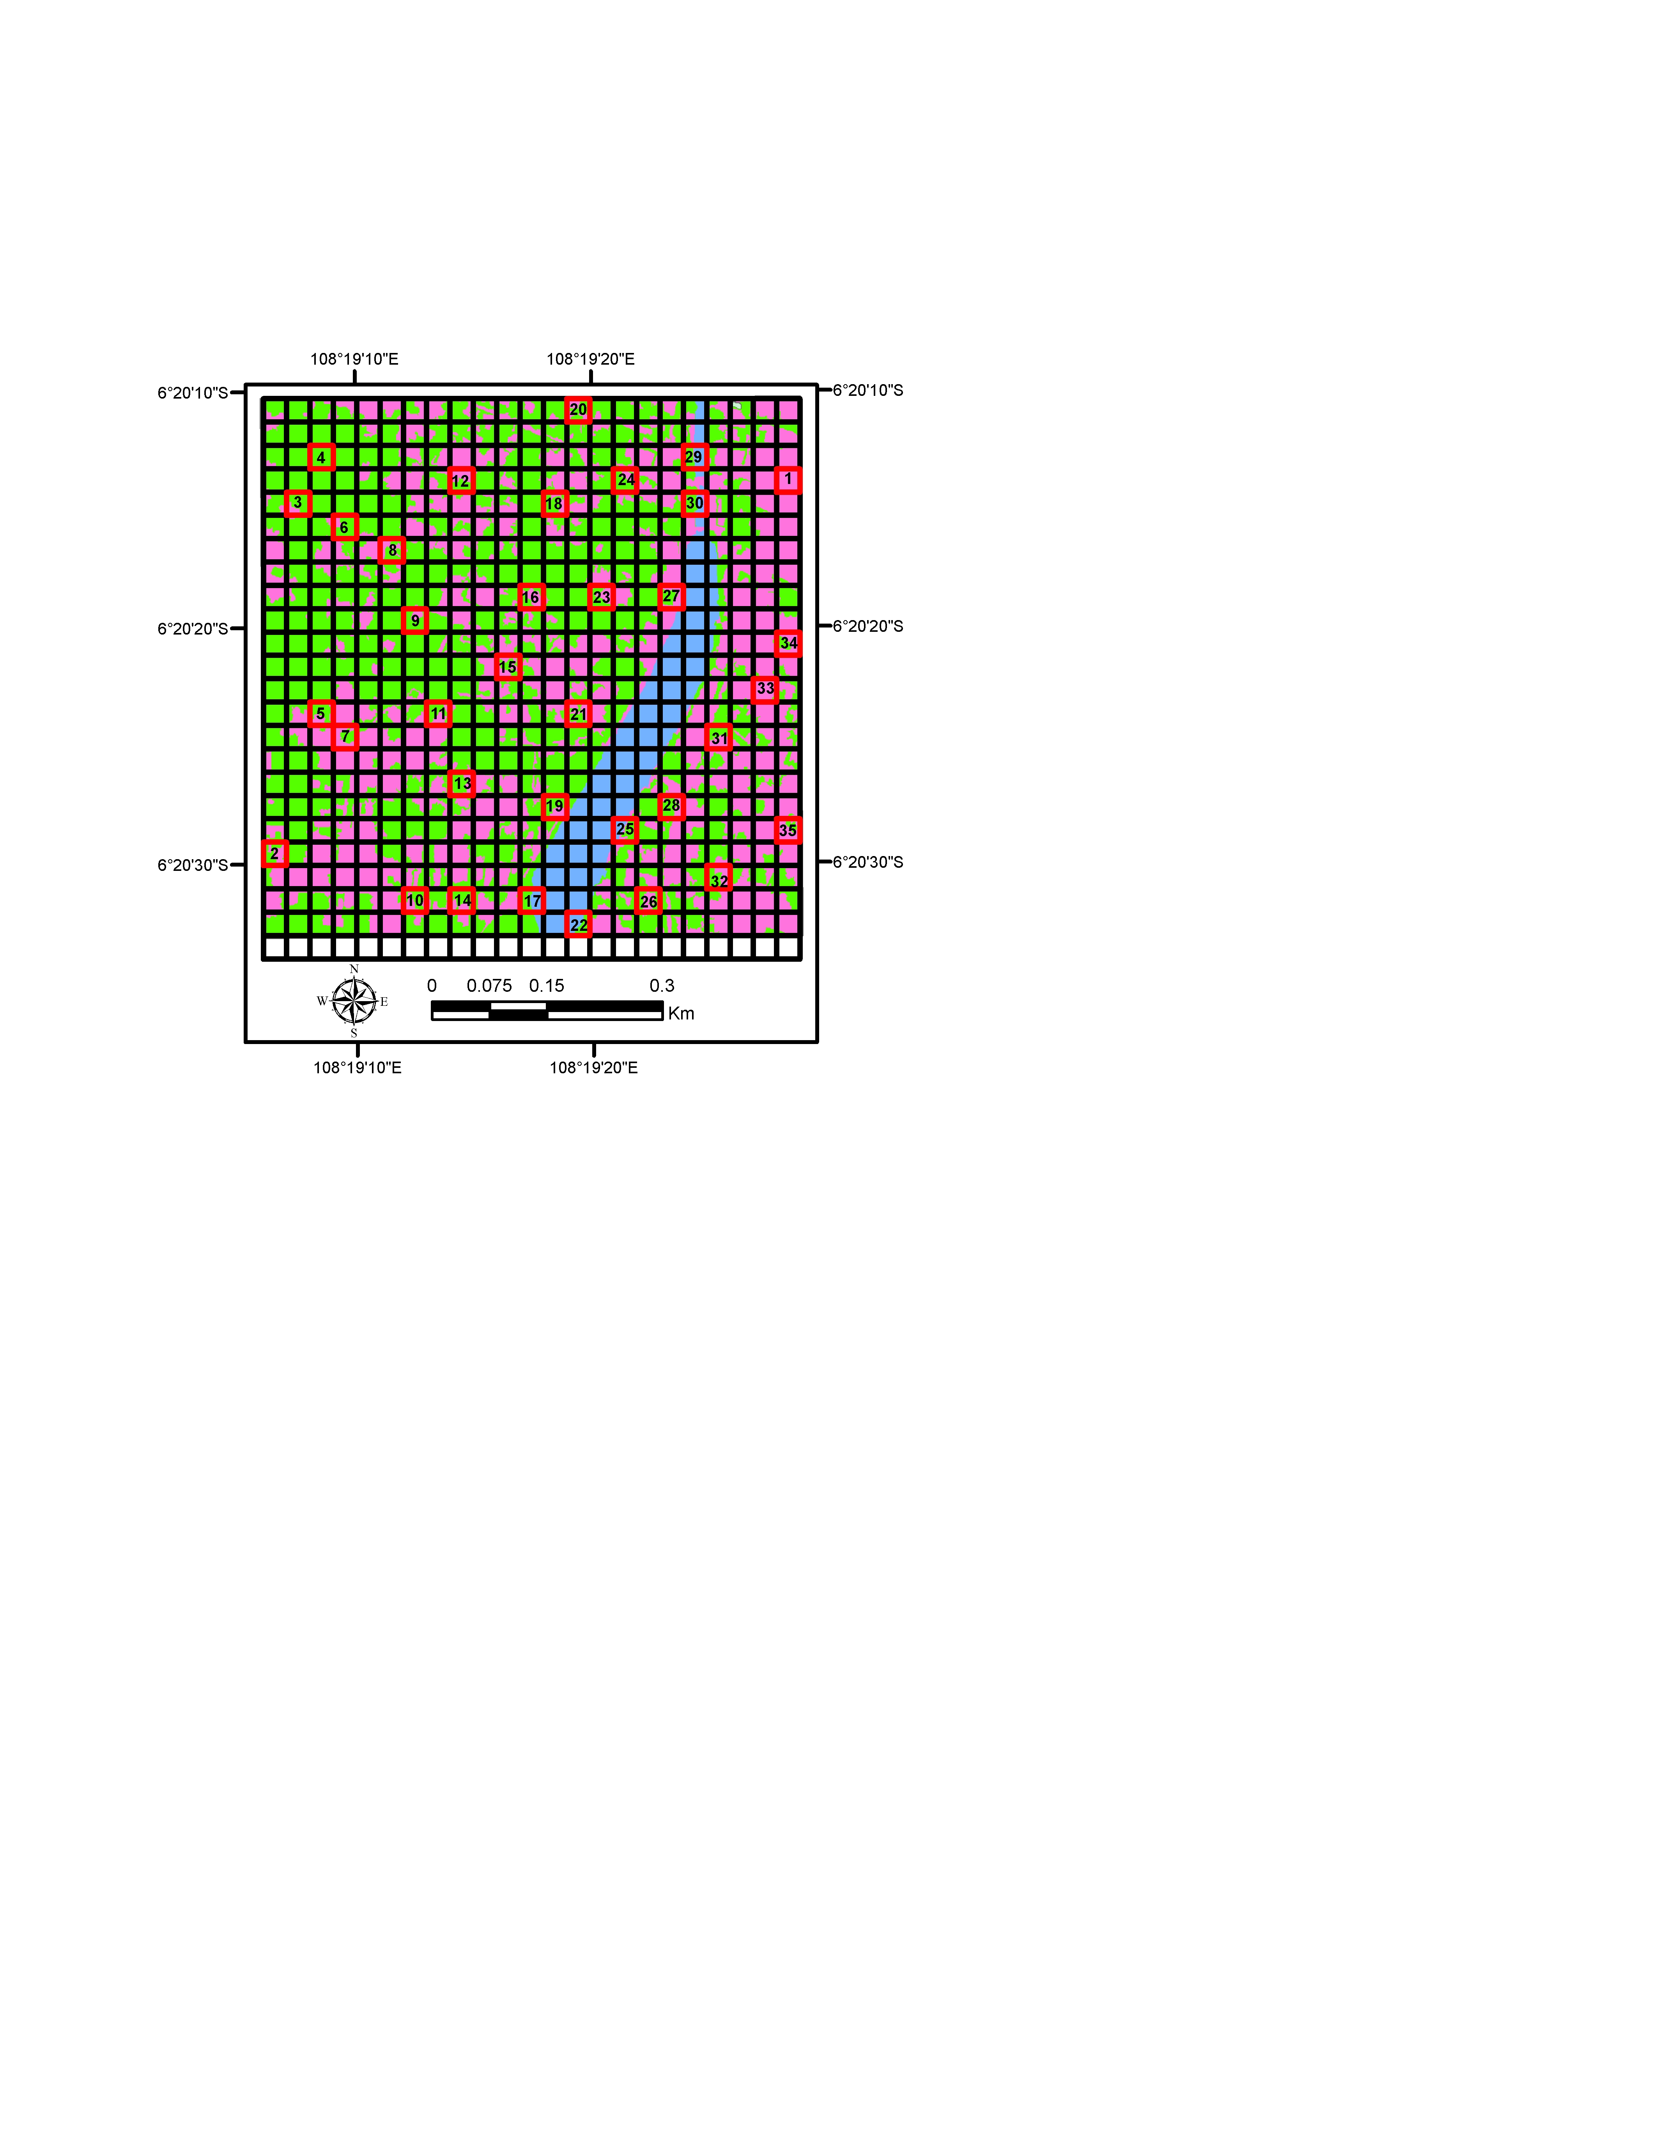
Figure 3-1 Visual interpretation result on LSA data and sample distribution

Water body color is blue, built up area color is magenta and vegetation color is green. From Figure 3.1 we can see that the classification result shows the distribution of three land cover classes based on LSA data and there are several class boundaries in one pixel size 30 meter x 30 meter. In those adjacent areas the occurance potential of mixed pixel is very high.
From visual interpretation result, there are 3 type of land cover, namely water body, built up area and vegetation. In Landsat mixed pixel area, it can be seen that the land cover in that area is a mixture of several objects based on LSA data interpretation. The combination constructed from Landsat mixel include: vegetation-built up area, water body-vegetation, water body-built up area and water body-built up area-vegetation. Besides, the pure pixel consists of vegetation, water body and development area.
To conduct further analysis including sample selection and analysis, the fishnet is constructed with Landsat pixel size 30 meter x 30 meter. Figure 3.1 shows the fishnet overlaid on visual interpretation result. The function of fishnet/ grid is to make the analysis easier like a study in Haiti for population sensus area and usage for modelling in Lake Icaria (Deichmann et al., 2001; Wang dan Cui, 2005).
Normality test was applied to 35 samples using vegetation area as primary variable. Sample distribution is also shown in Figure 3.1. Because of the total sample is less than 50, the normality test was conducted with Shapiro-Wilk method (Shapiro and Wilk, 1965). The first normality test result is shown in Table 3.1.
Table 3.1. Normality test result Shapiro-Wilk version 1
 | Kolmogorov-Smirnovª |  |  | Shapiro-Wilk
 | Statistic | df | Sig. | Statistic | Df | Sig.
Shape_Area | .195 | 35 | .002 | .881 | 35 | .001
Significance value which less than 0.05 indicates that the samples did not meet the normal criteria. This was confirmed by histogram and box-plot of tested sample.

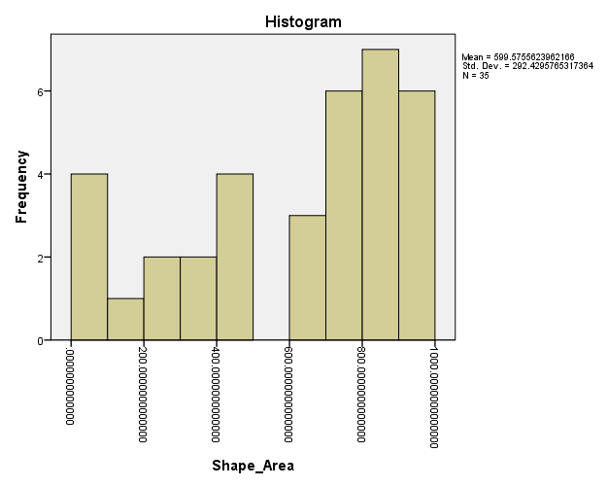 | 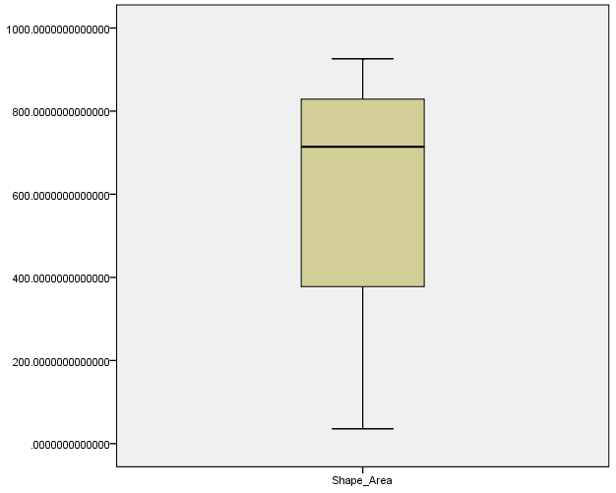
Histogram sample based on distribution of vegetation area | Box plot sample based on distribution of  vegetation area
Figure 3-2 Normality test result version 1

Because of the first sample group did not pass the normality test, then another sample group was taken with same amount as previous sample group. The result of the normality test on the second sample test shown in Table 3.2 and Figure 3.3.
Table 3.2. Normality test result Shapiro-Wilk untuk sample version 2
 | Kolmogorov-Smirnovª |  |  | Shapiro-Wilk
 | Statistic | df | Sig. | Statistic | df | Sig.
Shape_Area | .089 | 35 | .200* | .967 | 35 | .368

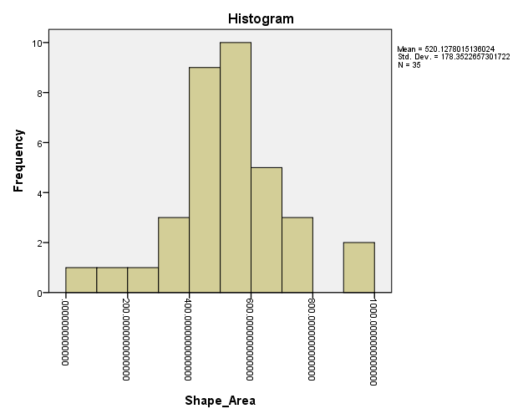 | 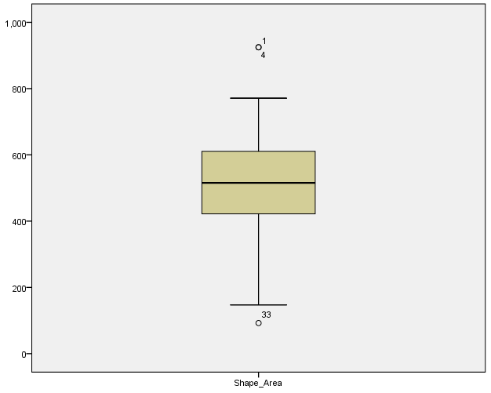
Histogram sample based on distribution of vegetation area | Box plot sample based on distribution of  vegetation area
Figure 3-3 Normality test result version 2

Table 3.2 shows that the Shapiro-Wilk significance value is more than 0.05, this indicates that the sample pass the normality test requirement. This was confirmed with histogram and box plot from that sample. Because the normality test requirement is passed, the analysis of the sample can be continued.

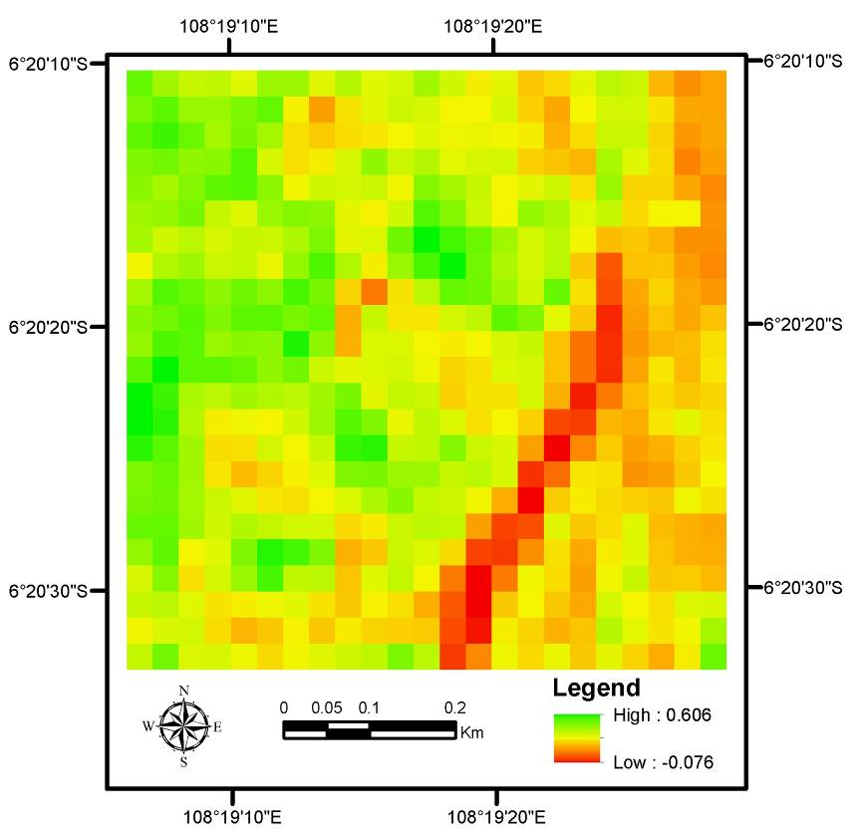
Figure 3-4 Transformation result to NDVI of Landsat Data

Landsat spectral data value was transformed into vegetation index and the result is shown in Figure 3.4 where the lowest value of NDVI is -0.075 and the highest value is 0.61. NDVI value that close to 1 shows vegetation conditions were quite green and dense. When viewed from Landsat composite in Figure 2.2, area with high NDVI value or green located on vegetation area while low NDVI value (yellow until red) located in mixel area and non-vegetation area (water).

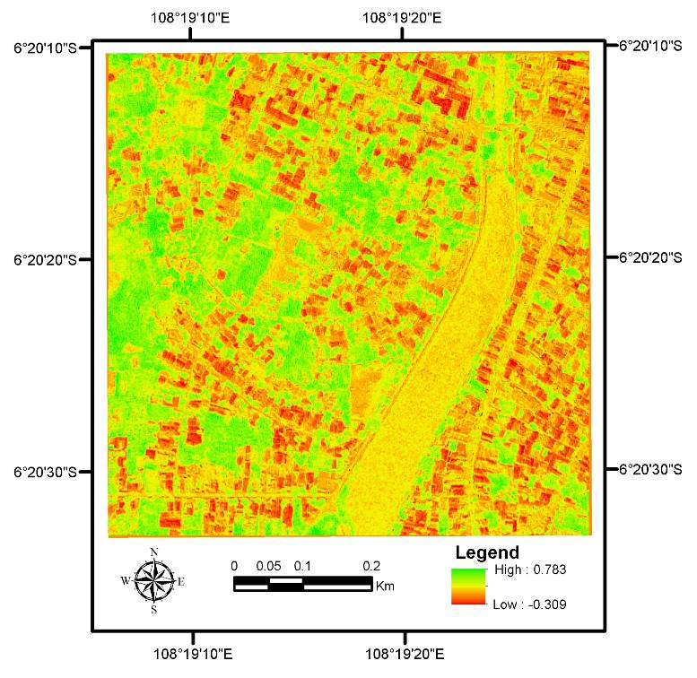
Figurer 3-5 Transformation result to NDVI of LSA Data
Transformation to the same index was conducted to LSA data where the NDVI value range from -0.31 until 0.78. The low NDVI value color is red and was located on non-vegetation area/ built up area. Meanwhile the high NDVI value color is green located in vegetation land cover area.

Table 3.3. NDVI Value of Landsat and LSA Data
NO. | NDVI_L8 | NDVI_LSA | NO. | NDVI_L8 | NDVI_LSA
1 | 0.1673 | 0.0178 | 21 | 0.2571 | 0.0989
2 | 0.3339 | 0.1367 | 22 | 0.1360 | 0.1702
3 | 0.4044 | 0.1978 | 23 | 0.4160 | 0.2029
4 | 0.4812 | 0.2337 | 24 | 0.2332 | 0.0845
5 | 0.3785 | 0.2339 | 25 | 0.1469 | 0.1446
6 | 0.3558 | 0.1347 | 26 | 0.1920 | 0.0471
7 | 0.2495 | 0.0251 | 27 | 0.2588 | 0.1651
8 | 0.3513 | 0.1132 | 28 | 0.2220 | 0.0792
9 | 0.4648 | 0.2531 | 29 | 0.3480 | 0.1795
10 | 0.2794 | 0.1051 | 30 | 0.4230 | 0.2454
11 | 0.4183 | 0.1948 | 31 | 0.1695 | 0.0335
12 | 0.3343 | 0.1103 | 32 | 0.2870 | 0.0982
13 | 0.3276 | 0.1360 | 33 | 0.2252 | 0.0541
14 | 0.2706 | 0.0770 | 34 | 0.2559 | 0.1009
15 | 0.3425 | 0.1443 | 35 | 0.1901 | 0.0605
16 | 0.3734 | 0.1559
17 | 0.2301 | 0.1837
18 | 0.4035 | 0.2014
19 | 0.3644 | 0.1638
20 | 0.2761 | 0.0844

NDVI value from Landsat and LSA data shown at Table 3.3 that show NDVI at the same location and same pixel sized area of Landsat 30 meter x 30 meter. From Table 3.3, Landsat 8 and LSA has different NDVI value where LSA NDVI value which has higher spatial resolution has lower NDVI value from Landsat NDVI value except in some areas with grey highlight in Table 3.3 which the value difference is not too high and even has higher value than LSA data. This is because the wavelength of NIR band on Landsat 8 OLI data is narrower than LSA data which can help for water detection (Ke et al, 2015) where the wavelength of LSA data Red, Green, NIR located on TM2, TM3 and TM4 (Tetracam, 2011).

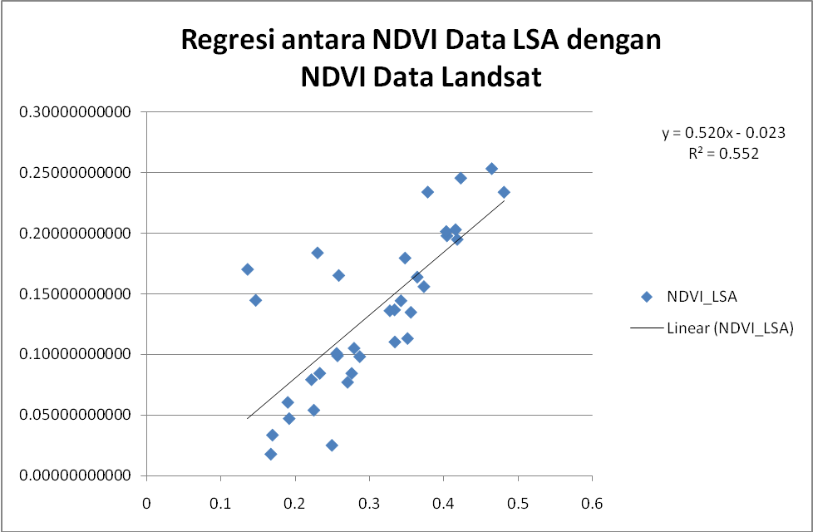
Figure 3-6 Regression between NDVI of LSA Data with NDVI of Landsat Data (35 samples)

The result of the regression test between NDVI of LSA and Landsat data is shown at Figure 3-6 with significance value less than 0.05 that makes error rate less than 5%, the regression equation is y = 0.520x – 0.023 with coefficient of determination or R² is 0.552, which means that the independent variables are able to explain variances 55.2%. From the graphic at Figure 3-6, there are some outliers from the sample distribution and that outliers are four samples in grey highlight area in Table 3.3.
Figure 3-1 shows the distribution of total 35 samples. In the study area, the four samples have significance part in water object so the NDVI value on that samples are less related one another as well as the influence of NIR band that has been discussed before. The four samples are those with sample number 17, 22, 25 and 27. On the second regression test, the four samples are removed so the samples used were 31 samples.
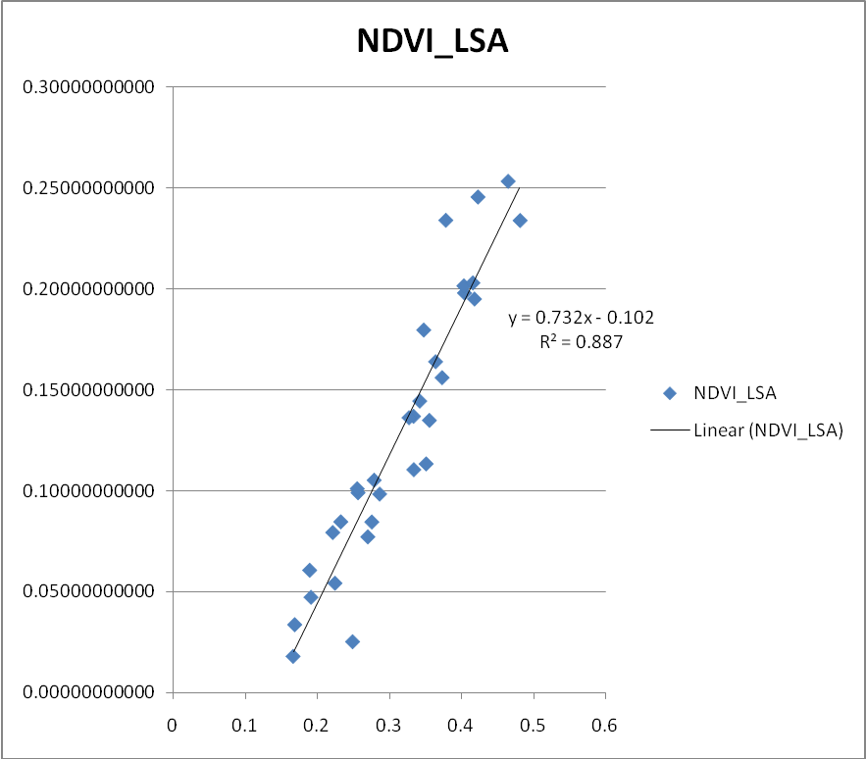
Figure 3-7 Regression between NDVI of LSA Data with NDVI Data Landsat (31 samples)
Figure 3-7 shows the result of the second regression test, it can be seen that the sample distribution is more linear and the regression equation is y = 0.732x – 0.102 with R² = 0.887. This mean that with significance less than 0.05 has confidence level more than 95% with coefficient of determination reaches 0.887. This value indicates that the independent variables are able to explain the variance as 88.7%. In other word, NDVI value on LSA data associated with NDVI value of Landsat data.
- Conclusion
This study examines how the pixel size of Landsat in 30 meters x 30 meters compared with the LSA data that has a spatial resolution of up to 58 cm. Based on research it is showed that the mixel area on Landsat is a mixture of several objects as seen from LSA multispectral data.
The combination created from each Landsat mixel including: vegetation-built up area, water body-vegetation, water body-built up area, water body-built up area-vegetation.
Spectrally the regression equation obtained by regression between NDVI of Landsat data and NDVI of LSA data after the elimination of 4 samples that were distributed non-linear (outliers) in sample plot regression test with a significance of less than 0.05 is y = 0.732x – 0.102 with value of R² = 0.887. Through these results we can conclude that the NDVI values on both the data related to one another.
- Acknowledgement
The authors deliver their gratitude to Aeronautic Technology Center LAPAN for the opportunity to use the LSA remote sensing data in this study and Prof. Lilik Budi Prasetyo from Institut Pertanian Bogor as our resource person.

References

Arifin, S., Annas, A., Sari, N. M., Kushardono, D. 2015. Identifikasi dan Interpretasi Visual Citra Kamera Digital Multispektral untuk Objek Wilayah Pesisir. Prosiding Seminar Nasional Penginderaan Jauh 2015, Bogor, Indonesia
Belgiu, M., Lampoltshammer, T. J. 2013. Ontology based interpretation of Very High Resolution imageries – grounding ontologies on visual interpretation keys. The 16th AGILE Conference on Geographic Information Science. Geographic Information Science at the Heart of Europe. 14-17 May 2013, Leuven, Belgium

Bosdogianni, P. Petrou, M., Kittler, J. 1996. Robust Mixed Pixel Classification in Remote Sensing. International Archives of Photogrammtery and Remote Sensing Vol. XXXI, Part B7, Vienna 1996
Danoedoro, P. 2009. Penginderaan Jauh untuk Inventarisasi Mangrove; Potensi, Keterbatasan dan Kebutuhan Data. Prosiding Workshop “Sinergi Survei dan Pemetaan Nasional dalam Mendukung Pengelolaan Mangrove Berkelanjutan”, BAKOSURTANAL Bogor 30 Juli 2009
Deichmann, U., Balk, D., & Yetman, G. (2001). Transforming population data for interdisciplinary usages: from census to grid. Washington (DC): Center for International Earth Science Information Network, Pp 200(1)
Dony K., Annas, A., Maryanto, A., Utama, A. A., Winanto. 2014. Pemanfaatan Data LSA (LAPAN Surveillance Aircraft) Untuk Mendukung Pemetaan Skala Rinci. Prosiding Pertemuan Ilmiah Tahunan XX MAPIN 2014, Bogor
Fisher, P. 1997. The Pixel: A Snare and A Delusion. International Journal of Remote Sensing February 1997 DOI: 10.1080/014311697219015
Foody, G. M., Mathur, A. 2006. The Use of Small Training Sets Containing Mixed Pixels for Accurate Hard
Image Classification: Training on Mixed Spectral Responses
for Classification by A SVM. Remote Sensing of Environment 103 (2006) 179–189
Haque, M. I., Basak, R. 2017. Land Cover Change Detection Using GIS and Remote Sensing Techniques: A Spatio-temporal Study on Tanguar Haor, Sunamganj, Bangladesh. The Egyptian Journal of Remote Sensing and Space Sciences (2017), http://dx.doi.org/10.1016/j.ejrs.2016.12.003
Hoyano, A., Komatsu, Y. 1988. Influence of Mixels on Land Cover Classification in Residential Areas Using Airborne MSS Data. ISPRS Archives – Volume XXVII Part B7, 1988
Iryadi, R., Sadewo, M. N. 2015. Influence the Existence of the Bali Botanical Garden for Land Cover Change in Bedugul Basin Using Landsat Time Series. Procedia Environmental Sciences 24 ( 2015 ) 158 – 164
Ke, Y., Im, J., Lee, J., Gong, H., Ryu, Y. 2015. Characteristics of Landsat 8 OLI-derived NDVI by Comparison with Multiple Satellite Sensors and In-situ Observations. Remote Sensing of Environment 164 (2015) 298–313
Kurniawan, F. Adrianto, L., Bengen, D. G., Prasetyo, L. B. 2016. Patterns of Landscape Change on Small Islands: A Case of Gili Matra Islands, Marine Tourism Park, Indonesia. Procedia - Social and Behavioral Sciences 227 ( 2016 ) 553 – 559
Larkins, R. L., Michael J. C., Adrian A. D., John P. G. 2009. Surface Projection for Mixed Pixel Restoration. 24th International Conference Image and Vision Computing New Zealand (IVCNZ 2009)
Lv, Zhi-qiang, Qi-gang Z. 2011. Utility of Landsat Image in the Study of Land Cover and Land Surface Temperature Change. Procedia Environmental Sciences 10 ( 2011 ) 1287 – 1292
Marshall, A. D., Martin, R.R. 1992. Computer Vision, Models, and Inspection. World Scientific Series in Robotics and Automated Systems Vol. 4
Mikovits, C., Rauch, W., Kleidorfer, M. 2014. Dynamics in Urban Development, Population Growth and Their Influences on Urban Water Infrastructure. Procedia Engineering 70 ( 2014 ) 1147 – 1156

Mokarram, M., Boloorani, A. D., Hojati, M. 2016. Relationship Between Land Cover and Vegetation Indices. Case Study: Eghlid Plain, Fars Province, Iran. European Journal of Geography Volume 7, Number 2:48 - 60, June 2016
Monkkonen, P. 2013. Urban Land-use Regulations and Housing Markets in Developing
Countries: Evidence from Indonesia on the Importance of Enforcement. Land Use Policy 34 (2013) 255–264
Mueller, N., A. Lewis, D. Roberts, S. Ring, R.Melrose, J. Sixsmith, L. Lymburner, A.McIntyre, P. Tan, S. Curnow, A. Ip. Water Observations from Space: Mapping Surface Water from 25 Years of Landsat Imagery across Australia. Remote Sensing of Environment 174 (2016) 341–352

Narulita, S., Zain, A. F. M., Prasetyo, L. B. 2016. Geographic Information System (GIS) Application on Urban Forest Development in Bandung City. Procedia Environmental Sciences 33 ( 2016 ) 279-289
Nasihin, I., Prasetyo, L. B., Kartono, A. P., Kosmaryandi, N. Land Cover Change in Kuningan District during 1994 – 2015. Procedia Environmental Sciences 33 ( 2016 ) 428 – 435
Parsa, I. M., Yudhatama, D., Harini, S. 2014. Validasi Model Pemetaan Lahan Sawah Menggunakan Teknik Segmentasi dan Klasifikasi Citra Landsat Ortho (Studi Kasus Lampung). Pemanfaatan Citra Penginderaan Jauh untuk Sumber Daya Wilayah Darat ISBN No : 978-602-14437-6-7
Pour, A. B., Mazlan H. 2015. Hydrothermal Alteration Mapping from Landsat-8 Data, Sar Cheshmeh Copper Mining District, South-Eastern Islamic Republic of Iran. Journal of Taibah University for Science 9 (2015) 155–166
Sari, N. M., Kushardono, D. 2016. Quality Analysis of Single Tree Object with OBIA and Vegetation Index from LAPAN Surveillance Aircraft Multispectral Data in Urban Area. Journal of Geomatics and Planning doi: 10.14710/geoplanning.3.2.93-106
Shapiro, S.S., Wilk, M. B. 1965. An Analysis of Variance Test for Normality (Complete Samples). Biometrika 52 (3): 591-611 http://www.jstor.org/stable/2333709
Shih, F. Y., Cheng, S. 2005. Automatic Seeded Region Growing for Color Image Segmentation. Image and Vision Computing 23 (2005) 877–886
Sholihah, R.I., Bambang H.T., Diar S., La Ode S. I., Selamet K., Manijo, Dyah R.P. 2016. Identification of Agricultural Drought Extent Based on Vegetation Health Indices of Landsat Data: Case of Subang and Karawang, Indonesia. Procedia Environmental Sciences 33 ( 2016 ) 14 – 20

Smith, A. R., Colombi, J. M., Wirthlin, J. R. 2013. Rapid Development: A Content Analysis Comparison of Literature and Purposive Sampling of Rapid Reaction Projects. Procedia Computer Science 16 ( 2013 ) 475 – 482

Subudhi, B. N., Patwa, I., Ghosh, A., Cho, S. 2015. Edge Preserving Region Growing
for Aerial Color Image Segmentation. Intelligent Computing, Communication and Devices, Advances in Intelligent Systems and Computing 309, DOI 10.1007/978-81-322-2009-1_54
Sun, X., Du, H., Han, N., Zhou, G., Lu, D., Ge, H., Xu, X., Liu, L. 2014. Synergistic Use of Landsat TM and SPOT 5 imagery for Object-Based Forest Classification. Journal of Applied Remote Sensing Vol. 8 2014 083550-1 - 083550-15
Tarantino, C., Adamo, M., Lucas, R., Blonda, P. 2016. Detection of Changes in Semi-Natural Grasslands by Cross Correlation Analysis with WorldView-2 Images and New Landsat 8 Data. Remote Sensing of Environment 175 (2016) 65–72
Tetracam Inc. 2011. Agricultural Camera Digital User’s Guide. Tetracam Inc. California, USA
Topp, L., Barker, B., Degenhardt, L. 2004. The External Validity of Results Derived from Ecstasy Users Recruited Using Purposive Sampling Strategies. Drug and Alcohol Dependence 73 (2004) 33–40
Vorontsova, A. V., Vorontsova, V. L., Salimgareev, D. V. 2016. The Development of Urban Areas and Spaces with the Mixed Functional Use. Procedia Engineering 150 (2016) 1996-2000
Wang, J.X., Jun W., Fuxia Z. 2011. Investigate Research of Soil Erosion Base on Ikonos and Landsat Images in Jinning. Procedia Engineering 15 (2011) 1345 – 1349
Wang, X., Cui, P. 2005. Support Soil Conservation Practices by Identifying Critical Erosion Areas within an American Watershed Using the GIS-AGNPS Model. Journal of Spatial Hydrology Vol. 5 No. 2 31-44
Widodo, B., Lupyanto, R., Sulistiono, B., Harjito, D. A., Hamidin, J.,
Hapsari, E., M., Yasin, C., Ellinda. 2015. Analysis of Environmental Carrying Capacity for the Development of Sustainable Settlement in Yogyakarta Urban Area. Procedia Environmental Sciences 28 (2015) 519-527
Xing, Y., Liang, H., Xu, D. 2013. Sustainable Development Evaluation of Urban Traffic System. Procedia - Social and Behavioral Sciences 96 ( 2013 ) 496 – 504
Zald, H.S.J., Michael A.W., Joanne C.W., Thomas H., Txomin H., Geordie W.H., Nicholas C.C. 2016. Integrating Landsat pixel composites and changemetrics with lidar plots to predictively map forest structure and aboveground biomass in Saskatchewan, Canada. Remote Sensing of Environment 176 (2016) 188–201

