Physiotherapy Management in Cases of Cerebral Palsy Flaccid Ec Microcephaly
¹Orlens Rambu Jeara, ²Adnan Faris Naufal , ³ Rina Kusuma Wardani
^{1,2} Program Studi Fisioterapi, Fakultas Ilmu Kesehatan, Universitas Muhamadiyah Surakarta
³ Praktik Mandiri Oemah Fisioterapi Solo
Email : j130225120@student.ums.ac.id

Date of Submission: 19 March ; Receipt date: 17 April 2023

ABSTRACT
can occur starting from the fetus or baby accompanied by disorders of the musculoskeletal system, sensation, perception, awareness, communication, and behavior. the study used a case report study conducted at the Oemah Physiotherapy Clinic in Solo. The cause of cerebral palsy begins during the prenatal period which is caused by infection, anoxia, toxic, genetics, and congenital malformations of the brain, the neonatal period occurs due to anoxia, traumatic, and postnatally caused by trauma, infection, and toxicity. Physiotherapy helps in optimizing children's active movements by using interventions in the form of myofascial release, patterning, and exercise. After being treated for 4 times T1-T4 there were no increase or change in muscle strength by measuring XOTR muscle strength and motor function in children using gross motor function measure (GMFM) and gross motor function classification system (GMFCS) measurements.

Keywords: Cerebral Palsy, XOTR, GMFM, GMFCS

ISSN 2722-9610
E – ISSN 2722-9629

I. INTRODUCTION

Cerebral Palsy is a disorder of the development of movement and posture, resulting in movement limitations that can occur starting in the fetus or baby accompanied by disorders of the musculoskeletal system, sensation, perception, awareness, communication, and behavior (Peterson et al., 2016). The cause of cerebral palsy begins during the prenatal period and is caused by infection, anoxia, toxic, genetics, and congenital malformations of the brain, during birth occurs due to anoxia, traumatic, and postnatally caused trauma, infection, and toxic (Upadhyay, Tiwari and Ansari, 2020).
Based on research that has been done, shows that the prevalence of CP for all live births in the world ranges from 1.5 to 3 per 1,000 live births. The reported prevalence of CP tends to be higher during infancy (Patel et al., 2020). In Indonesia alone, the prevalence of CP sufferers is estimated to be around 1-5 per 1,000 live births. It is often found in the first child and there are more boys than girls (Santa et al., 2016).
Classification of cerebral palsy based on motor function is divided into two groups, namely spastic and non-spastic. Nonspastic cerebral palsy is also called flaccid or hypotonic which is commonly referred to as decreased muscle tone (Paulson and Vargus-Adams, 2017). Cerebral Palsy with flaccid conditions indicates the location of extrapyramidal injuries, namely injuries outside the canal such as the basal ganglia, thalamus, and cerebellum. Non-spastic or flaccid cerebral palsy may present with deformity of the joints and extremities. The ability to speak may be impaired as a result of physical, not intellectual, impairment.
Children with cerebral palsy generally have movement disorders associated with abnormal reflexes, stiffness or weakness in the upper and lower limbs, abnormal postures, unstable movements or a combination of these symptoms. Based on these symptoms physiotherapy has a very important role in maintaining and improving the function of body movement in order to achieve a level of independence and fitness and improve the quality of life of children. The physiotherapy management that has been carried out by previous research conducted by (Ahmed et al., 2021) regarding the effect of Pelvic girdle training in children with hypotonic cerebral palsy on functional sitting control with criteria Children have a level 3 rating on GMFCS, without adult assistance, movements in and out of sitting can be done, children can crawl on hands and knees, children have mild hypotonia so they don't droop, children aged 2 -4 years, children understand instructions. Based on this research, pelvic girdle stability training can be used to improve functional sitting control in children with hypotonic cerebral palsy.

2. RESEARCH METHODOLOGY
Lower Limb | Movement | T1 |  | T2 |  | T3 |  | T4
 |  | D | S | D | S | D | S | D | S
Trunk | Flexion, extension | T | T | T | T | T | T | T | T
Hip | Flexion, extension, abduction, adduction | T | T | T | T | T | T | T | T
Knee | Flexion, extension | T | T | T | T | T | T | T | T
Ankle | Plantar flexion, Dorsion flexion, Inversion, Eversion | T | T | T | T | T | T | T | T
The research method used a case report study which was carried out at the Oemah Physiotherapy Clinic in Solo in patient An. KC is 13 years old with a medical diagnosis of Flaccid Cerebral Palsy ec. Microcephaly. The patient has undergone therapy 4 times with physiotherapy interventions in the form of myofacial release, patterning, and exercise. The above intervention in the form of myofacial release is used to reduce muscle spasms in the cervical area (scalene, sterno, upper) because patients extend their neck and lie down, in the vertebral area because scoliosis causes muscle spasm (erectorspine, multifidus, latisimusdorsi), and the hip area tends to flex the knee when lying down (abductor longus, abductor brevis, tibialis anterior and posterior). Intervention in the form of patterning is given according to the patient's ability to improve the child's active movement abilities. Because the patient is not yet able to crawl, sit, roll, and squat, a pattern is given according to his ability. While exercise interventions are used to strengthen weak muscles so they can maximize motion. Such as the abdominal muscles, latissimus, erector spine, because the patient lies a lot and the trunk has scoliosis, it is good for the core and vertebral muscles to stretch properly.

3. RESULTS
This study provided 2 physiotherapy interventions to patients for 4 weeks with a total of 4 meetings. Giving this intervention has the aim of optimizing the child's ability to carry out active movements.
After the administration of physiotherapy interventions, evaluation of muscle strength was carried out using XOTR, functional measurements using Gross Motor Function Measure (GMFM), and Gross Motor Function Classification System (GMFCS).

3.1 Evaluation of Muscle Strength (XOTR)
To check normal muscle strength, you can use XOTR due to central nervous system disorders which result in motor disturbances in children so children cannot carry out orders given by the therapist (Naufal., 2019).
XOTR Scale:
X: The child can move the joints normally
O: No movement and muscle tone
T: There is muscle tone, but no movement in the joints
R: The appearance of movement caused by reflex
Table 1. XOTR
Upper Limb | Movement | T1 |  | T2 |  | T3 |  | T4
 |  | D | S | D | S | D | S | D | S
Neck | Flexion, extension, rotation | X | X | X | X | X | X | X | X
Shoulder | Flexion, extension, abduction, adduction, internal rotation, and external rotation | T | T | T | T | T | T | T | T
Elbow | Flexion, extension | T | T | T | T | T | T | T | T
Wrist | Palmar flexion, Dorsal Flexion | T | T | T | T | T | T | T | T

3.2 Evaluation of Gross Motor Function Measure (GMFM)
Examination of children's special motor movement functions using (GMFM). This aims to monitor the growth and development of children who have normal growth and motor delays.
• Dimension A (lying and rolling) = 60.7%
• Dimension B (Sitting) = 30%
• Dimension C (Crawling and kneeling) = 0%
• Dimension D (Standing) = 0%
• Dimension E (Walking, running, and jumping) =0%
Total dimensions = 60.7% + 30% + 0% + 0% +0% 5 =18.14 %

Table 2. Interpretation of the GMFM measurement assessment Naufal.(2019).
Grade | Explanation
0 | Do not understand or do not have the initiative to carry out orders
1 | Has the initiative to carry out orders, but cannot carry out
2 | Able to carry out orders but not to completion
3 | Able to complete tasks
NT | Test not performed
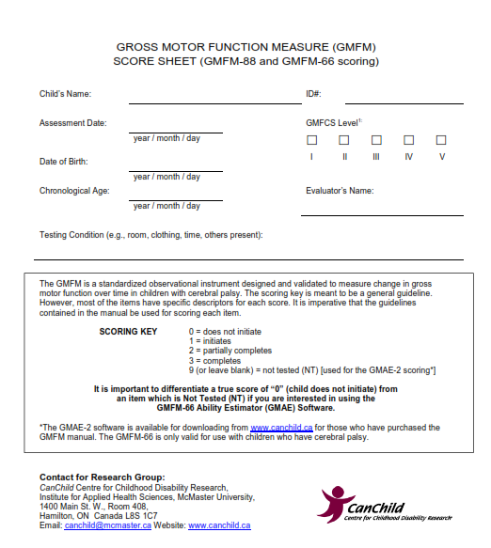
Figure 1. GMFM measurement (Russell et al., 2013)

Table 3. GMFM

Dimensi | T1 | T2 | T3 | T4
Dimension A | 60,7% | 60,7% | 60,7% | 60,7%
Dimension B | 30% | 30% | 30% | 30%
Dimension C | 0% | 0% | 0% | 0%
Dimension D | 0% | 0% | 0% | 0%
Dimension E | 0% | 0% | 0% | 0%
Total Dimension | 18,14 % | 18,14 % | 18,14 % | 18,14 %
3.3 Gross Motor Function Classification System (GMFCS) Evaluation
Examination of motor movement function using (GMFCS). This examination uses five levels of ability and impairment limitations with higher numbers indicating the highest level of severity (Naufal, 2019).
GMFCS Classification Levels:
• GMFCS Level I : Runs without restrictions
• GMFCS Level II: Walks with limitations
• GMFCS Level III: Walks with the aid of adaptive equipment
• GMFCS Level IV: Able to make transfers independently, but with great effort.
• GMFCS Level V: Very severe head and core control limitations rely heavily on technological assistance that can support activities.

GMFCS examination results in children:
Children are included in GMFCS Level V: Very severe head and core control limitations are very dependent on technological assistance that can help activities.

Table 4. GMFCS
T1 | T2 | T3 | T4
Level V | Level V | Level V | Level V

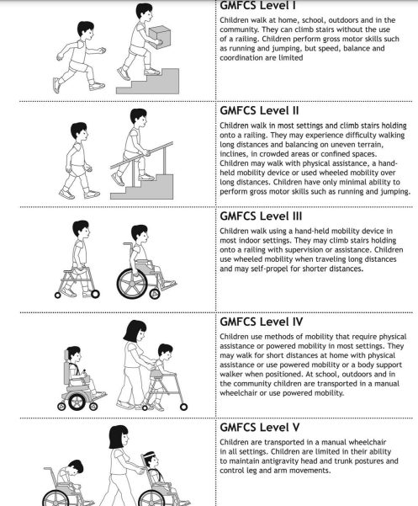
Figure 2. GMFCS measurements (Russell et al., 2013)

4. DISCUSSION

4.1. Evaluation of Muscle Strength (XOTR)
Table 1 is an evaluation of muscle strength measurements using XOTR. After administration of physiotherapy interventions in the form of myofascial release and patterning, the results obtained from T1-T4 for the upper limbs in the neck region can move the joints normally (X) while in other regions of the upper and lower limbs, There is muscle tone but no movement in the joints (T). From the results of evaluating muscle strength during 4 treatments every Monday and Thursday from T1-T4, there was no increase in muscle strength in patients, this is in line with previous studies which explained that children who experience microcephaly make the brain which regulates tone also be disrupted or their muscle development is disrupted (Ekanem et al., 2020).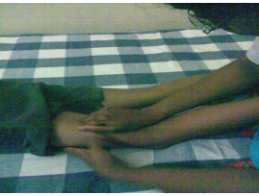
Figure 3. Myofacial Release (Paul et al., 2018)
Research conducted by Paul et al concluded that myofascial release is effective for reducing spasticity in children with spastic diplegia cerebral palsy. This study is in line with (Snehashri N Vaidya, 2014) regarding the effectiveness of myofascial release in spasticity and lower extremities in diplegic cerebral palsy

4.2. Evaluation of Gross Motor Function Measure (GMFM)
Table 3 is an evaluation of the measurement of children's motor function using (GMFM) after administration of physiotherapy interventions in the form of myofascial release and patterning, the results obtained from T1-T4 with the results of dimension A (lying and rolling over) with a value of 60.7%, dimension B (sitting) with a value 30%, dimension C (Crawling and kneeling) with a value of 0%, dimension D (standing) with a value of 0%, and dimension E (walking, running and jumping) with a value of 0%. After the intervention, there was no change in every dimension from the first day of therapy to the end of the patient's ability to lie down, roll over, sit, crawl and kneel, stand, walk, run, and jump. This shows that the child has a low score. In previous studies, it was observed that the lower the gross motor functional score (GMFM), the higher the level of severity (GMFCS Level IV and V); while the gross motor score, the higher the child's functional score, the lower the level of severity (Levels I and II) (Omole et al., 2018).
It is very important in patterning (patterning) in children with cerebral palsy to optimize the functional abilities of children in carrying out daily activities, one of the studies conducted for patterning on the upper extremities or upper limb of the upper extremities of children with cerebral palsy. Giving patterns to children is easy to use and assisted by parents to optimize children's abilities.
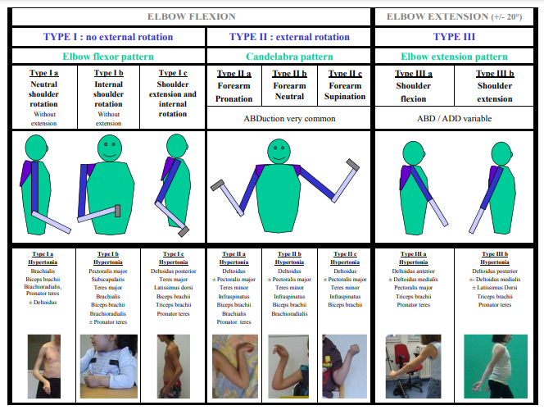
Figure 4. Patterning Upper Limb (Chaleat-Valayer et al., 2017)
The crawling and crawling phase is an important part of a child's development. Crawling is not only a preparation for walking but a process that helps in motor development, visual perception, coordination between the eyes and extremities. Therefore, children who cannot crawl will experience developmental delays. By crawling, they will strengthen the muscles of the neck, head, arms, hands, back, arms and legs as well as gross and fine motor skills (Haqia et al., 2022). In addition, exercise training such as sitting to standing, standing on the road improves walking ability, lower limb functional strength, and balance in child participants with cerebral palsy (Peungsuwan et al., 2017)

4.3. Gross Motor Function Classification System (GMFCS) Evaluation
Table 4 is an evaluation of the measurement of children's motor function using (GMFCS) after the administration of physiotherapy interventions in the form of myofascial release and patterning, the results obtained from T1-T4 the patient had very severe head and core control limitations so that from the first day of therapy to the fourth day there was no change in the level of motor function of the child. Based on research conducted (Omole et al., 2018) regarding the condition of cerebral palsy in children with GMFCS from level V, explains that the control of voluntary movements is greatly restricted due to disorders of the child's body that require a high level of assistance from caregivers (parents, siblings or guardians). for mobility, usually requires a wheelchair and a high level of dependency for activities of daily living.

5. Conclusion
Based on research that has been conducted on children with a diagnosis of Flaccid Cerebral Palsy by providing physiotherapy interventions in the form of myofascial release and patterning, there has been no increase or change in muscle strength with XOTR measurements and children's motor function using GMFM and GMFCS measurements.

Reference
Ahmed, W. S., Gharib, R. M., Salah El-Din, H. M., & El-Talawy, H. A. (2021). Effect of pelvic girdle stability training on functional sitting control in children with hypotonic cerebral palsy. International Research Journal of Medicine and Medical Sciences, 9(1),24–33. https://doi.org/10.30918/irjmms.91.21.011
Chaleat-Valayer, E., Bard-Pondarre, R., Bernard, J. C., Roumenoff, F., Lucet, A., Denis, A., Occelli, P., & Touzet, S. (2017). Upper limb and hand patterns in cerebral palsy: Reliability of two new classifications. European Journal of Paediatric Neurology, 21(5),754–762. https://doi.org/10.1016/j.ejpn.2017.04.1332
Ekanem, P. E., Nyaga, A. C. K., Imbusi, E. A., Ekanem, R., Mebrahte, B., Gebreslasie, A., & Peter, N. (2020). Neuroimaging patterns of anatomical features in pediatric cerebral palsy patients at Ayder hospital, Mekelle, Ethiopia. PLoS ONE, 15(11 November), 1–18.https://doi.org/10.1371/journal.pone.0241436
Haqia, S. S., Sudaryanto, W. T., & Herlinawati, I. (2022). Effects of Core Stability Exercise and Neurosensorimotor Reflex Integration on the Crawling Ability of Children with Quadriplegi Spastic Cerebral Palsy : Case Report Efek Core Stability Exercise dan Neurosensorimotor Reflex Integration pada Kemampuan Mera. 2(2), 43–52.
Naufal, Faris Adnan.2019.Mengenal dan memahamiFisioterapiAnak.Surakarta:Muhamadiyah University Surakarta
Omole, J. O., Adegoke, S. A., Omole, K. O., & Adeyemi, O. A. (2018). Pattern of cerebral palsy seen in children attending the outpatient paediatric physiotherapy clinics in Osun state tertiary hospitals in Nigeria. SAJCH South African Journal of Child Health,12(2),52–57. https://doi.org/10.7196/SAJCH.2018.V12I2.1452
Paul, J., Nathan, S. C., Kumar, P., & R, R. K. (2018). International Journal of Medical and Exercise Science Effectiveness Of Myofascial Release In Reduction Of Hamstrings Spasticity Among Diplegic Cerebral Palsy Children. Ijmaes, 4(1), 453–458. www.ijmaes.org
Patel, D. R., Neelakantan, M., Pandher, K., & Merrick, J. (2020). Cerebral palsy in children:A clinical overview. Translational Pediatrics,9(1),S125–S135. https://doi.org/10.21037/tp.2020.01.01
Paulson, A., & Vargus-Adams, J. (2017). Overview of four functional classification systems commonly used in cerebral palsy. Children,4(4). https://doi.org/10.3390/children4040030
Peungsuwan, P., Parasin, P., Siritaratiwat, W., Prasertnu, J., & Yamauchi, J. (2017). Effects of combined exercise training on functional performance in children with cerebral palsy: A randomized controlled study. Pediatric Physical Therapy, 29(1), 39–46. https://doi.org/10.1097/PEP.0000000000000338
Peterson, N., Walton, R., Peterson, N., & Walton, R. (2016). Ambulant cerebral palsy. Orthopaedics and Trauma, 30(6), 525–538. https://doi.org/10.1016/j.mporth.2016.08.005
Russell, D., Burrows, L., Rosenbaum, P., Raina, P., Walter, S., & Palisano, R. (2013). 20 the Gross Motor Function Measure (Gmfm & Gmfcs). Pediatric Physical Therapy, 11(4), 221. https://doi.org/10.1097/00001577-199901140-00035
Santa, F., Boru, A., Mogi, T. I., Gessal, J., Skripsi, K., Kedokteran, F., Sam, U., & Ratulangi, U. S. (2016). Prevalensi Anak Cerebral Palsy Di Instalasi Rehabilitasi Medik Rsup Prof.Dr.R.D.Kandou Manado Periode 2015. JKK (Jurnal Kedokteran Klinik), 1(1), 14–19.
Snehashri N Vaidya, C. K. (2014). Effectiveness of Myofascial Release on Spasticity and Lower Extremity Function in Diplegic Cerebral Palsy: Randomized Controlled Trial. International Journal of Physical Medicine & Rehabilitation, 03(01), 1–9. https://doi.org/10.4172/2329-9096.1000253
Upadhyay, J., Tiwari, N., & Ansari, M. N. (2020). Cerebral palsy: Aetiology, pathophysiology and therapeutic interventions. Clinical and Experimental Pharmacology and Physiology, 47(12), 1891–1901. https://doi.org/10.1111/1440-1681.13379

