Appendix 1
INSTRUMENT OF TEST VALIDITY
(EXPERT JUDGEMENT)

Petunjuk Penilaian
- Memberikan catatan langsung.
- Memberi tanda () pada kolom skor penilaian dengan kriteria:

5= sangat baik
4=baik
3= cukup
2=kurang
1=sangat kurang
No. | Aspek yang dinilai | Skala Penilaian |  |  |  |  | Saran
No. | Aspek yang dinilai | 1 | 2 | 3 | 4 | 5 | Saran
1 | Soal sesuai dengan Silabus
2 | Komponen Soal sesuai dengan Kisi-kisi (Blueprint)
3 | Pengecoh berfungsi
4 | Mempunyai satu jawaban yang benar atau paling benar
5 | Pokok soal dirumuskan secara jelas dan tegas
6 | Pokok soal tidak menunjuk ke arah jawaban yang benar
7 | Pokok soal tidak mengandung pernyataan negatif ganda
8 | Pilihan jawaban homogen dan logis ditinjau dari sisi materi
9 | Panjang rumusan jawaban relatif sama
10 | Pilihan jawaban tidak mengandung pernyataan “semua jawaban di atas benar atau semua jawaban di atas salah”.
11 | Pilihan jawaban yang berbentuk angka disusun berdasarkan urutan.
12 | Butir soal tidak tergantung pada jawaban sebelumnya
13 | Bahasa yang digunakan didalam soal sesuai dengan kaidah bahasa Inggris.
14 | Bahasa yang digunakan komunikatif
15 | Bahasa yang digunakan sesuai dengan tata bahasa inggris yang benar
16 | Pilihan jawaban tidak mengulang kata/frasa yang bukan merupakan satu kesatuan pengertian

Sumber: Endang Mulyatiningsih (2012)

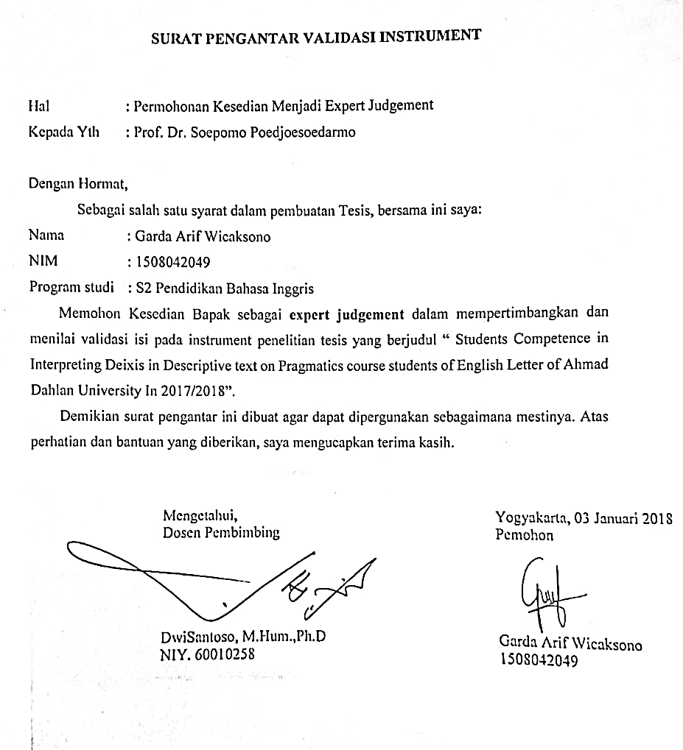

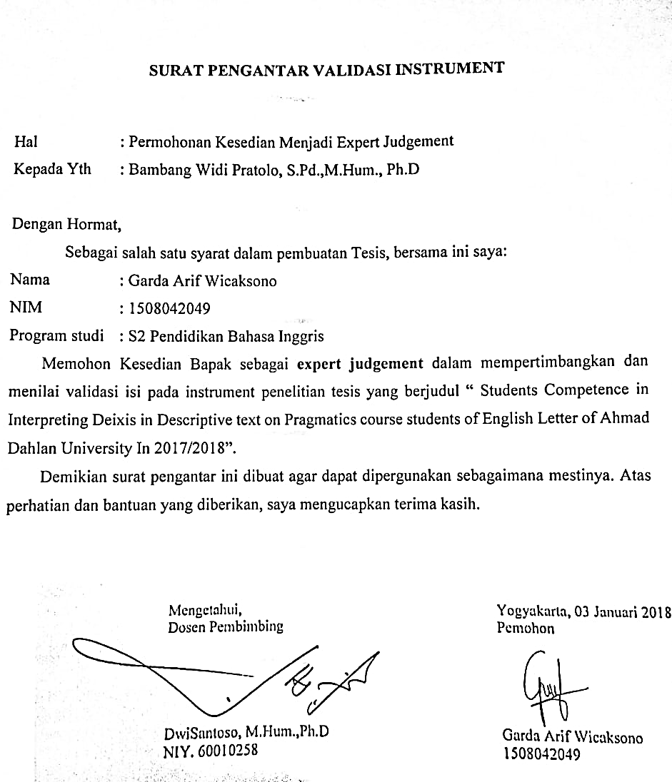

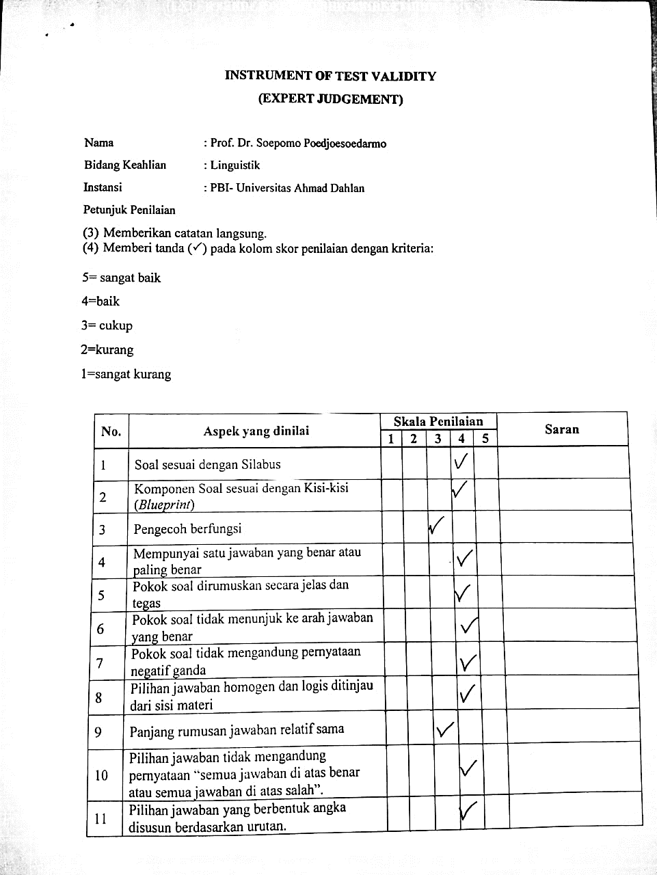

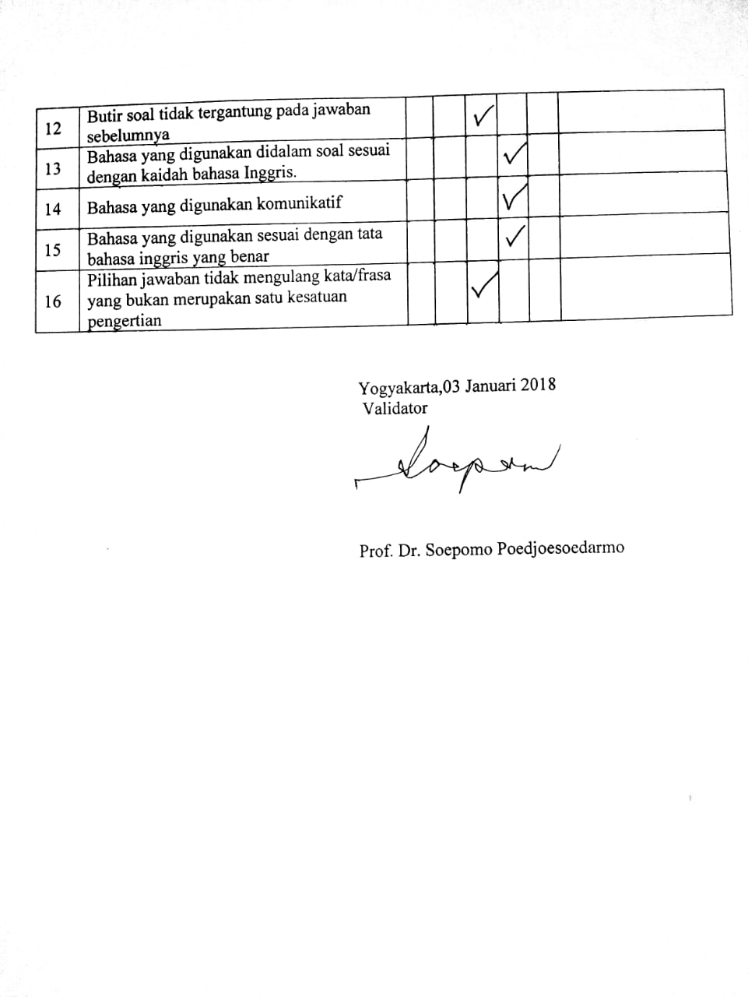

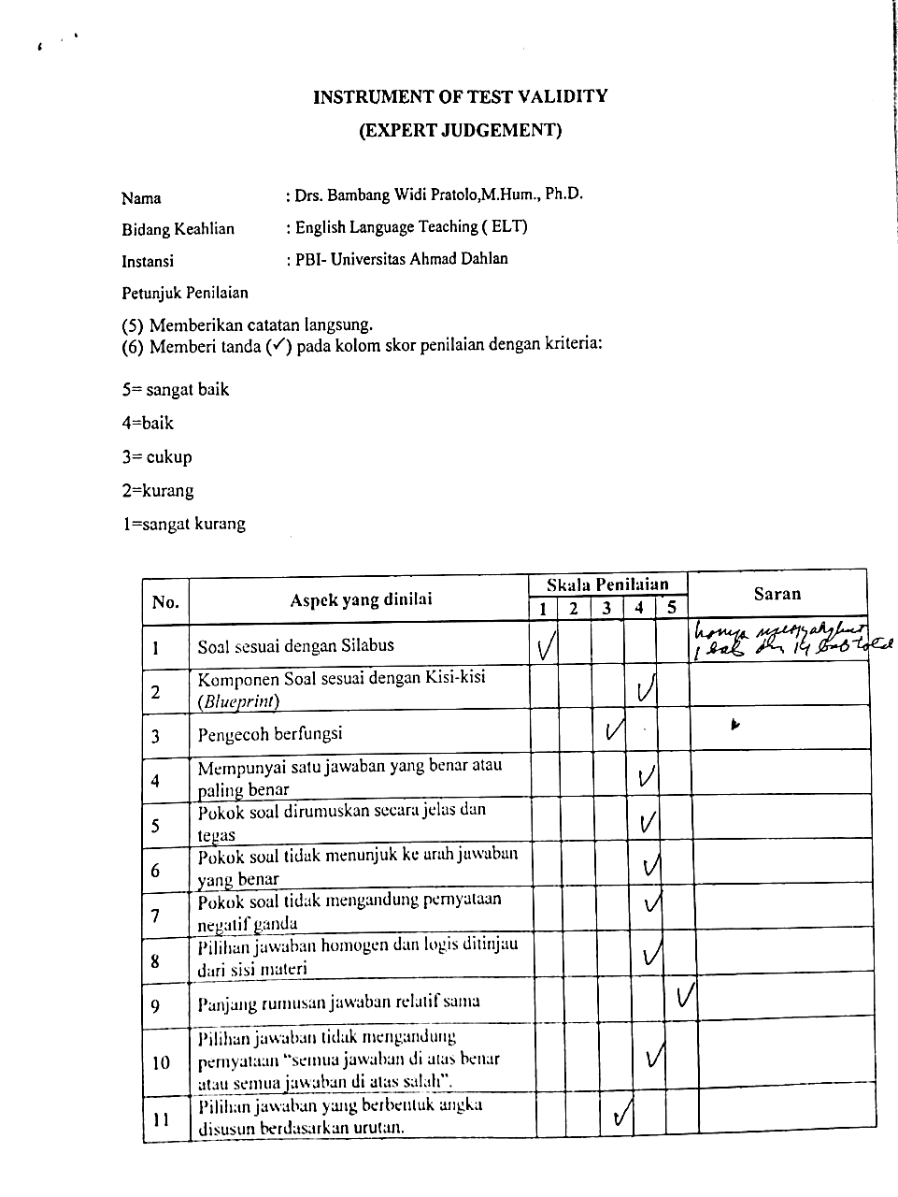

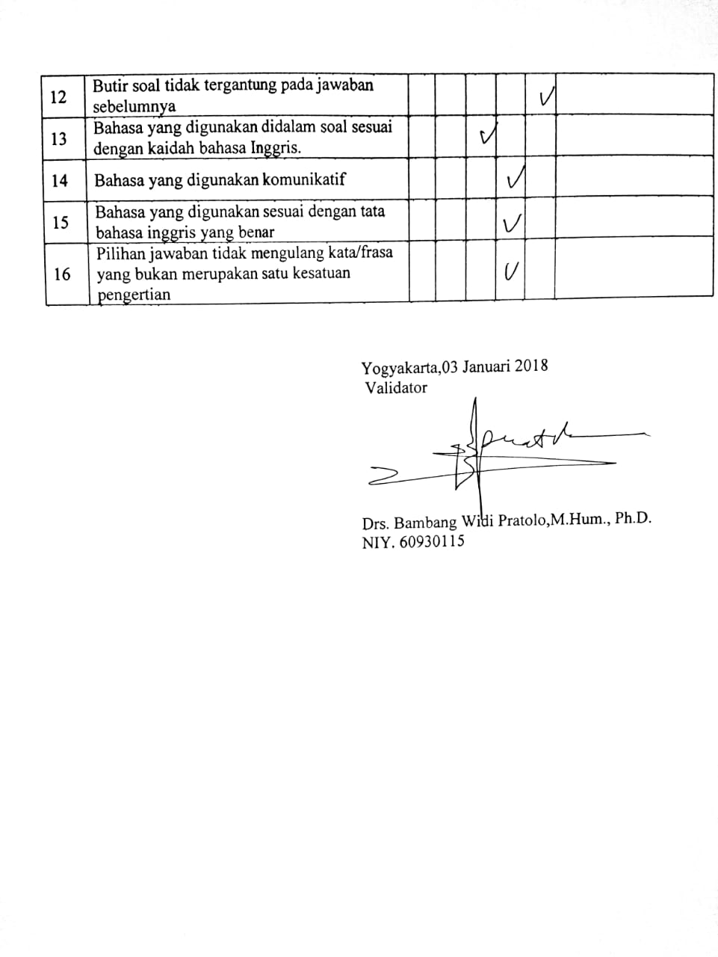

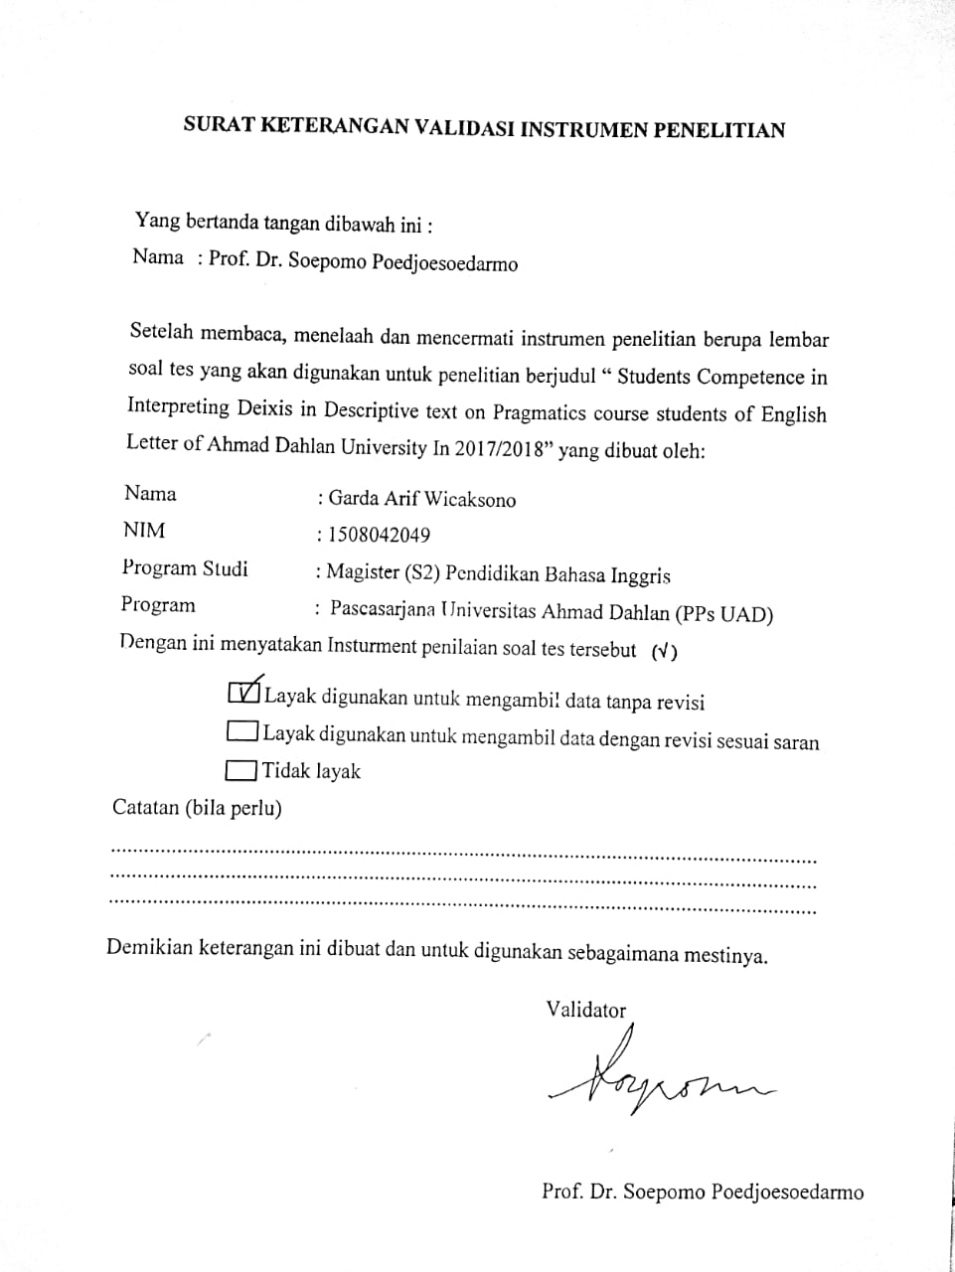

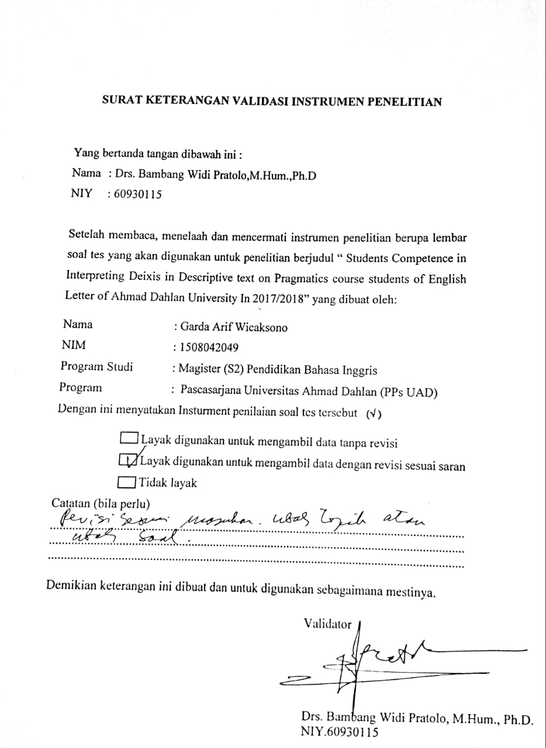

Appendix 2

Case Processing Summary
 |  | N | %
Cases | Valid | 2 | 100,0
Cases | Excludedª | 0 | ,0
Cases | Total | 2 | 100,0
a. Listwise deletion based on all variables in the procedure.

Reliability Statistics
Cronbach's Alpha | N of Items
,952 | 16

Item-Total Statistics
 | Scale Mean if Item Deleted | Scale Variance if Item Deleted | Corrected Item-Total Correlation | Cronbach's Alpha if Item Deleted
item_1 | 47,50 | 180,500 | 1,000 | ,944
item_2 | 46,50 | 220,500 | 1,000 | ,948
item_3 | 47,00 | 242,000 | ,000 | ,956
item_4 | 47,00 | 200,000 | 1,000 | ,943
item_5 | 46,50 | 220,500 | 1,000 | ,948
item_6 | 47,00 | 200,000 | 1,000 | ,943
item_7 | 47,50 | 180,500 | 1,000 | ,944
item_8 | 47,00 | 200,000 | 1,000 | ,943
item_9 | 47,00 | 242,000 | ,000 | ,956
item_10 | 47,00 | 200,000 | 1,000 | ,943
item_11 | 47,00 | 200,000 | 1,000 | ,943
item_12 | 46,50 | 264,500 | -1,000 | ,968
item_13 | 46,50 | 220,500 | 1,000 | ,948
item_14 | 46,50 | 220,500 | 1,000 | ,948
item_15 | 47,50 | 180,500 | 1,000 | ,944
item_16 | 46,00 | 242,000 | ,000 | ,956

Tabel r untuk df = 1 50
df = (N-2) | Tingkat signifikansi untuk uji satu arah
df = (N-2) | 0.05 | 0.025 | 0.01 | 0.005 | 0.0005
df = (N-2) | Ti ngkat signifikansi untuk uji dua arah
df = (N-2) | 0.1 | 0.05 | 0.02 | 0.01 | 0.001
1 | 0.9877 | 0.9969 | 0.9995 | 0.9999 | 1.0000
2 | 0.9000 | 0.9500 | 0.9800 | 0.9900 | 0.9990
3 | 0.8054 | 0.8783 | 0.9343 | 0.9587 | 0.9911
4 | 0.7293 | 0.8114 | 0.8822 | 0.9172 | 0.9741
5 | 0.6694 | 0.7545 | 0.8329 | 0.8745 | 0.9509
6 | 0.6215 | 0.7067 | 0.7887 | 0.8343 | 0.9249
7 | 0.5822 | 0.6664 | 0.7498 | 0.7977 | 0.8983
8 | 0.5494 | 0.6319 | 0.7155 | 0.7646 | 0.8721
9 | 0.5214 | 0.6021 | 0.6851 | 0.7348 | 0.8470
10 | 0.4973 | 0.5760 | 0.6581 | 0.7079 | 0.8233
11 | 0.4762 | 0.5529 | 0.6339 | 0.6835 | 0.8010
12 | 0.4575 | 0.5324 | 0.6120 | 0.6614 | 0.7800
13 | 0.4409 | 0.5140 | 0.5923 | 0.6411 | 0.7604
14 | 0.4259 | 0.4973 | 0.5742 | 0.6226 | 0.7419
15 | 0.4124 | 0.4821 | 0.5577 | 0.6055 | 0.7247
16 | 0.4000 | 0.4683 | 0.5425 | 0.5897 | 0.7084
17 | 0.3887 | 0.4555 | 0.5285 | 0.5751 | 0.6932
18 | 0.3783 | 0.4438 | 0.5155 | 0.5614 | 0.6788
19 | 0.3687 | 0.4329 | 0.5034 | 0.5487 | 0.6652
20 | 0.3598 | 0.4227 | 0.4921 | 0.5368 | 0.6524
21 | 0.3515 | 0.4132 | 0.4815 | 0.5256 | 0.6402
22 | 0.3438 | 0.4044 | 0.4716 | 0.5151 | 0.6287
23 | 0.3365 | 0.3961 | 0.4622 | 0.5052 | 0.6178
24 | 0.3297 | 0.3882 | 0.4534 | 0.4958 | 0.6074
25 | 0.3233 | 0.3809 | 0.4451 | 0.4869 | 0.5974
26 | 0.3172 | 0.3739 | 0.4372 | 0.4785 | 0.5880
27 | 0.3115 | 0.3673 | 0.4297 | 0.4705 | 0.5790
28 | 0.3061 | 0.3610 | 0.4226 | 0.4629 | 0.5703
29 | 0.3009 | 0.3550 | 0.4158 | 0.4556 | 0.5620

Appendix 3

TEXT COMPETENCE TEST

- Read Carefully the following text, choose the correct Answer.

One of my favourite places for vacation is Mexico. I really the weither because it never gets cold there. The people are very nice, too. They laught at my bad Spanish and the food is wonderful.
Mexico is very interesting to visit. It has some great museums and lots of fascinating old buildings and the hotels are not too expensive. But you can stay in other places in Mexico. For example you should go to one the beach resorts like Acapulo and you shouldn’t miss the Mayan temples near Merida.

- The word “I” in second line refers to
- The Writer
- John
- James
- Celia

- The word “ There” in line 4 refers to
- Museum
- Temples
- Mexico
- Spain

Paris is the capital of European nation, France. It is also one of the most beautiful and most famous cities in the world.
line
Paris is called the City of Light. It is also an international fashion center. What stylish women are wearing in Paris will be worn by women all over the world. Paris is also famous for its world center of education. For instance, it is the headquarters of UNESCO, the United Nations Educational, Scientific and Cultural Organization.
10
5
The Seine River divides the city into two parts. Thirty-two bridges cross this scenic river. The oldest and perhaps the most well-known is Pont Neuf, which was built in the sixteenth century.Sorbonne, a famous university, is located on the left bank (south side) of the river. The beautiful white church Sacre Coeur lies on the top of a hill called Montmartre on the right bank (north side) of the Seine.
15
20
There are many other famous places in Paris, such as the famous museum the Louvre as well the cathedral of Notre Dame. However, the most famous landmark in this city must be Eiffel Tower.
300
Paris is named after a group of people called the Parisii. They built a small village on an island in the middle of the Seine River about two thousand years ago. This island is called Ile de la Cite. It is where Notre Dame located. Today around eight million people live in the Paris area.
350

- The word “ it” in second line refers to
- European
- Paris
- City of Light
- UNESO

- The word “this ” in line 30 refers to
- Chathedral of Notre Dame
- Museum the Louvre
- Paris
- Eiffel Tower

- The word “ They” in line 33 refers to
- People
- Parisii
- Million people
- Scientist

England is one of countries located in Europe that has four seasons. They are winter, spring, summer and autumn.
In winter, we can find snow every where. It is always very cool. The temperature can be lower than 0º C. you should wear jacket if you want to go out. We usually have winter from December to February. After winter, we have spring from March to May. The snow melts down. It is the time when trees and plants start to grow their leaves. The temperature is warmer than before, we also have a lot of rain.
Then, it is summer! We have summer from June to August. The sun shine very bright and it is a holiday time. We finish out school and we can play all day or travel to another place. We usually visit our relatives in difference city. It is sometime very hot and people go to the beach or swimming pool.

- What seasons is indicated by the phrase “ Then” in Last Paragraph
- Winter
- Autumn
- Spring
- Summer

- What season “after” winter?
- Winter
- Autumn
- Spring
- Summer
Joko Widodo (Jokowi ) was born in Surakarta, Indonesia 21 June 1961. He has 3 children. They are Kaesang Pangarep, Kahiyang Ayu and Gibran Rakabuming Raka. Jokowi is thin. He has brown skin, short hair, and tall body. He looks friendly because he often keeps smile to everybody near him. Jokowi is an Indonesian politician. He is the governor of capital city of Indonesia, Jakarta 2012 - 2017. His political career begins since he joined Indonesian Democratic Party - Struggle (PDI-P)
15
10
5
line
JokoWidodo isan Indonesian politician and the current governor of Jakarta. He is often better known by his nickname Jokowi.
25
He was previously the mayor of Surakarta (often also known as Solo in Indonesia). He was nominated by his party, the Indonesian Democratic Party – Struggle, to run in the 2012 Jakarta gubernatorial election .
20
Jokowi's national popularity has risen sharply since his election to the high-profile position of governor of Jakarta. He is now seen as a strong potential candidate for the Indonesian presidential election in 2014
30

- The Word “He” in line 6 refers to
- Joko Widodo
- Gibran Rakabumi
- Governor
- Kaesang Pangarep

- What year is indicated by the phrase “ Since” ?
- 2011
- 2012
- 2013
- 2014

- What does the phrase “high profile” in line 29 refers to?
- Governor
- Joko Widodo
- President
- Politicians

Danau Toba or Toba Lake is one of the most popular destinations in Indonesia, especially in Medan, North Sumatra. Danau Toba is the largest volcanic lake in Indonesia, even in the Southeast Asia. Which make it more special is taken from the Samosir Island, an Island that settled in the middle of the lake.
10
5
line
Lake Toba is an area of 1,707 km², we can say that this is 1,000 km² bigger than Singapore. It formed by a gigantic volcanic eruption some 70,000 years ago, it is probably the largest resurgent caldera on Earth. Pulau Samosir or Samosir Island, The island in the middle, was joined to the caldera wall by a narrow isthmus, which was cut through to enable boats
15

to pass; a road bridge crosses the cutting. Samosir island is the cultural centre of the Batak tribe, the indigenous from North Sumatra.
25
20
20
By the eruption of a super volcano (Mount Toba) was estimated to have caused mass death and extinction of several species of living creatures. The eruption of Mount Toba has led to changes in the earth’s weather and the start into the ice age that affects the world civilization.
25
30
Lake Toba is actually more like a sea than a lake considering its size. Therefore, the Lake placed as the largest lake in Southeast Asia and the second largest in the world after Lake Victoria in Africa. Lake Toba is also includes the deepest lake in the world, which is approximately 450 meters.
35

- What does the word “that” in line 8 refers to?
- volcanic lake in Indonesia
- even in the Southeast Asia
- Samosir Island
- in the middle of the lake.

- What does the word “this” in line 11 refers to?
- Lake Toba
- Samosir
- Singapore
- 1, 000 km²

Raja Ampat or The Four Kings is a famous island located off the northwest tip of Bird's Head Peninsula on the island of New Guinea, in Indonesia's West Papua Province. It’s well known as a diving heaven for people around the world.
5
line
Raja Ampat covers 9.8 million acres of land and sea, home to 540 types of corals, 1,000 types of coral fish and 700 types of mollusks. it makes Raja Ampat as the most diverse living library for world’s coral reef and underwater biota. Beside that, Raja Ampat has a beautiful scenery, especially from its underwater corals and its beach.
15
10
Under the water of Raja Ampat Island, we can see many natural coral’s reef that never touched by human. We can also see many fishes that have many colors and types. They usually hide between the coral reefs to take a rest or brood their eggs. Not only that, we can see many war planes and ships that sunken in World War II
Because of its beautiful underwater scenery, many tourists come to Raja Ampat island. They come from Indonesia or from the other country. They come to Raja Ampat by plane or by ship, but most tourists go to Raja Ampat by plane to shorten their trip time.
35
30
There are many things that you can see also beside the underwater scenery. You can meet many fishermen around the beach, some of them become the tourist guide for the foreign tourists. The fishermen are very friendly and they will offer you “Pinang” (betel nuts) or some sweet candies.
40
- What does the word “that” in line 15 refers to?
- Raja Ampat is a famous island.
- Raja Ampat as the most diverse living library for world’s coral reef.
- Raja Ampat as the most diverse living library for world’s coral reef and underwater biota.
- Raja Ampat has a beautiful scenery

- What does the word “There” in line 35 refers to?
- Papua Province
- Famous Island
- Underwater
- Raja Ampat

- What does the word ”them” in line39 refers to?
- Tourist guide
- The Fishermen
- Foreign tourists
- Tourist

The palace court with its grand and elegant Javanese architecture lies in the center of the city. Prince Mangkubumi founded the palace in 1755. The Prince then was called Sri Sultan Hamengkubuwono I and he chose the right location of the compound between Winongo River and Code River. The palace stretches out from north to south. The front yard is called alun-alun Utara (the North Square), and the back yard is called Alun-alun Selatan (the South Square).
15
10
5
line
The layout of the buildings shows that the Palace, the commemorative column and Mount Merapi lie in one line. The palace meeting hall is called Pagelaran, where formal meetings of palace officials are held, while the "Manguntur Tingkil" hall is the place where the Sultan is seated.
20
The visitors can enjoy the atmosphere of the kraton in former times by visiting the life-size diorama of wedding ceremonies on the palace meeting hall, performed by puppets, which are intentionally arranged to create such an atmosphere. Sets of Javanese musical instruments, antiques and heirlooms have made the palace of Yogyakarta worth to visit. Many sets of gamelan music instruments, antiques, and heirlooms make the palace of Yogyakarta the most interesting tourist attractions in Yogyakarta.
25
30
35
The palace of Ngayogyokarto Hadiningrat is now the dwelling place of Sultan Hamengku Buwono X and the family.West of the palace, there is Water Castle, built in 1758 by the prince, Sultan Hamengkubuwono I.
45
40
The Water Castle is located in the older part of the city within walking distance from the Bird Market. Part of the pleasure garden and castle is at present no more than an intriguing collection of ruins, pools, arches and underground passages enclosed by massive walls, however, the central courtyard with the nymph-baths has been restored. A number of batik workshops line the avenue leading to the pleasure garden's entrance.
55
50

- What does the word “Prince” in line 5 refers to?
- Sri Sultan Hamengkubowono I
- Gusti Raden Mas Dorodjatun
- Sri Sultan Hamengkubuwono X
- Visitor

- What does the sentence “The palace stretches out from north to south” in line refers to?
- Back yard
- The buildings
- The north square and the south square
- Winongo river and code river

- What does the word “that” in line 16 refers to?
- The layout of the buildings shows
- the Palace, the commemorative column and Mount Merapi lie in one line.
- The palace meeting hall is called Pagelaran
- The north square and the south square

Albert Einstein was born near the end of the 1800s in Ulf, Germany. He graduated from the University of Zurich in Switzerland at age 26. That was also when he did his famous work in physics. Fourteen years later he won the Nobel Prize for Physics. For the next ten years he lived in Germany and traveled a lot to talk to other scientists. Then in the early 1930s he had to leave Germany because of Hitler and the Nazi party. He moved to the United States. From that time until his death he lived in Princeton, New Jersey.
Albert Einstein received honorary doctorate degrees in science, medicine and philosophy from many European and American universities. During the 1920’s he lectured in Europe, America and the Far East, and he was awarded Fellowships or Memberships of all the leading scientific academies throughout the world. He gained numerous awards in recognition of his work, including the Copley Medal of the Royal Society of London in 1925, and the Franklin Medal of the Franklin Institute in 1935. He died at the age of 74.

- What year is indicated by the phrase “then” ?
- 1826
- 1840
- 1920
- 1930

- What does the phrase “honorary” refers to?
- Hitler
- Scientist
- Albert Einstein
- Nazi party

Ki Hajar Dewantara Born in Yogyakarta on 2 May 1889, under the name Raden Mas Soewardi Soeryaningrat. He derived from the royal family environment Yogyakarta.
Raden Mas Soewardi Soeryaningrat, now reached the age of 40 years according to a count of Caka, renamed the Ki Hajar Dewantara.This meant that he can freely close to the people, both physically and heart.
The journey of his life truly marked the struggle and devotion for the sake of his people. He graduated from elementary schools in the ELS (Elementary School Holland) then had continued to STOVIA (Bumiputera medical school), but not until the end because of illness.
Later he worked as a journalist at several newspapers, among others Sedyotomo, Midden Java, De Express, Oetoesan Indies, Kaoem Moeda, Tjahaja Timoer and Poesara. In his time, he considered the author handal. others tenacious as a young journalist, he was also active in social and political organization. In 1908, he was active in the propaganda section Boedi Oetomo to socialize and arouse public awareness of Indonesia.
Then, along Douwes Dekker (Dr. Danudirdja Setyabudhi) and dr. Cipto Mangoenkoesoemo, he founded the Indische Partij (political party first wing nationalism Indonesia) which aims to achieve Indonesia's independence.
They are trying to register this organization to obtain legal status in the Dutch colonial government. But the Dutch colonial government through the Governor General's Idenburg refused registration. Refusal reason is because this organization is considered to evoke a sense of nationalism and unity to move against the Dutch colonial government.
After independence, Ki Hadjar Dewantara has served as Minister of Education, Teaching and Culture of the first. The name of Ki Hajar Dewantara not only immortalized as a hero figure and education (National Education father) that dates of birth May 2 made the day of National Education, but also designated as National Hero Movement. Other awards he received is the title of Doctor Honoris Causa from the University of Gajah Mada in 1957.
Two years after obtaining the degree of Doctor Honoris Causa, he died on April 28, 1959 in Yogyakarta and is buried there.
Day of birth, celebrated as National Education Day.
Famous teachings is
" tut wuri handayani " (behind giving encouragement),
" ing middle Mangun intention " (in the middle of creating opportunities for initiative),
" ing ngarsa sungtulada "

- The word “they” in sixth paragraph refers to
- Journalists
- Dowes Dekker, dr. Cipto Mangoenkoesoemo.
- Dutch Colonial
- STOVIA

- What does the phrase “Minister of Education” refers to?
- Ki Hajar Dewantara
- K.H. Ahmad Dahlan
- Prof. Dr. Muhajir Effendy, M.A.P
- H. Anies Rasyid Baswedan, Ph.D.

- What year is indicated by “two years after”?
- 1957
- 1958
- 1959
- 1960

Barrack Obama is the most phenomenal state leader of USA. He was broken the myth of the impossibilities. He become the first black US president. He was underestimated since the nomination but he finally won the thicket to the White House where he lives and manages US.
Obama was born on 4 august 1961, Honolulu, Hawaii, USA. His complete birth name is Barrack Hussein Obama Jr but he is popular called Barrack Obama instead of his four nicknames : Barry, Bama, Rock, and The One. His mother is Ann Dunham, a white American. And his father is Barrack Obama Sr, a black Kenyan. After his parents divorced, Obama experienced living in Indonesia when he was six as his mother married an Indonesian Oil manager Lolo Sutoro. He lived in Indonesia for not more than two years than returned to US to grow up and study. That became sufficient reason why he was so popular in Indonesia. Obama began his career in 2004 when he was elected to the U.S. Senate as a Democrat, representing Illinois, and gained national Convention in Boston. In 2008 he ran for president as a democrat and won.
He was set to become the president of the Unite States and the first African-American ever elected to the position. He succesfully won the vote for 44th president for US after defeated John M'chain.He completed his successful career of being a big president after defeating Mitt Romey for the 2012 election. He will be recorded in the great history of the 45th president of the United State.

- What does the word “that” in the second paragraph refers to?
- Obama began his career in 2004
- In 2008 he ran for president as a democrat and won.
- He succesfully won the vote for 44th president for US after defeated John M'chain
- He lived in Indonesia for not more than two years than returned to US to grow up and study

- What does the phrase “President” refers to?
- Joe Biden
- Barrack Obama
- Donald Trump
- Roland Burris

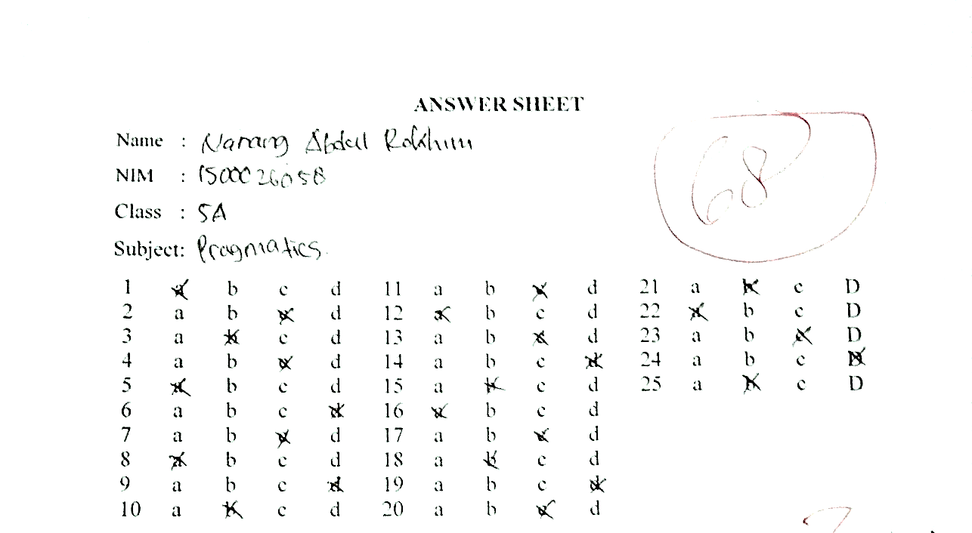
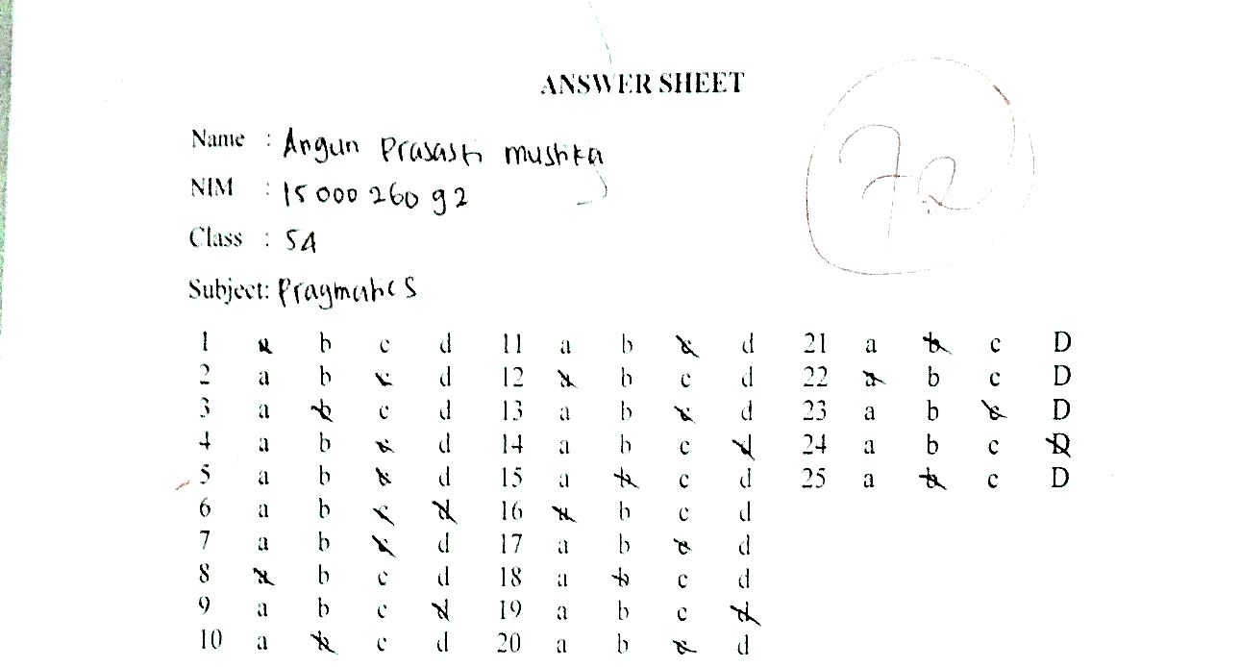

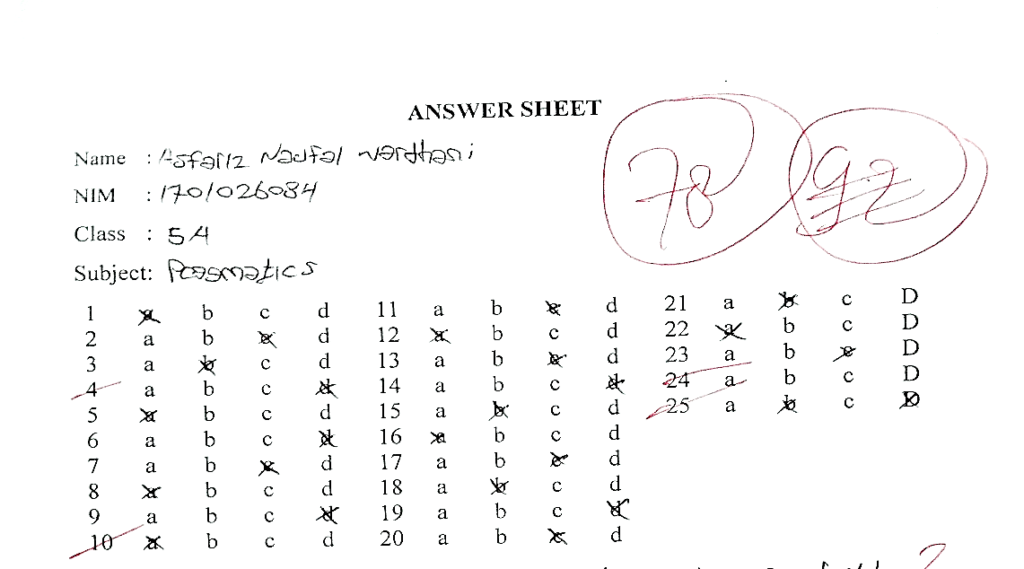

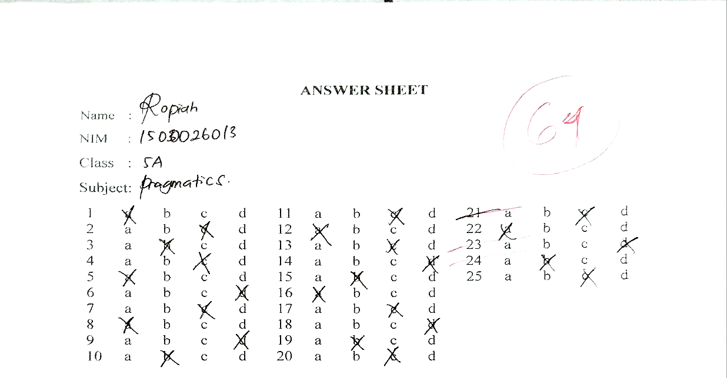
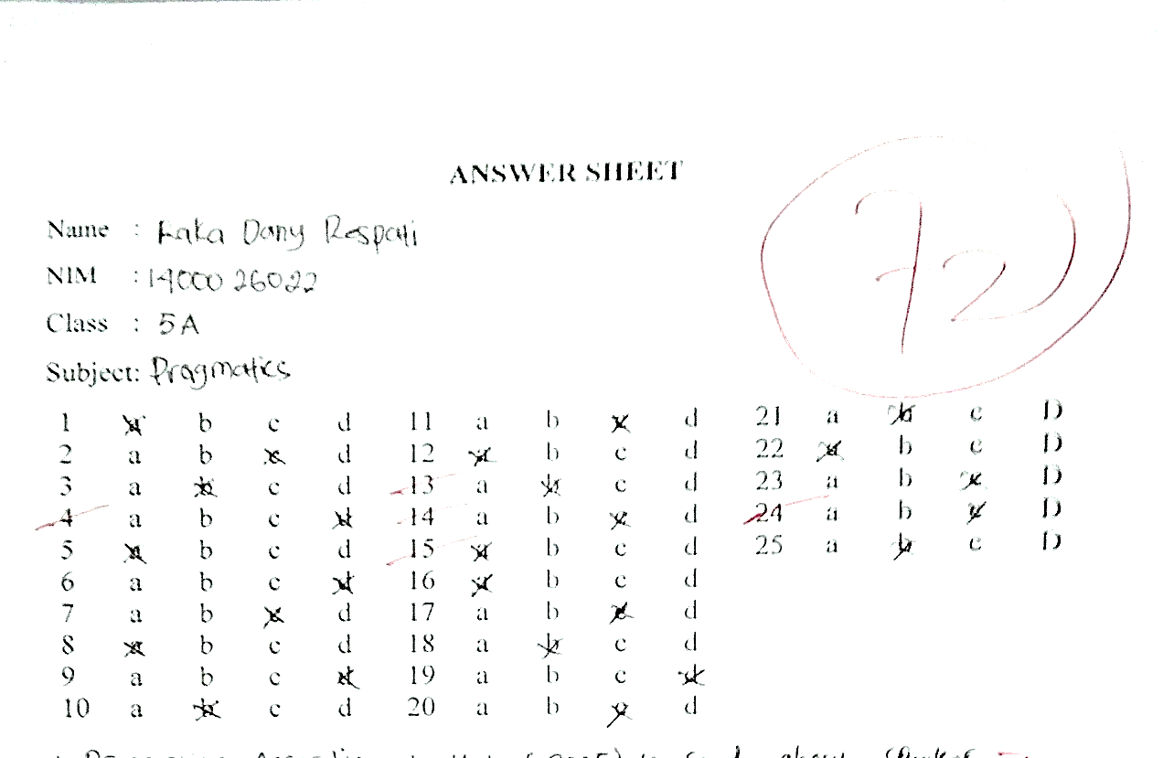

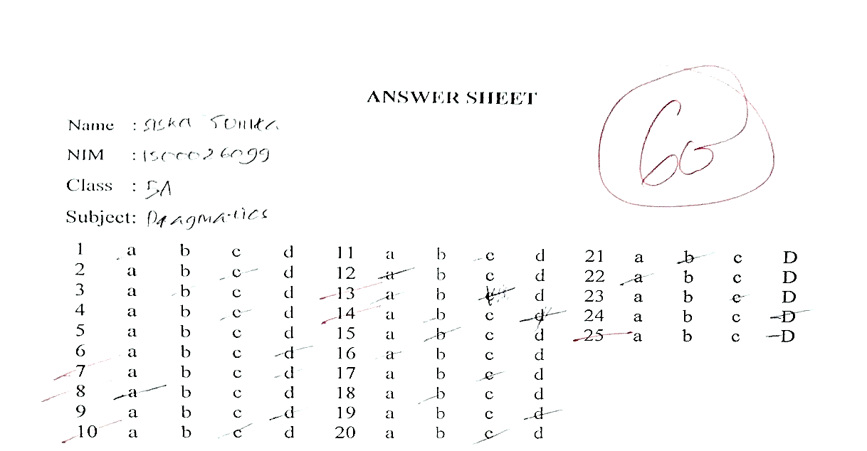

Sample Code | NOMOR SOAL
Sample Code | 1 | 2 | 3 | 4 | 5 | 6 | 7 | 8 | 9 | 10 | 11 | 12 | 13 | 14 | 15 | 16 | 17 | 18 | 19 | 20 | 21 | 22 | 23 | 24 | 25 | BENAR | SALAH | SKOR | NILAI
1 | 1 | 1 | 1 | 1 | 1 | 0 | 1 | 1 | 1 | 1 | 0 | 0 | 1 | 1 | 1 | 0 | 0 | 1 | 1 | 1 | 1 | 1 | 1 | 1 | 1 | 20 | 5 | 20 | 80
2 | 1 | 1 | 1 | 0 | 1 | 1 | 1 | 1 | 1 | 1 | 1 | 1 | 0 | 0 | 0 | 1 | 1 | 1 | 1 | 1 | 1 | 1 | 1 | 0 | 1 | 20 | 5 | 20 | 80
3 | 1 | 1 | 1 | 0 | 0 | 1 | 1 | 1 | 0 | 1 | 0 | 1 | 0 | 1 | 1 | 1 | 1 | 1 | 1 | 1 | 1 | 1 | 0 | 1 | 1 | 19 | 6 | 19 | 76
4 | 1 | 1 | 1 | 1 | 1 | 1 | 1 | 1 | 1 | 1 | 1 | 1 | 1 | 1 | 1 | 1 | 0 | 0 | 1 | 1 | 0 | 1 | 1 | 1 | 1 | 22 | 3 | 22 | 88
5 | 1 | 1 | 1 | 1 | 1 | 1 | 1 | 1 | 1 | 1 | 1 | 1 | 1 | 1 | 1 | 1 | 1 | 1 | 1 | 1 | 0 | 1 | 0 | 0 | 1 | 22 | 3 | 22 | 88
6 | 1 | 1 | 1 | 1 | 1 | 0 | 1 | 1 | 1 | 1 | 1 | 1 | 1 | 1 | 1 | 1 | 0 | 1 | 1 | 1 | 1 | 1 | 1 | 1 | 1 | 23 | 2 | 23 | 92
7 | 1 | 1 | 0 | 1 | 1 | 0 | 1 | 1 | 1 | 0 | 1 | 1 | 0 | 1 | 1 | 1 | 1 | 0 | 1 | 1 | 1 | 1 | 1 | 1 | 1 | 20 | 5 | 20 | 80
8 | 0 | 1 | 1 | 1 | 1 | 0 | 1 | 1 | 0 | 1 | 1 | 0 | 0 | 0 | 1 | 0 | 0 | 1 | 1 | 1 | 1 | 1 | 0 | 0 | 1 | 15 | 10 | 15 | 60
9 | 1 | 0 | 0 | 1 | 1 | 1 | 1 | 1 | 1 | 1 | 1 | 1 | 1 | 1 | 1 | 1 | 1 | 1 | 1 | 1 | 1 | 1 | 1 | 1 | 1 | 23 | 2 | 23 | 92
10 | 1 | 1 | 1 | 1 | 1 | 1 | 0 | 0 | 1 | 0 | 1 | 1 | 0 | 0 | 1 | 1 | 1 | 1 | 1 | 1 | 1 | 1 | 1 | 1 | 1 | 20 | 5 | 20 | 80
11 | 1 | 1 | 1 | 0 | 0 | 1 | 1 | 1 | 1 | 1 | 1 | 1 | 1 | 1 | 1 | 1 | 1 | 1 | 1 | 1 | 1 | 1 | 1 | 1 | 1 | 23 | 2 | 23 | 92
12 | 1 | 1 | 1 | 1 | 1 | 1 | 1 | 0 | 1 | 0 | 1 | 1 | 1 | 1 | 0 | 0 | 1 | 1 | 1 | 1 | 1 | 1 | 0 | 1 | 1 | 20 | 5 | 20 | 80
13 | 1 | 1 | 1 | 1 | 1 | 1 | 1 | 1 | 1 | 1 | 1 | 0 | 0 | 1 | 1 | 1 | 1 | 1 | 1 | 1 | 0 | 1 | 1 | 1 | 1 | 22 | 3 | 22 | 88
14 | 1 | 1 | 1 | 1 | 1 | 1 | 1 | 1 | 1 | 1 | 1 | 1 | 1 | 1 | 1 | 1 | 1 | 1 | 1 | 1 | 1 | 1 | 1 | 1 | 1 | 25 | 0 | 25 | 100
15 | 1 | 1 | 1 | 1 | 1 | 1 | 1 | 1 | 1 | 1 | 1 | 1 | 1 | 1 | 1 | 1 | 0 | 1 | 1 | 1 | 1 | 1 | 1 | 1 | 0 | 23 | 2 | 23 | 92
16 | 1 | 1 | 1 | 1 | 0 | 1 | 1 | 1 | 1 | 1 | 1 | 1 | 1 | 1 | 1 | 1 | 1 | 1 | 1 | 1 | 1 | 1 | 1 | 1 | 1 | 24 | 1 | 24 | 96
17 | 1 | 1 | 1 | 1 | 1 | 1 | 0 | 0 | 1 | 0 | 1 | 1 | 0 | 0 | 1 | 1 | 1 | 1 | 1 | 1 | 1 | 1 | 1 | 1 | 0 | 19 | 6 | 19 | 76
18 | 1 | 1 | 1 | 1 | 1 | 1 | 1 | 1 | 1 | 0 | 1 | 1 | 1 | 1 | 1 | 1 | 1 | 1 | 1 | 1 | 1 | 1 | 1 | 1 | 1 | 24 | 1 | 24 | 96
19 | 1 | 1 | 1 | 0 | 1 | 1 | 1 | 1 | 1 | 0 | 1 | 1 | 1 | 1 | 1 | 1 | 1 | 1 | 1 | 1 | 1 | 1 | 1 | 1 | 1 | 23 | 2 | 23 | 92
20 | 1 | 1 | 1 | 0 | 1 | 1 | 1 | 1 | 1 | 1 | 1 | 1 | 1 | 1 | 0 | 1 | 1 | 1 | 1 | 1 | 0 | 1 | 1 | 1 | 1 | 22 | 3 | 22 | 88
0 | 19 | 19 | 18 | 15 | 17 | 16 | 18 | 17 | 18 | 14 | 18 | 17 | 13 | 16 | 17 | 17 | 15 | 18 | 20 | 20 | 16 | 20 | 16 | 17 | 18 | 429 | 71 | 429 | 1716

respon |  | score
1 | 20 | 80
2 | 20 | 80
3 | 19 | 76
4 | 22 | 88
5 | 22 | 88
6 | 23 | 92
7 | 20 | 80
8 | 15 | 60
9 | 23 | 92
10 | 20 | 80
11 | 23 | 92
12 | 20 | 80
13 | 22 | 88
14 | 25 | 100
15 | 23 | 92
16 | 24 | 96
17 | 19 | 76
18 | 24 | 96
19 | 23 | 92
20 | 22 | 88
score | NS | PERCENTAGE
90-100 | 8 | 40%
80-89 | 9 | 45%
70-79 | 2 | 10%
60-69 | 1 | 5%
0-59 | 0
 | 20 | 100%

sample | PERSON |  | PLACE |  | TIME |  | DISCOURSE |  | SOCIAL
sample | correct | SCORE | correct | SCORE | correct | SCORE | correct | SCORE | correct | SCORE
1 | 5 | 100 | 3 | 60 | 4 | 80 | 4 | 80 | 4 | 80
2 | 4 | 80 | 3 | 60 | 5 | 100 | 3 | 60 | 5 | 100
3 | 4 | 80 | 4 | 80 | 3 | 60 | 3 | 60 | 5 | 100
4 | 4 | 80 | 4 | 80 | 5 | 100 | 4 | 80 | 5 | 100
5 | 4 | 80 | 5 | 100 | 4 | 80 | 4 | 80 | 5 | 100
6 | 5 | 100 | 4 | 80 | 4 | 80 | 5 | 100 | 5 | 100
7 | 5 | 100 | 5 | 100 | 4 | 80 | 2 | 40 | 4 | 80
8 | 4 | 80 | 2 | 40 | 2 | 40 | 3 | 60 | 4 | 80
9 | 5 | 100 | 4 | 80 | 5 | 100 | 4 | 80 | 5 | 100
10 | 4 | 80 | 4 | 80 | 4 | 80 | 4 | 80 | 4 | 80
11 | 4 | 80 | 4 | 80 | 5 | 100 | 5 | 100 | 5 | 100
12 | 3 | 60 | 5 | 100 | 4 | 80 | 5 | 100 | 3 | 60
13 | 4 | 80 | 4 | 80 | 5 | 100 | 4 | 80 | 5 | 100
14 | 5 | 100 | 5 | 100 | 5 | 100 | 5 | 100 | 5 | 100
15 | 5 | 100 | 4 | 80 | 5 | 100 | 5 | 100 | 4 | 80
16 | 4 | 80 | 5 | 100 | 5 | 100 | 5 | 100 | 5 | 100
17 | 4 | 80 | 4 | 80 | 4 | 80 | 4 | 80 | 3 | 60
18 | 5 | 100 | 5 | 100 | 5 | 100 | 5 | 100 | 4 | 80
19 | 5 | 100 | 4 | 80 | 5 | 100 | 5 | 100 | 4 | 80
20 | 3 | 60 | 4 | 80 | 5 | 100 | 5 | 100 | 5 | 100
 | 4,3 | 86 | 4,1 | 82 | 4,4 | 88 | 4,2 | 84 | 3,45 | 89

