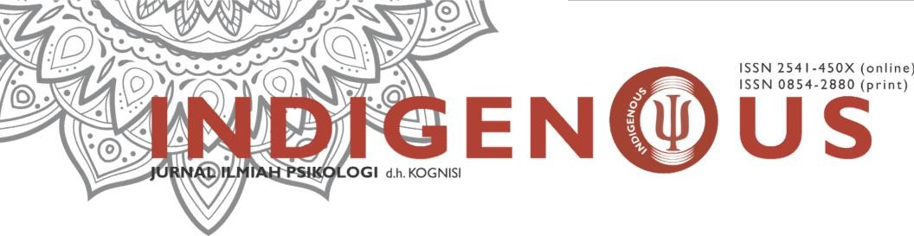

http://journals.ums.ac.id/index.php/indigenous email: jurnal.indigenous@ums.ac.id

COPYRIGHT TRANSFER FORM

(Please Compile This Form, Sign and Send By E-mail)
Please complete and sign this form and send it back to us with the final version of your manuscript. It is required to obtain a written confirmation from authors in order to acquire copyrights for papers published by Indigenous: Jurnal Ilmiah Psikologi.

Full Name and Surname | Sri Lestari
Title | Prof. Assoc.Prof. Asst.Prof. Dr. Mr. Ms.
Organisation | Universitas Muhammadiyah Surakarta
Address | Jl. Ahmad Yani Pabelan Surakarta
Postal code | 57162
City | Surakarta
Country | Indonesia
Telephone | 085229055979
Fax
E-mail | Sri.lestari@ums.ac.id
Paper Title | Krisis seperempat baya pada individu dewasa awal di Indonesia
Authors | Adita Lintang Kharisma Putri, Sri Lestari, Yayah Khisbiyah
Paper Pages | 21

Copyright Transfer Statement

The copyright to this article is transferred toIndigenous: Jurnal Ilmiah Psikologi if and when the article is accepted for publication. The undersigned hereby transfers any and all rights in and to the paper including without limitation all copyrights toIndigenous: Jurnal Ilmiah Psikologi. The undersigned hereby represents and warrants that the paper is original and that he/she is the author of the paper, except for material that is clearly identified as to its original source, with permission notices from the copyright owners where required. The undersigned represents that he/she has the power and authority to make and execute this assignment.
We declare that:

- This paper has not been published in the same form elsewhere.
- It will not be submitted anywhere else for publication prior to acceptance/rejection by this Journal.
- A copyright permission is obtained for materials published elsewhere and which require this permission for reproduction.

Furthermore, I/We hereby transfer the unlimited rights of publication of the above mentioned paper in whole to Indigenous: Jurnal Ilmiah Psikologi.The copyright transfer covers the exclusive right to reproduce and distribute the article, including reprints, translations, photographic reproductions, microform, electronic form (offline, online) or any other reproductions of similar nature.

The corresponding author signs for and accepts responsibility for releasing this material on behalf of any and all co- authors.This agreement is to be signed by at least one of the authors who have obtained the assent of the co-author(s) where applicable.After submission of this agreement signed by the corresponding author, changes of authorship or in the order of the authors listed will not be accepted.

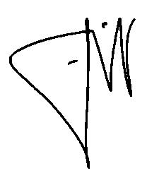
Yours Sincerely,

Corresponding Author‘s Full Name Sri Lestari Signature………………………………………………

Date 24 Agustus 2021

Indigenous: Jurnal Ilmiah Psikologi ISSN: 2541-450X

