Sentiment Analysis of Consumers for Determining the Packaging Features of Eucalyptus Oil Products
Wilma Latuny^{1a *}, Victor Oryon Lawalata^{1b}, Daniel Bunga Pailin^{1c} Rahman Ohoirenan^{1d}
UD Sinar Baru has eucalyptus oil products with various sizes from 30 ml to 550 ml. The 550 ml is the most eucalyptus oil product sought after. This can be seen in the sales results of eucalyptus oil packaging in the form of sales presentations where the 550 ml packaging has a sales presentation value of 70% compared to other sizes where the presentation is carried 65%. However, this product still has shortcomings in the packaging where this packaging has been criticized by consumer for design changes. Regarding this problem, this study aims to obtain to obtain the accuracy prediction of eucalyptus oil packaging features and to extract the most features to-be-improved for redesigning eucalyptus oil packaging This research begins with taking consumer comments using a power query and then processing it using the data mining method and processed using WEKA to find sentiment analysis and accuracy of consumer comments regarding eucalyptus oil products. This study succeeded in obtaining the tendency of comments on each attribute with an assessment of the accuracy for all classes of 83% and for each positive sentiment 3% of comments and 57% of comments for negative classes. The sentiment that shows the packaging tends to be normal at 20% which is interpreted as neutral and from this research can provide a suggestion to redesign the packaging based on the commentary sentiment of eucalyptus oil.

Keywords: Sentiment Analysis, Eucalyptus Oil Packaging, Accuracy of Prediction

I. INTRODUCTION¹

One of the industrial sectors that contributes to the development process in Maluku is the small industry of eucalyptus oil refining. The existence of these small industries has contributed to strengthening the industrial structure in Indonesia, including in Maluku (Smith and Idrus, 2016). Eucalyptus oil is a mainstay because of its properties to provide warmth to the body, relieves itching from insect bites, relieves stomach aches, flatulence, colds, and its fragrant and aromatic aroma for health. These products are generally produced by small and medium industries (IKM) in Maluku.

- Department of Industrial Engineering, Faculty of Engineering, University of Pattimura, Jl. Ir. M. Putuhena, Kampus Poka, Ambon, Maluku, 97233, Indonesia.

ª email: wlatuny@gmail.com
^{b} email: victor.lawalata@fatek.unpatti.ac.id
^{c}dani.ti.fatek@gmail.com
^{d} email: rahmanohoirenan45@gmail.com
* corresponding author

Submitted: 08-12-2020 Corrected: .-..- 2021
Approved: ..-..- 2021

Competition for eucalyptus oil products in the market is quite tight, making SMIs need innovative in order to have an advantage over its competitors. One of them is making attractive product packaging designs so that they can invite consumers to buy marketed products.
The appeal of a product cannot be separated from the packaging. Packaging is a "trigger" because it is directly dealing with consumers. Therefore, the packaging have to be able to influence consumers to provide a positive feedback (Dwiningsih, 2012).
The challenge for IKM relates to communication with consumers to find out what the wants, needs or attractiveness inherent in eucalyptus oil product packaging. Limited access to information and the ability to operate supporting technology have made the industry more reliant on consumer experience and "mouth to mouth" promotion to get responses from consumers regarding the quality of its products. At this time, people depend more on social media such as Facebook, Twitter, Instagram and WhatsApp for access to information, communication and trade. A global online purchasing survey including Indonesia, as many as 71% of consumers review a product before buying the product. As many as 43% agree that social media is a tool to meet knowledge needs in the form of product reviews and forum reviews, to help make purchasing decisions (Manalu, 2014). Product reviews and forum reviews are submitted through comments on social media that contain complaints, praise or views on products or services from an online store. The comments describe the different responses from each customer. Comments in the form of text can be collected and processed with sentiment analysis. This approach analyzes opinions, sentiments, evaluations, judgments, attitudes and public emotions towards entities such as products, services, organizations, individuals, problems, events, topics, and their attributes (Liu, 2012). Sentiment analysis studies opinions that express or express positive or negative views (Ibrahim and Othman, 2012). The opinion needed to conduct the analysis comes from the comments of the online shop page on Facebook. Facebook was chosen because its users interact massively with each other, where the total number of Facebook users is 1.44 billion with daily users of 936 million (Hapsari et al., 2018). Since the increasing use of social media and the limited social activities of the community, opinion surveys will be more effective and efficient in using social media to improve the packaging of eucalyptus oil products.
Related study of sentiment analysis of the product packaging was conducted severely in the last decade. For instance, the research method using big data is possible to conduct in order to understand emotion and feeling by customer (Kang et al., 2018). The product review has an eligible result by applying sentiment analysis technique to gather insightful information from consumer, (Jebaseeli and Kirubakaran, 2012), in line with that, the findings of product review features using sentiment analysis and joint sentiment topic (JST) model has an accuracy prediction (Lee and Lyu, 2020). The extraction of sentiment comments of product reviews by customer will be well predicted to obtain high accuracy by using support vector machine (SVM) compare to naïve bayes classifier (Shivaprassad and Shetty, 2017). On the other hand, the sentiment analysis is rarely found to predict the packaging product, for example sentiment analysis was applied to gather feature for designing process of product by employing machine-generated data to identify a series of customer need, the result showed that many of incorporating logical, computational methods into highly subjective and creative process of design (Ireland and Liu, 2018). The study conducted to identify the to-be-improved product features with case to Iphone 6 showed that the survey data online combined with traditional survey may be a comprehensive method of evaluation customer to be able to identify product development improvement (Xang et. al, 2018). However, until now, there is a limitation study related to applying sentiment analysis to redesign the package of essential oil. Therefore, this study aims to obtain the accuracy prediction of eucalyptus oil packaging features and to extract the most features to-be-improved for redesigning eucalyptus oil packaging.

II. RESEARCH METHOD

Text mining is a cross-disciplinary that refers to information retrieval, data mining, machine learning, statistics, and computational linguistics (Han, 2012). Text mining, also known as text data mining or searching for knowledge in textual databases, is a semi-automatic process of extracting data from patterns (Turban, 2005).
The types of text mining work include categorization, text clustering, concept / entity extraction, sentiment analysis, document summarization, and entity-relation modeling (i.e., learning relationships between entities) (Han, 2012). Data sources used in text mining are collections of text has unformat, unstructured or at least semi-structured. The purpose of text mining is to get useful information from a set of documents.
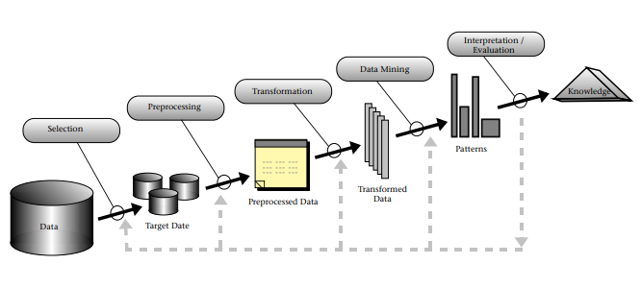
Text mining is a variation of data mining that attempts to find interesting patterns from large amounts of textual data. The difference lies in the patterns used, the text-mining pattern is taken from a set of unstructured natural languages, while in the datamining the pattern is taken from a database structured (Han & Kamber, 2006). There are several main process stages in text mining, namely text processing, text transformation or feature generation, feature selection, and pattern discovery or datamining.

Figure 1. Process Text Mining (Andini, 2013)

Sentiment, Opinions, Sentiment Analysis

Sentiment

According to Big Indonesian Dictionary (KBBI), sentiment means the opinions or views that are based on exaggerated feelings towards something. Meanwhile, according to Merriam-Webster's Online Dictionary, sentiment shows a fixed opinion (continuously) that reflects / reflects a person's feelings.

Opinions

Opinions and related concepts such as sentiment, evaluation, behavior, and emotions are the subjects of study from sentiment analysis and opinion mining (Liu, 2012). Opinion or opinion is central to almost all human activities and become the main influence of behavior. Perception of reality to evaluate surrounding objects.
The definition of opinion in the journal Opinion Mining and Sentiment Analysis: A Survey in 2012 (Ibrahim & Othman, 2012), are:
- Views or judgments that are formed about something, are not always based on facts or knowledge. And
- The beliefs or views of a large number or majority of people on a particular subject. In general, opinion refers to what people think about something. In other words, opinions are subjective beliefs, and are the result of emotions or interpretation of facts.

Sentiment Analysis

Sentiment analysis or opinion mining, is a domain of science that analyzes public opinion, sentiment, evaluation, judgment, attitudes and emotions towards entities such as products, services, organizations, individuals, problems, events, topics, and their attributes (Liu, 2012). Sentiment analysis focuses on opinions that express or express positive or negative sentiments.
In general, the sentiment analysis that has been studied has three levels, namely:
- Document level: classifies whether all opinion documents reveal positive or negative sentiments. Analysis assumes that each document expresses an objective opinion about a single entity (for example, a single product).
- Sentence level: refers to expression of the sentence that contains a positive, negative, or neutral opinion.
- Entity and aspect level: Find sentiments on the entity and / or its aspects. For example, the phrase "iPhone call quality is good, but battery life is short". There are two evaluation aspects, call quality and battery life, of the iPhone (entity). Sentiment on iPhone call quality is positive, but sentiment on life battery is negative. Call quality and iPhone battery life are the targets of opinion.
Sentiment analysis is a branch of text mining research (Sudalma, 2015). Sentiment analysis exists to deal with the explosion of textual information unstructured. As predicted by Putten (2002) in his research, the state of the information explosion more made the data mining process difficult because the data was unstructured and the number was very large.

Naïve Bayes Classifier
The naïve Bayes classifier makes very strong (naive) assumptions about the independence of each labeled event class (Han, 2012). The Naive Bayes classifier is used to classify sentiment from the data obtained. Naive bayes is also used by Hidayatullah (2014) to determine sentiment towards public shops that are conveyed via tweets in Indonesian.
Naïve Bayes is a machine learning method that has a model for shaping probabilities and opportunities. Therefore, Naïve Bayes will calculate the probability of the appearance of features that present comments based on positive or negative classes.

K-Nearest Neighbor Nearest-neighbor Classifier
classification is based on learning by analogy, namely by comparing testing with datasimilar training data (Han, 2012). K-Nearest Neighbor is a machine learning method that classifies objects based on learning data that is closest to the object (Dwi, 2014).

Decision Tree
Decision tree is a method that summarizes statements from a testing data label on training data, to find problems that lead to making a decision (Kamber., 2006). Decision tree is a prediction model in the form of a miniature tree structure where there are internal nodes (not leaves) that describe the attributes, each branch describes the results of the attributes being tested, and each leaf describes the class.

Testing / Measuring Accuracy

- K-Fold Cross Validation
Cross validation is used as a method of evaluating classification results. Tests are carried out to predict the error rate. The training data is divided into K random subsets of the same size, one of these random subsets is used as testing data. After that, iterates K times and calculates the error rate for each subset. Based on the results for error rate each subset, the average is calculated to get the error rate overall.

- Confusion Matrix
One of the evaluation methods used for the classification of naïve Bayes is confusion matrix. Confusion matrices are one of the important tools in the visualization method used on machine learning which usually contains two or more categories (Horn & Horn, 2010). As much as half or two thirds of the overall data is used for the purposes of the training process while the rest is used for testing purposes (Kantardzic, 2003)

III. RESULT AND DISCUSSIONS

Data Processing used in Ms. Excel Power query

Data sets are taken from pages in Facebook researchers who have been in post for 6 months and every 1 month do reposting in order to get the number of data sets in want researchers to analyze the sentiments of public comment.
Comments obtained later in the Crawling text to Ms. Excel Power Query is then carried out in the text preprocessing stage where the data totals 100 comments from different people.
This dataset are 100 sets of data that is cleaned as well- data set to use in training and testing task. Cleaning consists of processing the beginning of the text (text preprocessing), Transforming text (text transformation) or (Feature Generation), Selection feature (feature selection), pattern discovery or data mining (pattern discovery), Interpretation / Evaluation.

Text Preprocessing
Text preprocessing here is done using Ms. Excel by paying attention to data that has been separated such as suggestions in comments that are not related to processing for classification methods for comment sentiment with attributes that have been determined, order the optimal classification stage in its calculations. The preprocessing stage in this research includes:

- Tokenizing
At this stage delimiters will be namely numeric characters and symbol characters except for letter characters by listing the required character codes

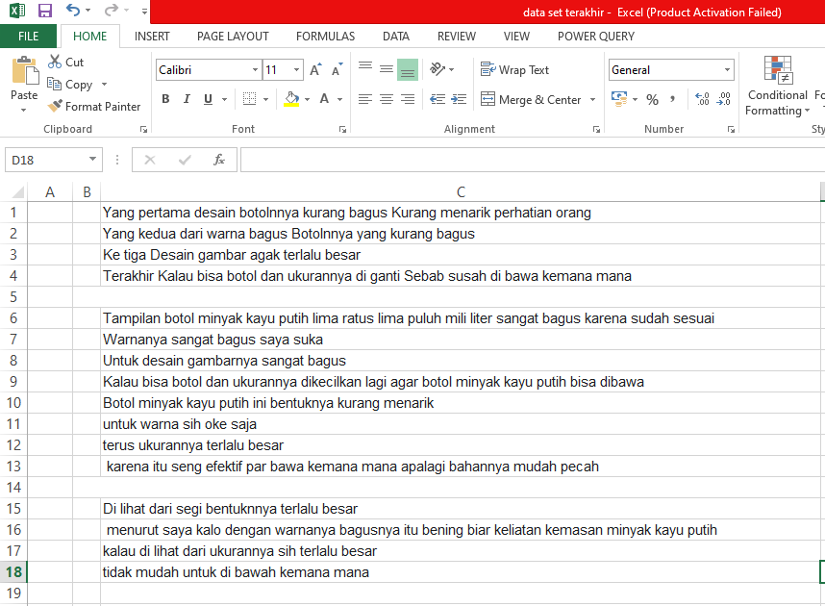
Figure 2. Tokenizing

2. Case Folding
At this stage the data in comments is changed to All lowercase letters and other emoticon characters will be removed.
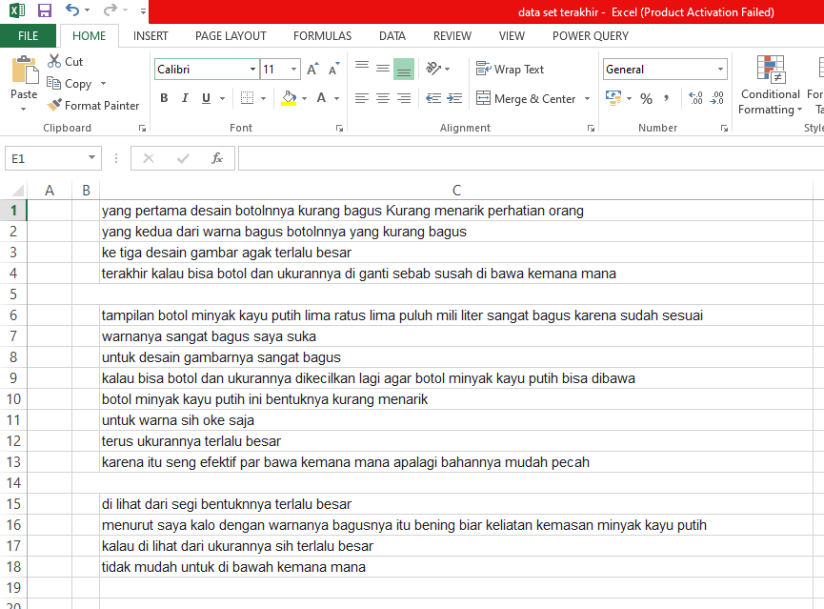
Figure 3. Case Folding

Text transformation or (Feature Generation)

At this stage the researcher divides and selects each comment corresponds to 4 attributes for the classification method to be processed. The data that is divided consists of the shape, size, color and efficiency data.

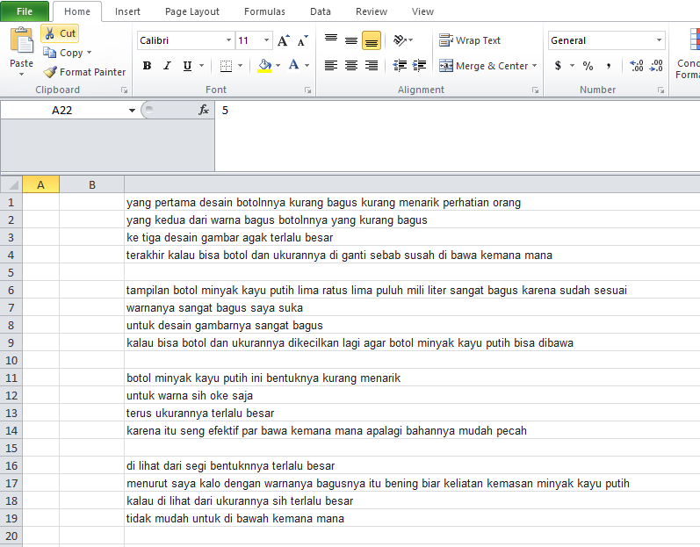
Figure 4. Feature Generation

Features Selection

The feature selection stage is an advanced stage of reducing dimensions in the text transformation process. At the feature selection stage, it is divided into:
Stage 1. Filtering
At this stage, will be removed the words that often appear and are general in nature
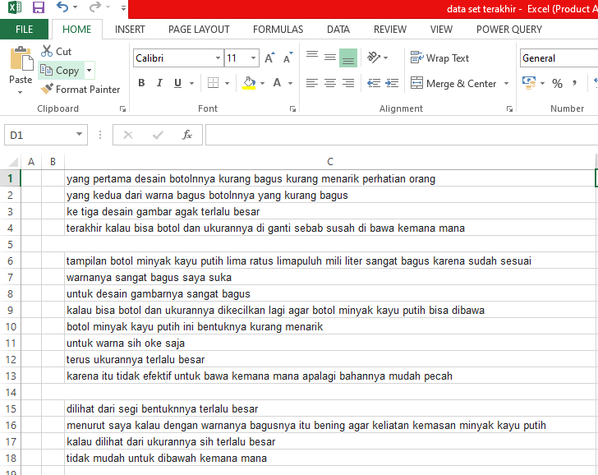
Figure 5. Example of Filtering
Stage 2. Stemming
Stage This stage the words in the comments will be returned to their basic form by eliminating the affixes to each word.
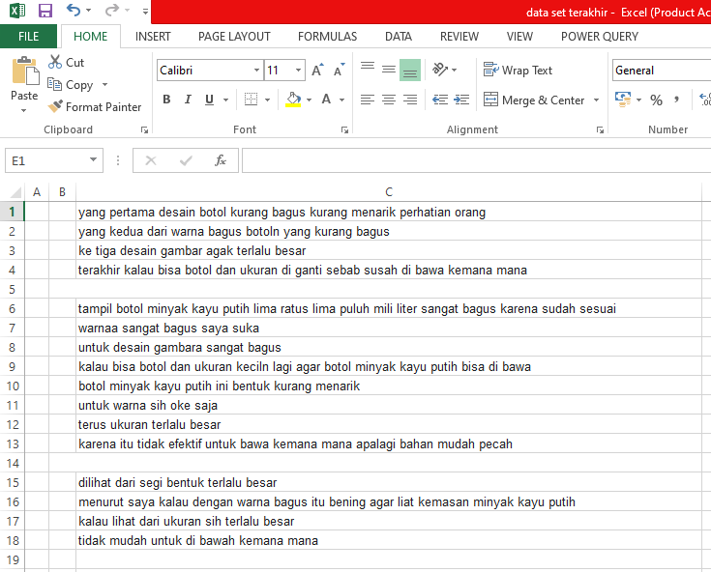
Figure 6. Display Stemming Stage

Stage 3. Convert Negation
At this stage the words that are negated will be converted, such as, "no", "no", "nga", "zinc", etc.
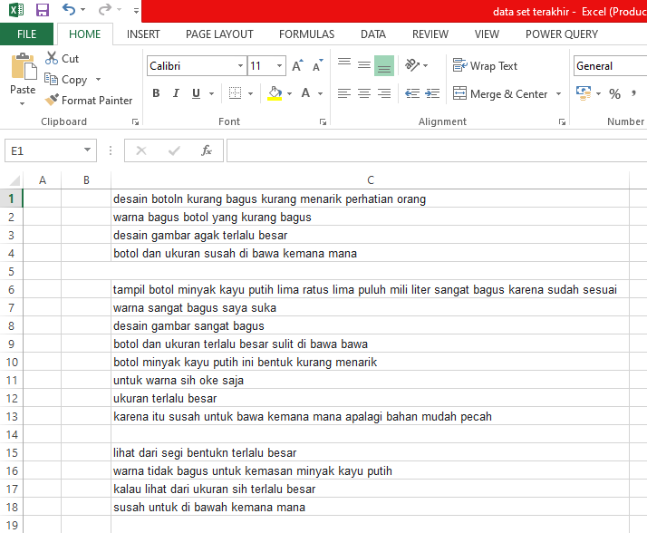
Figure 7. Convert Negation Stage

Pattern discovery
Data Mining Classifiers and Data Testing
Data Mining Classification and Data Testing For data classification that has been preprocessed above, the researcher uses WEKA software to classify data where in WEKA there are Naïve Bayes, k-NN and Decision Tree.
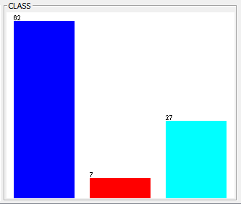
Figure 8. Visualize for Class Attributes
From the histogram image above, it is identified that the blue block is the total number of negative data in the data set obtained by the number 62, while the red block is the total number of positive data obtained by the number as many as 7 data and for the light blue blocks are the total neutral data totaling 27 data. The datasets are trained with Zero-R, Naïve Bayes, and K-NN classifier. The result of each classifier is represented below.

a. Zero-R Classifier
Classifier Zero-R in this data classification is a baseline to see accurate data to compare the three classification methods, where this classification is used to assess the success rate of data accuracy for the three methods that will be later tested.
Table 1. Stratified Cross-Validation
Stratified cross-validation
Correctly Classified Instances | 62 | 64,58%
Incorrectly Classified Instances | 34 | 35,42%

Table 2. Confusion Matrix
Confusion Matrix
a | b | c | <-- | classified as
62 | 0 | 0 | | | A | = | Negatif
7 | 0 | 0 | | | B | = | Positif
27 | 0 | 0 | | | C | = | Netral

In the Zero-R classification, it can be seen that the data obtained in the classifier output are Run information, Stratified cross-validation, Detailed Accuracy b
y Class, and Confusion Matrix. From this result, it is known that the standard value that will be the baseline for the 3 methods used for Correctly Classified Instances is 64.58% and for the Confusion Matrix, namely 62 data instances for negative classes, 7 instances for classes positive and 27 instances for neutral classes.

b. Naïve Bayes Classifier

Table 3. Stratified cross-validation

Stratified cross-validation
Correctly Classified Instances | 78 | 81,25%
Incorrectly Classified Instances | 18 | 18,75%

Table 4. Confusion Matrix
Confusion Matrix
a | b | c | <-- | classified as
58 | 1 | 3 | | | a | = | Negatif
0 | 0 | 7 | | | b | = | Positif
6 | 1 | 20 | | | c | = | Netral
For the test results using this method, it can be seen that the output classifier is Run information, Classifier model (full training set), Time taken to build model: 0.01 seconds,
Stratified cross-validation, Detailed Accuracy By Class, and Confusion Matrix. From that, it is seen that Correctly Classified Instances exceed the baseline standard by the number of 81.25% and the Confusion Matrix which is classified as a total of 62 instances for negative, 7 instances for positive and 27 instances for neutral.

c. k-NN Classifier
Table 5. Stratified cross-validation
Stratified cross-validation
Correctly Classified Instances | 62 | 64,58%
Incorrectly Classified Instances | 34 | 35,42%

Table 6. Confusion Matrix

In testing using the k-NN method, it still uses the same data set as the previous method with the Output Classifier, including Run information, Stratified cross
validation, Detailed Accuracy by Class, and Confusion Matrix. From the results, it can be seen that Correctly Classified Instances exceed the baseline standard by the number of 83.33% and the Confusion Matrix which is classified as a total of 62 instances for negative, 7 instances for positive and 27 instances for neutral.

d. Decision Tree.
Table 7. Stratified cross-validation
Stratified cross-validation
Correctly Classified Instances | 80 | 83,33%
Incorrectly Classified Instances | 16 | 16,67%

Table 8. Confusion Matrix
Confusion Matrix
a | b | c | <-- | classified as
57 | 0 | 5 | | | a | = | Negatif
1 | 3 | 3 | | | b | = | Positif
6 | 1 | 20 | | | c | = | Netral
processing this data, it is known that the Output Classifier that is obtained is Run information, Classifier model (full training set), Time taken to build model: 0.26 seconds, Stratified cross validation, Detailed Accuracy By Class, and Confusion Matrix. from the results seen for Correctly Classified Instances are at the baseline standard with a total of 64.58% and a total classified Confusion Matrix of 62 instances for negative, 7 instances for positive and 27 instances for neutral.

Confusion Matrix
a | b | c | <-- | classified as
62 | 0 | 0 | | | a | = | Negatif
7 | 0 | 0 | | | b | = | Positif
27 | 0 | 0 | | | c | = | Netral
Interpretation / Evaluation of the classifier result

In the calculation using the 3 methods above, it can be seen that the value obtained in the 3 methods tested for cross-validation is Confusion Matrix, so the K-NN method is the most accurate method compared to the other 2 methods, namely Naïve Bayes and decision trees with greater Correctly Classified Instances are 83.33% and Incorrectly Classified Instances smaller amounting to 16.67%, for the Confusion Matrix it is also seen that this method can obtain good accuracy with a value for negative class of 57 classified instances. correctly while 5 instances data are classified in the neutral class, for the positive class it is known that the value obtained in the matrix is 3 instances out of 7data is classified 27 instances incorrectly in the negative class while the correct one is 0. Thus, it can be interpreted that the K-NN method better at analyzing public comment sentiment for in this research, to test the accuracy of this method, the researcher conducted a test data test on training data that had used well-confirmed methods, namely K-NN.

Testing and Training

Before doing testing with testing data, here the researcher will perform Class Balancing so that the number of datasets for each balanced attribute, this is done so that when testing using testing data it can make more accurate results. Here the researcher uses a (cost sensitive classifier) to make the dataset into balance.
Table 9. Stratified cross-validation
Stratified cross-validation
Correctly Classified Instances | 78 | 81,25%
Incorrectly Classified Instances | 18 | 18,75%

Table 10. Confusion Matrix
Confusion Matrix
a | b | c | <-- | classified as
55 | 2 | 5 | | | a | = | Negatif
1 | 4 | 2 | | | b | = | Positif
4 | 4 | 19 | | | c | = | Netral

55 instances listed in the positive class while 4 other data sharing on as many negative class 1 and 3 instances of data instances that are in the class neutral, and for class In neutral, it is known that the results of instances that are correctly classified are 20 instances of 27 known data, while the other 7 data are divided into negative and positive classes where for negative 6 instances data and 1 instance data for positive class. The result of prediction provides Correctly Classified Instances of 81.25% and Incorrectly Classified Instances of 18.75%, in the Confusion Matrix for this method it is known that the Negative Class value in the matrix is 58 instances which are classified correctly while the other 4 are divided into positive classes 1 data instances and 3 neutral instances of data.
For the decision tree method with the results of Correctly Classified Instances 64.58%, Incorrectly Classified Instances 35.42% and Confusion Matrix in this method, it is known that the class value for negative is 62 data from 62 data instances, for the positive class it is known that this matrix is 0 classified correctly while 7 instances of data are classified incorrectly in the negative class and for the neutral class.

Results of Testing and Training
In the test results for testing data, it can be seen that the amount of data used is 10 testing data with unknown labels or classes, in this trial the researcher using training data that has previously been processed using the best classification method of the 3 methods tested, namely the K-NN method. Before conducting the trial, the researcher makes the training data balanced or balance so that the prediction results on the testing data being tested are more accurate, therefore the researcher uses a cost sensitive classifier to make the training data balance, after that the testing data is run using the K method. -NN as the preferred method because it has a better predictive accuracy value and obtains results, namely:

Table 11. Results of Predicted Class
Predicted CLASS | Prediction Margin
Predicted CLASS | Statistic | value
Predicted CLASS | Minimum | -0,995
Netral = 5 komentar | Maximum | 0,993
Negatif = 3 komentar | Maen | -0,333
Positf = 2 komentar | StdDev | 0,899

Discussion
From data processing using the above classification analysis, the researcher obtained different presentation accuracy values. Where 83% for Correctly Classified Instances and 16% for Incorrectly Classified Instances using the K-NN method. Meanwhile, 81% for Correctly Classified Instances and 18% for Incorrectly Classified Instances using the Naïve Bayes Method. And 64% for Correctly Classified Instances and 34% for Incorrectly Classified Instances using the decision tree method. From this it is known that the K-NN classification Data Mining Technique has a very accurate level of prediction. This classification can better analyze instances of data for each class attribute with an accuracy rate of 81%. To try the
success rate of predicting the K-NN classification, the researcher conducted a test test on the obtained training data. In the trial application of this classification, the researcher obtained a prediction result of 81.25% for Correctly Classified Instances and 18.75% Incorrectly Classified Instances. With class prediction results for positive 2 comments, negative 3 comments and neutral 5 comments. From this it can be interpreted that the presentation of predictions using the K-NN classification gets very good results. And from this research it can be concluded that for the features of 550 ml eucalyptus oil packaging such as shape, color, size, efficiency can affect changes to the redesign of the 550 ml eucalyptus oil bottle packaging from the previous design. Where based on comments from social media users for packaging features such as forms that have a negative class value of 47 comments, while positive class is 36 comments, and for neutral class there are 13 comments. And because the negative is bigger than the other classes. So, it needs to be made as attractive as possible to increase the attractiveness of this packaging by paying attention to several suggestions, namely. Shapes can be made simpler because consumers prefer simple shapes rather than complex shapes. The two shapes regular on the packaging are more concerned with because the regular shapes have more appeal. The three forms of packaging can be made smaller than the initial size without reducing the volume of eucalyptus oil. The four forms of packaging can be made more comfortable when used or carried around. The five shapes of eucalyptus oil bottles are preferably convex rather than concave shapes. The packaging size attribute can affect the packaging redesign with a negative class value of 82 comments, a positive class of 11 comments, while the neutral class is only 3 comments. So from there, the size still has to be adjusted according to the conditions of use, such as if it can be carried as souvenirs, it can be made smaller as in the third part of the form attribute, namely reducing the size without reducing the volume of eucalyptus oil content 550 ml, because for efficiency it is also one attributes that affect the redesign of the packaging that really must be considered 3 things such as, first the addition of a handle or grip to make it easier when used or carried around, secondly, this bottle packaging can be made using alternatives other than glass to reduce the burden on the packaging without losing the properties of eucalyptus oil, and the last one is that the head of the bottle is curved for easy use. This is because for the attribute efficiency with a negative class value of 94 comments, and a positive class with only 2 comments. For that it is necessary to make improvements to make it easier and help consumers to consume this eucalyptus oil product. And for the color attribute on the packaging, it is very influential in changing the packaging design. Where the packaging color is requested to be clearer or more transparent so that consumers can see the color directly from eucalyptus oil, this proposal is because the color attribute has a negative class value of 46 comments, and a positive class of 32 comments, while for the neutral class there were 18 comments. And because the negative value is greater, this proposal is made to fulfill consumer desires.

IV.CONCLUSION

Based on the data processing results above, the researcher obtained a presentation accuracy value of 83% for Correctly Classified Instances and 16% for Incorrectly Classified Instances
using the K-NN method. Meanwhile, 81% for Correctly Classified Instances and 18% for Incorrectly Classified Instances using the Naïve Bayes Method. And 64% for Correctly Classified Instances and 34% for Incorrectly Classified Instances using the decision tree method. From this it is known that the K-NN classification Data Mining Technique has a very accurate level of prediction. This classification can better analyze instances of data for each class attribute with an accuracy rate of 81%. To try the success rate of predicting the K-NN classification, the researcher conducted a test on the obtained training data. In the trial application of this classification, the researcher obtained a prediction result of 81.25% for Correctly Classified Instances and 18.75% Incorrectly Classified Instances. With class prediction results for positive 2 comments, negative 3 comments and neutral 5 comments.
For the 550 ml eucalyptus oil packaging features such as Shape, Color, Size, Efficiency, it can affect changes to the redesign of the 550 ml eucalyptus oil bottle packaging from the previous design. Where based on comments from social media users for packaging features such as forms that have a negative class value of 47 comments, while positive class is 36 comments, and for neutral class there are 13 comments. The packaging size attribute can affect the packaging redesign with a negative class value of 82 comments, a positive class of 11 comments, while the neutral class is only 3 comments. For the efficiency attribute with a negative class value of 94 comments, and a positive class with only 2 comments. And for the color attribute on the packaging, it is very
influential in changing the packaging design. Where the color attribute has a negative class value of 46 comments, and a positive class of 32 comments, while for the neutral class there are 18 comments. And because the results of the comparison of comments have negative values greater than positive and neutral values, this attribute greatly affects the packaging redesign.

BIBLIOGRAPHY

Andini, S. (2013). Klasifikasi Dokument Teks Menggunakan Algoritma Naive Bayes Dengan Bahasa Pemograman Java.
Blanco, E., & Moldovan, D. (2011, March). Some issues on detecting negation from text. In Twenty-Fourth International FLAIRS Conference.
Case, D. A., Dairy, P., Mutsikiwa, M., & Marumbwa, J. (2017). The Impact of Aesthetics Package Design Elements on Consumer Purchase Decisions: A Case of Locally Produced Dairy Products.
Cenadi, C. S. (2000). Peranan desain kemasan dalam dunia pemasaran. Nirmana, 2(2).
Collie, R., & Singh, A. (2016). Power Pivot and Power Bi: The Excel User's Guide to Dax, Power Query, Power Bi & Power Pivot in Excel 2010-2016, Holy Macro.
Putranti, N. D., & Winarko, E. (2014). Analisis sentimen twitter untuk teks berbahasa Indonesia dengan maximum entropy dan support vector machine. IJCCS (Indonesian Journal of Computing and Cybernetics Systems), 8(1), 91-100..
Dwiningsih, N. (2002). Desain Produk Dan Manajemen Kualitas.
Frank, E., Hall, M. A., & Pal, C. J. (2011). Algorithms : The basic methods.
Gusriani, S., Wardhani, K. D. K., & Zul, M. I. (2016). Analisis Sentimen Terhadap Toko Online di Sosial Media Menggunakan Metode Klasifikasi Naïve Bayes (Studi Kasus: Facebook Page BerryBenka). In 4th Appl. Bus. Eng. Conf (Vol. 1, No. 1, pp. 1-7).
Han, J. (2012). Data Mining Concepts and Techniques.
Hapsari, Y., Hidayattullah, M. F., Dairoh, D., & Khambali, M. (2018). Opinion Mining Terhadap Toko Online Di Media Sosial Menggunakan Algoritma Naïve Bayes (Studi Kasus: Akun Facebook Dugal Delivry). Jurnal Informatika: Jurnal Pengembangan IT, 3(2), 233-236.Hidayatullah,
Hidayatullah, A. F., & Azhari, S. N. (2014). Analisis Sentimen dan klasifikasi kategori terhadap tokoh publik pada data Twitter menggunakan Naive Bayes Classifier (Doctoral dissertation, [Yogyakarta]: Universitas Gadjah Mada).
Horn, C., (2010). Analysis and Classification of Twitter messages Analyse und Kategorisierung von Twitter Nachrichten. (April).
Sadegh, M., Ibrahim, R., & Othman, Z. A. (2012). Opinion mining and sentiment analysis: A survey. International Journal of Computers & Technology, 2(3), 171-178.
Indonesia S. N., & Nasional, B. S. (2006). Minyak kayu putih.
Ireland, R., & Liu, A. (2018). Application of data analytics for product design: Sentiment analysis of online product reviews. CIRP Journal of Manufacturing Science and Technology, 23, 128-144.
Jackson, J. (2002). Data mining; a conceptual overview. Communications of the Association for Information Systems, 8(1), 19.
Jebaseeli, A. N., & Kirubakaran, E. (2012). A survey on sentiment analysis of (product) reviews. International Journal of Computer Applications, 47(11).
Han, J., & Kamber, M. (2006). Classification and prediction. Data mining: Concepts and techniques, 347-350.
Kang, W. G., Ko, E. S., Lee, H. R., & Kim, J. N. (2018). A Study of the Consumer Major Perception of Packaging Using Big Data Analysis-Focusing on Text Mining and Semantic Network Analysis. Journal of the Korea Convergence Society, 9(4), 15-22.
Kantardzic, M. (2003). Data Mining: Concepts, Models, Methods, and Algorithms. Technometrics, 45(3), 277.
Kaukab, M. E., Setyanto, R. P., & Soedirman, U. J. (2020). Pengembangan Kesesuaian Produk Ekspor (Export Product Fit Development).
Lee, R., & Lyu, J. (2020). Sentiment Analysis of Product Reviews Based on JST Model. In Proceedings of the 4th International Conference on Computer Science and Application Engineering (pp. 1-7).
Liu, B. (2012). Sentiment analysis and opinion mining. Synthesis lectures on human language technologies, 5(1), 1-167.
Shivaprasad, T. K., & Shetty, J. (2017, March). Sentiment analysis of product reviews: a review. In 2017 International Conference on Inventive Communication and Computational Technologies (ICICCT) (pp. 298-301). IEEE.
Smith, H., Idrus, S., Ambon, B. I., & Ambon, J. K. C. B. M. (2016). Estimasi Produksi Minyak Kayu Putih Pada Industri Kecil Penyulingan Di Maluku. Majalah BIAM, 12(1), 8-13.
Turban, E., Aronson, J. E., & Liang, T. P. (2005). Decision Support Systems and Intelligent System,(Sistem Pendukung Keputusan dan Sistem Cerdas) Ed. 7. Jld. 2.
Manalu, B. U. (2014). Analisis Sentimen Pada Twitter Menggunakan Text Mining. Universitas Sumatera Utara Medan.
Zhang, L., Chu, X., & Xue, D. (2019). Identification of the to-be-improved product features based on online reviews for product redesign. International Journal of Production Research, 57(8), 2464-2479.

