Professional competency : teacher candidates’ comprehension of concept towards probability lessons

Sitti Karimah Sulfiah ¹, Yus Mochamad Cholily², Agus Subaidi* ³

¹ Department of Mathematics Education, Muhammadiyah University of Malang, East Java, Indonesia
² Department of Mathematics Education, Muhammadiyah University of Malang, East Java, Indonesia
³ Department of Mathematics Education, Madura University, Panglegur Street No. 3,5 Km, Pamekasan, East Java, Indonesia

*Corresponding author: agus_math@unira.ac.id

ARTICLE INFO | ABSTRACT  This research is qualitative research which employs descriptive approach relevant to the research purpose that is describing the professional competency of teacher candidate concerning the apprehension of concept towards probability material which is observed based on mathematical ability, divided into three parts, the capability of advanced Mathematics, intermediate Mathematics, and basic Mathematics. The subjects of this research are three candidates of teacher who have passed the course of discrete Mathematics in a college in Madura. The result of this research shows that a subject with advanced Mathematics capability could utilize the appropriate concept and procedure from every completion step and could relate one concept to other concepts so that the solution of the answer they did was accurate and could connect a concept with its operation. Other subject with intermediate Mathematics capability could apply the concept and procedure accurately from every completion step, however he was not quite capable of connecting one concept to others so that it induced errors in resolving the solution of the answer, he also could correlate a concept with its operation. Another subject with basic Mathematics capability could not employ the concept and the procedure correctly from every completion step and was not able to connect some concepts, so that it cuased errors in determining the solution of the answer, he also could not link a concept with its operation. In terms of the indicator of concept understanding advancement, the three subjects have not attained this stage as yet since they have not apprehended the definition of concept well particularly the probability concept, even though the subject with advanced Mathematics capability is procedurally prodigious  ©2020 Universitas Muhammadiyah Surakarta
Article history:
Received:
Revised:
Accepted:
Published online:
Published regularly:

Keywords:
The comprehension of concept, Mathematical capability, Probability

Introduction
Probability is one of lessons in Mathematics which becomes a primary stucture in the curriculum of Mathematics in the world (Elbehary, 2020) and one of the standards of content which should be possessed by students (NCTM, 2000) and a context examined in PISA to measure the literacy of Mathematics (OECD., 2016). However, probability is one of lessons perceived to be abstruse to master by students in Mathematics (.A, 2016). They encounter difficulty in learning probability (Jamal, 2014). The apprehension of students’ mathematical concept capability (Handayani & Aini, 2019), mathematical reasoning (Utami & Meliasari, 2019) and the creativity of answering questions (Budi, Rifa’i, Yunanto, & Cahyaningrum, 2020; Jelo, Farida, & Murniasih, 2019) in probability lessons remain poor. Students meet with obstacle in resolving problem in the form of narrative questions (Tambunan, Sitinjak, & Tamba, 2019).
Students’ error in answering the questions of probability is a lack of thoroughness, incompetence in comprehending material, inability to read the data, not paying special attention to the time duration during the test, and a lack of enthusiasm for studying (Mursyida & Amalia, 2019). Students encounter obstacle in determining a sample space and a subset of the sample space of an event (Riana & Luvy, 2020). Several factors leading students’ difficulties in resolving the problems of probability are due to the lack of concept understanding, the use of pattern, and motivation for doing probability lessons (Jamal, 2014; Putridayani & Chotimah, 2020).
One of factors influencing students’ leaning is teacher. A teacher possesses an impperative role in the learning process of Mathematics (Shadiq, 2019) and influences students’ learning achievement (Abrar, 2019). However, teachers’ competence is still poor at solving the problems of probability (Batanero, Contreras, Díaz, & Sánchez, 2015) even though, according to the latest research conducted by Estrada & Batanero (2020) a teacher had performed a positive attitude towards probability lessons and his instruction was acceptable. To be able to perform an effective learning, teachers need to master the aspect of general and specific content knowledge of probability (Groth, 2010). Hence, based on some provious research, it is fascinating to research anew in order to achieve more credible result concerning the concept comprehension of teacher candidates based on the existing research result.
Based on the problem having analyzed, this research is aimed to describe the professional competency of teacher candidates in probability lessons as vessels who will enter into school to educate and teach students, since in the time of education 4.0, teachers should possess professional competency (Zulfitri, Setiawati, & Ismaini, 2019) inasmuch as teachers’ profile implicates in building students’ personal concept (Yuliyanti, Winarso, & Misri, 2019). However, the competency that will be researched is just limited to the concept understanding of probability lessons since the quality of concept understanding determines the learning effectiveness that needs to be considered (Afriyani, Sa’dijah, Subanji, & Muksar, 2018) and the primary provision to solve a problem is that apprehending the concept underlying a problem can adopt an appropriate strategy for resolution (Sundary, Jatmiko, & Widyastuti, 2020). The probbility lesson is specialized in combinatorics, since combinatorics is vital to be optimized or mastered by all grades (Ihsan & Kosasih, 2018).

Research Methods
This research employs qualitative research method with descriptive approach inasmuch as the research purpose is to describe the tecaher candidates’ professional competency of concept apprehension towards probability lessons which is observed based on mathematical capability. The subjects of this research are three college students of Mathematics education who have passed the course of discrete Mathematics ─whom each of them has advanced, intermediate, and basic Mathematics capability─ in a college in Madura. The three subjects are teacher candidates of Mathematics who will enter into the sphere of Mathematics later on and teach students especially probability lessons. The determination of sujects utilizes pruposive sampling technique. Several things considered in naming the subjects are the GPA (Grade-point Average) of the last semester and information from the incharge lecturer since it is unlikely to administer a subject election test due to online learning applied at the college, hence it is improbable to face to face.
These research instruments are worksheet and interview guidance. The worksheet was used to know the tecaher candidates’ professional competency towards combinatorics lessons which is observed based on mathematical capability while the guidance of semi-structural interview was employed to determine more thorough information and to be more relied on the credibility of data result in order to obtain a conclusion.
The phases employed in data analysis correspond to the steps of qualitative research, these are data reduction, data presentation, and drawing a conclusion. Afterwards, the outcome of the test conducted by the subjects and the interview transcript are reduced, the data which are reputedly imperative are presented in the research result and discussion, then obtaining a conclusion. To determine the tecaher candidates’ professional competency, the indicator used in this research refers to Jin & Wong (2015) that is individual concept, connecting some concepts, relating the concept to its operation, in Table 1 below is the studious description:

Table 1
The indicator of concept apprehension
Indicator | Description | Students’ ability
Individual concept | - Students understand the definition of concept.  - Students can determine example and nonexample.  - Students are able to understand verious representation such as table, diagram, symbol, and numeral. | - Students can explain the concept of probability based on what they comprehend.  - Students can determine example and nonexample of probability.  - Students can apprehend a representation such as table, diagram, symbol, and numeral.
Connecting some concepts | Students are able to connect between one concept and other concepts. | Students can implement the connection between concept and procedure.
Connecting concept to its operation | - Can define concept based on its operation.  - Through the operation, the conceptual undrstanding can be advanced to higher standard. | - Students can define the concept of probability based on its operation  - Students can develop concept having learned.

Results and Discussion
The intruments employed in this research are a written test of probability and an interview guidance to uncover the sujects’ concept understanding capability having validated at first by two validators. Based on the research result of three subjects with advanced, intermediate, and basic Mathematics capability using a written test and an interview to uncover concept understanding capability as one of professional competencies, the following data are obtained:

Subject with Advanced Mathematics Capablity

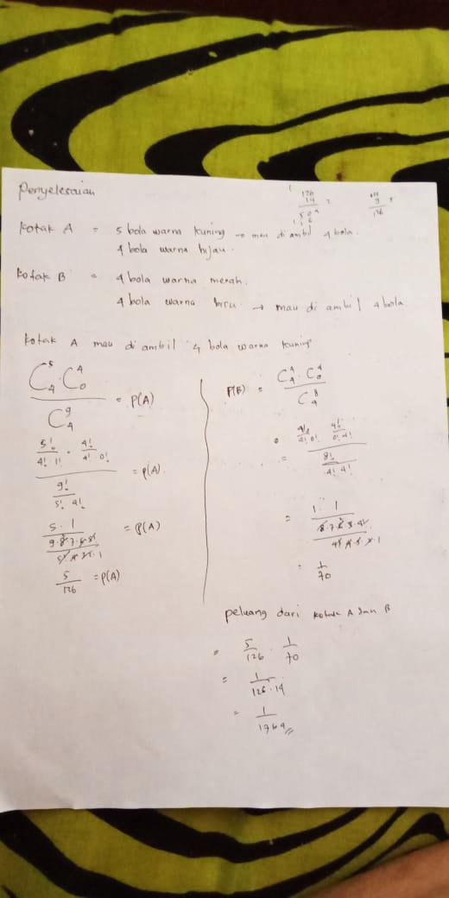
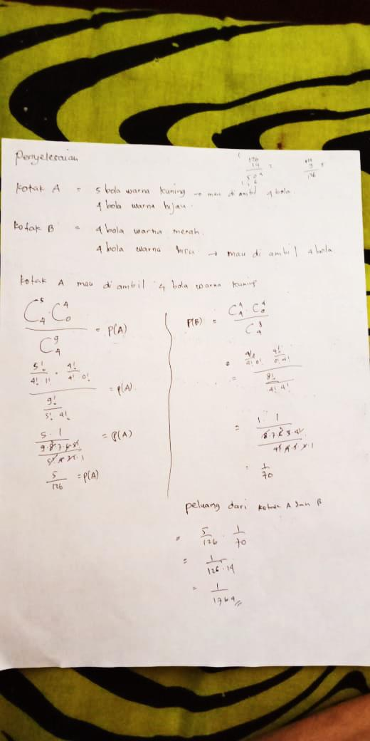

Figure 1. The Wirrten Test Result of Subject with Advanced Mathematics Capability

Based on the written test result in Picture 1, subject with advanced Mathematics capability (ST) could do the written test of probability lessons correctly. He was able to name a commensurate strategy to finish it, it is supported by the following interview result with ST:
P1 : When you read this question, what methods or strategies were used to solve it ?
ST1 : Looking for opportunities from each take on each box, namely in box A and box B, here it happens that in box A and box B all have different colors and here what you want to take has been determined, for box A it is devoted to take 4 yellow balls and box them B is devoted to taking 4 balls that are blue, so I am looking for the odds from each box, namely from box A about how many odds and from box B about how many odds. Because in box A it consists of two balls of different colors, namely yellow and green, so there is a possibility that when you want to take, you don't get the requested color right away, so here is my understanding because the four balls must be yellow balls then we have a chance of 5 color balls. it has to be taken four so it must use a combination
Based on the above interview result, ST has been able to choose an appropriate strategy to answer, that is searching the number of the probability of the occurance regarding 4 yellow balls removal from box A and 4 blue balls from box B by using combination concept, ST could also comprehend the reason why he utilized combination concept in answering the question, he had been able to determine example and non example from the concept used. However, he had not been able as yet to present any reason concerning the general use of combination concept, and when he was asked further reason why not employing another formula such as using permutation concept, ST was not been able to give any correct answer since he had not apprehended the concept completely, it is discussed in the following interview result:
P2 : Why do you have to use a combination
ST2 : Because in the question asked many ways to take it, so when we are going to take the ball then the possibility that I will not be able to immediately get the four is the same ball. Of the five balls, for example, all of them are yellow, we never know if the ball we get the first ball is yellow, the second ball is also yellow, for example there are balls 1,2,3,4,5 so we don't know, for example, what we took first 1,2,3,4,5 or 2,3,4,5,1 and so on
P4 : why don't you use permutation or something?
ST4 : Because after taking the ball it is still returned again, the meaning is not allowed, except in the matter of taking the ball without being returned again, it is different from the track. if that combination the retrieval may be repeated for example 1,2,3,4. the second take can be 3,2,4,1 and so on
P6 : Why should a combination why not just use other methods ?
ST6 : I used combination because it is faster than listed one by one
P7 : Why should a combination why not just Permutation ?
ST7 : I think the used of permutations is not suitable for solving this problem
P8 : where was the mismatch?
ST8 : It just doesn't match but I forgot what the basis is that makes it unsuitable
Besides being able to determine an appropriate strategy, ST could also connect one concept to other concepts, that is after having determined the number of event and determined sample space by using combination, then he continued using probability concept towards each box to seek the probability of 4 yellow balls removal from box A and the probability of 4 blue balls removal from box B at the same time, it is described in the following interview result:
ST9 : So we look for box A first, we look for opportunities from box A, so (combination of 4 of 5), the green color is not taken at all (combination 0 of 4), then for n (S) there are many possibilities how to take it want to take 4 pairs of green with yellow or all green or all yellow (combination of 4 of 9)
P10 : What is C (combination of 4 of 9) looking for?
ST10 : To find n(S)
ST15 : This is the formula for the combination, for example (a combination of n from m) then the formula is So n here is 4 and m is 5. We can write . And all the ways like that so you get the odds of box A are 5/6 to take 4 yellow balls
P17 : And then?
ST17 : Now continue looking for opportunities from box B, from box B we want to take 4 blue balls, so it's the same as before, the four are blue balls so the red ones are not taken so (combination of 4 of 5) and (combination 0 of 4) for N(S) (a combination of 4 of 8).
P18 : Why should (combination of 4 of 8)
ST18 : Because in the problem there are 4 red balls and 4 blue balls, so for the sample space we can take 1 blue ball or 1 red ball and other colour for N(S), so
P19 : And then?
ST19 : After simplifying it is obtained 1/70 so the odds are from box A and box B just multiplied by the odds from each box A and box B
P20 : Why did you have to multiply?
ST20 : Because we want to take the ball from box A and box B, so we look for opportunities from box A and box B. It could be that from box A when we take it we have the opportunity to take one ball, it turns out that the other one is not
P21 : And then?
ST21 : I think the odds of box A and box B are multiplied
P22 : Why is it multiplied why not added or divided or subtracted?
ST22 : For example, if added, it means that the taking is not simultaneous, so we must take it one by one, meaning that A has to finish first, B continues to finish first, so it does not coincide, here is the word "and" so simultaneously, so take it simultaneously, in box A too Approximately how many chances were taken and in Box B about how many opportunities were taken according to my understanding
P23 : That means you have to multiply it, right?
ST23 : Yes
P24 : This question belongs to what kinds of opportunities ?
ST24 : I did’nt know
However, at the end of answering the question, ST could not able completely to give any reason why seeking the probability of ball removal from box A and box B, why it should be multiplication, why it did not use other operations such addition, substraction, or division. Even though the answer given was literally correct and when asked further question regarding to what category of probability that he answered belongs, he could not answer. Furthermore, the last concept understanding is connecting symbol with a concept, ST had been able to answer accurately, that is based on the following interview result:
P11 : What is n(S) ?
ST11 : n(S) is the whole possibility or many possibilities, if the probability is commonly known as n (S)
P12 : What it mean n(S) in general?
ST12 : The set of universes
P13 : What you mean is the sample space?
ST13 : Yes, it i mean
P14 : And then, what is n(A)?
ST14 : n (A) is the actual number of possibilities or the many occurrences
P25 : So what are C, P (A) and P (B) ?
ST25 : P (A) means that the probability of occurrence A and P (B) is the probability of occurrence B
P26 : And then?
ST26 : Symbol of a combination
A thoroughgoing interview with ST regarding the definition of concept, ST did not get the comprehension of its definition itself, he avowed that the concept he employed in answering the question is only combination concept since probability is not a concept but it is a theory, because concept according to him is a technique or a completion strategy in solving a problem such as the interview result below:
P34 : Probability is a concept or not?
ST34 : Probability is a theory
P35 : What exactly is the concept?
ST35 : The concept is a material or in a concept material that is technical or the solution is how we solve problems related to opportunities, for example, I use the concept of a combination so this combination is a technical one of how we solve problems related to probability, for example in this problem, like that concept. or the handle
P36 : So in your opinion, this probability material is not a concept
ST36 : yes

Subject with Intermediate Mathematics Capablity
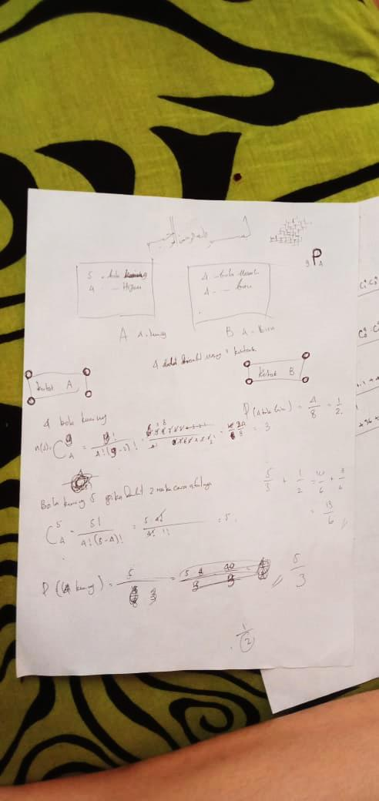

Figure 2. The Wirrten Test Result of Subject with Intemediate Mathematics Capability

Based on the written test result in Picture 2, subject with intermediate Mathematics capability (SS) could not do the written test of probability lessons correctly, even though based on the interview result with the subject, he has been able to to name an appropriate strategy to finish the question, it is discussed as the following interview result:
P1 : What strategies or methods did you use in solving this problem
SS1 : Combination
P4 : Why do you ​​use that method or strategy
SS4 : Because there are 5 yellow balls and 4 green balls here, the balls will be unified so 9 will be mixed. Here there are 5 yellow balls while here asked box A to take 4 yellow balls. Looking for opportunities, the chances of A are taking 4 yellow balls from box A and 4 blue balls from box B
P5 : And then?
SS5 : Looking for opportunities, namely the chances of being taken for the sum of all the balls because here there are 5 yellow balls that you want to take, only 4 yellow balls, so the way to take 5 yellow balls is if I take 4 yellow balls I use a combination.
However, when asked further question concerning the reason why he employed combination in finishing the question, he could not give any correct answer, he did not understand why combination was used. He stated that he utilized combination due to random removal, as what is quoted from the interview below:
P6 : Why do you use a combination method? why not use another way
SS6 : I don't know the other way, I just remember the combination
P7 : Why not use a permutation, or something else?
SS7 : Because I only know the combination
P8 : Why should use a combination
SS8 : Because the ball is randomly drawn
P9 : So if the random collection uses a combination and if it's not random using a permutation, is it right?
SS9 : I don’t know
P12 : So you don't know the reason why you are using a combination and you only know that this is using a combination like that?
SS12 : Yes, because the ball is randomly drawn, because the combination is the chance of taking it randomly, so unless if all the colors are the same, it will still be mixed, except the 4 balls that must be taken from the 4 new balls are not random and all taken.
SS’s incomprehension towards combination concept induces him false in determining probability towards box B, he did not use combination in determining either sample point or sample space to decide the probability of 4 blue balls in box B, since the available balls in box B are 4 blue balls and 4 red balls, so that the number of balls which will be taken out is equal to the number of available balls. Therefore, he perceived that balls which are going to be taken are definitely 4 desired blue balls, it is discussed as the following interview:
P46 : You only explain about taking the ball in box A, then what about taking the ball in box B?
SS46 : In the problem, you are instructed to take 4 blue balls, while in box B there are 4 blue balls, so I don't need to look for the combination anymore because the number is the same
P47 : So just take 4 balls right?
SS47 : Yes
P48 : So when you take the ball in box B, you immediately get 4 balls all blue righ?
SS48 : Not necessarily
P49 : But you just said you don't need to look for combinations anymore because there are 4 balls that are blue in box B
SS49 : Here there are 4 blue balls, and in the question I was told to take 4 blue balls so I don't need to look for ways of taking like in box A again, because 4 blue balls will already be taken, all there will be no blue balls left in the box, so all the balls blue will be taken all
P52 : So you don't need to look for that combination?
SS52 : Yes, i don’t
Besides the lack of comprehension of combination concept, he also lacked the understanding of probability concept. He could not able to comprehend probability definition. He was a bit short of apprehending either sample point or sample space in probability even though he understood the procedure of doing probability and had been able to do combination with a correct procedure, such as the following interview quotations below:
SS30 : These 5 are not specific, while the 4 balls to be taken are yellow, here there is a requirement for 4 yellow out of 5 so I use this combination
P31 : Why do you have to use probability (a combination of 4 of 5)
SS31 : Because the condition is to take 4 yellow balls from 5 yellow balls
P32 : In fact these 5 are what the name implies in the possibilities
SS32 : I don’t know
P33 : Why did you make these 5 as the numerator why not the denominator
SS33 : Because 5 ways are obtained from (a combination of 4 of 5), namely the specific collection of 4 yellow balls from 5 yellow balls
P34 : For example, if I change the position of 5 to be the denominator, is it okay or not?
SS34 : I don’t know
P35 : Actually what do you think about the probability?
SS35 : The chances of taking 4 red balls are 4 out of 8 so the odds are that
P36 : According to your understanding what is opportunity? Here you write the odds of taking 4 yellow balls as . What is 5, what is 8, and what is actually 8, why the position is like that, why don't you just turn around
SS36 : 5 that's the way he took it from the 4 yellow balls
P37 : What are the 5 called in the opportunity material?
SS37 : I don’t know
At the end of answering the question, SS could not also able to seek the probability of 4 yellow balls removal from box A and 4 blue balls removal from box B. He added the outcome of probability removal in box A and box B and he also did not know the reason why he used addition, and he was not able to determine to what category the probability that he answered belongs. It is discussed in the following interview quotations:
P53 : The question in the question is what is the chance of taking 4 yellow balls from box A and the chances of taking 4 blue balls from box B
SS53 : the results are Summed,
P54 : So the odds of box A and box B are ?
SS54 : Yes
P55 : Why do you add up?
SS55 : I don’t know
P56 : Why don't you subtract, multiply, or divide?
SS56 : Because this is looking for opportunities to take 4 yellow balls from box A and the chances of taking 4 blue balls from box B, so just add them up.
P57 : The problem in this question is included in what part of the opportunity material?
SS57 : I don’t know
Furthermore, the last concept understanding is connecting symbol with a concept, SS had been able to answer corrrectly, that is based on the interview result below:
P58 : What C and P this means?
SS58 : C is the symbol of combination, P is the symbol of probability

Subject with Basic Mathematics Capablity
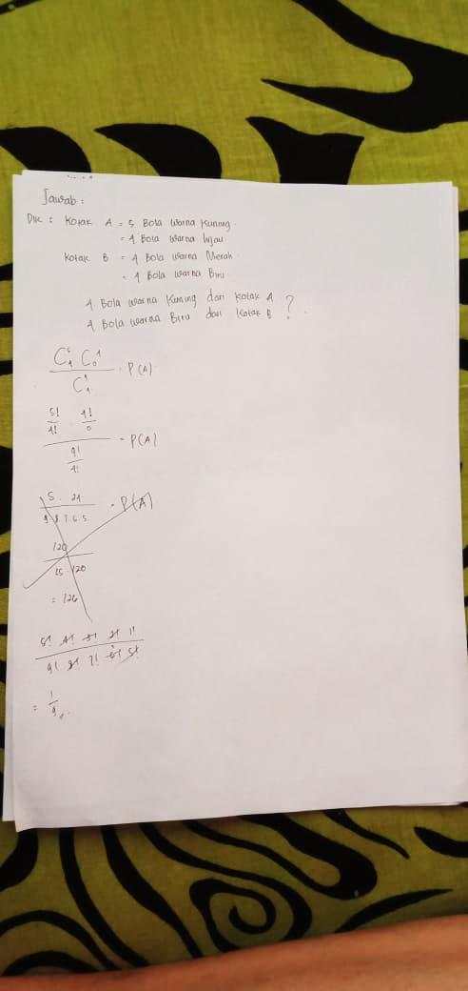

Figure 3. The Wirrten Test Result of Subject with Basic Mathematics Capability

Based on the written test result in Picture 3, the subject with basic Mathematics capability (SR) could not do the written test of probability lessons accurately. SR could name an appropriate completion strategy to answer it that is seeking combination to determine the sample point and the sample space of the probability of the ball removal from the box, however, it is arguable that he only memorized the procedure without comprehending what he was answering, SR himself was not able to clarify the result of his answer, he did not apprehend what combination is and how it is used. In addition to that, he could not determine the example and the nonexample of combination concept itself, as what is discussed in the following interview:
SR1 : Because here there are two boxes, namely box A and box B, box A contains 5 yellow balls and 4 green balls and for box B contains 4 red balls and 4 yellow balls. The question is the chances of taking 4 yellow balls from box A and 4 blue balls from box B, so I focused on taking 4 yellow balls from box A and 4 blue balls from box B
P2 : Then how is the solution why your answer is straightforward ?
SR2 : Because in my opinion if the question is the opportunity to take it then it must use a combination method
P3 : Why do you have to use a combination, why not use another?
SR3 : It just crossed my mind
P4 : So you just want to use a combination?
SR4 : When I read the problem in my mind it appears that it uses a combination, so it immediately comes to mind that it uses a combination
P5 : Is there no other way than a combination
SR5 : There is, but I immediately used a combination
P9 : Why is this C (a combination of 4 of 5)?
SR9 : Because 5 is the yellow ball in box A and 4 is the blue ball in box B
P10 : Then?
SR10 : So a combination of 5 out of 4 sorry means a combination of 4 of 5
P11 : So 4 means the number of blue balls and 5 is the number of yellow balls?
SR11 : Yes
P12 : Then what does this mean?
SR12 : Because 4 balls will be taken from each box, namely 4 blue balls and 4 yellow balls
P13 : So you write C (Combination of 0 of 4)
SR13 : Yes
P14 : Why is this zero?
SR14 : Because it starts at 0 I forgot why I wrote it
Besides the incomprehensibility of concept definition used, the procedure employed in answering the question was also incorrect, like the use of combination procedure, factorial, and probability, he was not able to understand what he was writing, it is discussed in the interview quotation below:
P15 : What this means P(A)?
SR15 : I forgot
P16 : Why did you write P (A) here
SR16 : I forgot because I haven't learned about this in a long time
P19 : What this means C?
SR19 : The symbol of combination
P20 : Why is this the position to be the numerator? Why not be the denominator?
SR20 : Because what you want to take is a yellow ball and a blue ball
P21 : Why does it have to be in the form of a fraction like this ? Why can't this be multiplied or added ?
SR21 : I don’t know
P22 : Where did this come from ?
SR22 : 5! Is the number of yellow balls and 4! of the number of yellow balls that will be taken
P23 : You mean this is the formula for the combination right?
SR23 : Yes
P24 : How about this
SR24 : 5!+4! = 9! and 4!+0! = 4!, then
P25 : Why should it be like that?
SR26 : I forgot
P27 : Where did you get (5!.4!.3!.2!.1!)?
SR27 : Because the denominator of starts from 4! .3! .... 1! then I divide so that the result is 5! So the rest remains
P28 : How about this (9!.8!.7!.....1!) ?
SR28 : The same as the previous one as it starts at 9! Then 9! .8! ...... 1! out of 4! I am divided because the remainder is 9! .8! .7! ... 5 !. so that it produces
Furthemore, the last concept understanding; defining concept and its symbol, SR also could not correlate them since when asked reganding the meaning of P(A) he wrote, he was not able to answer correctly, he answered that he did not know and forgot about what he was writing as what is explained in the following interview:
P32 : What is C?
SR32 : The symbol of combination
P33 : What is P(A)?
SR33 : I don’t know

The Capability of Concept Apprehension Viewed Based on Mathematics Capabllity
Based on the analysis result of the three research results towards the subjects, it is grouped as the following table:

Table 2
The Difference of Concept Apprehension Viewed Based on Mathematics Capabllity
Indicator | Subject with Advanced Mathematics Capability | Subject with Intermediate Mathematics Capability | Subject with Basic Mathematics Capability
Individual Concept | - Based on this indicator, the subject has not been able to understand the definition of concept, however, he has been able to explain correctly concerning the use of the concept he employed in answering the question and coul give the example and the nonexample of the concept such as in determining the use of combination and seeking probability of an event.  - The subject has been able to employ the correct procedure of every completion step, such as the use of pattern, symbol, and numeral like factorial numbers, combination procedure, and the procedure of answering probability. | - Based on this indicator, the subject has not been able to comprehend the definition of concept and explain the concept he used in answering the question, for instance he has not understood the reason of the used combination concept and to determine probability of the ball removal in 2 boxes so that it caused an error in determining probability of the ball removal in the second box.  - The subject has been able to employ the correct procedure of every completion step, such as the use of pattern, symbol, and numeral like factorial numbers, combination procedure, and the procedure of answering probability. | - Based on this indicator, the subject was not able to comprehend the definition of concept and the concept he used in answering the question.  - The subject was not able to employ the correct procedure of every completion step, such as the use of pattern, symbol, and numeral like factorial numbers, combination procedure, and the procedure of answering probability.
Conneting some concepts | The subject has been able to connect one concept to other concepts, he was able to determine the finishing strategy correctly so that the solution of the answer he did was also correct even though he did not comprehend what concept he employed in the last completion. | The subject was lack of capability to connect some concepts. Even though he employed the accurate strategy, in the last completion, he lacked the understanding of connecting one concept to other concepts so that it caused an error in determining the solution of the completion. | The subject was not able to connect some concepts, the strategy he used was not accurate so that it caused an error in determining the solution of the completion.
Connecting concept with its operation | - The subject has been able to connect a concept with its operation, for instance P(A); the probability of event A, n(A); the number of event in A, n(S); the sample space of an event and (the combination of 4 of 5).  - The subject had not been able to enhance concept apprehension he had since he had not been able to understand concept well particularly probability concept. | - Thhe subject has been able to connect concept with its operation, for instance P(A); the probability of event A, n(A); the number of event in A, n(S); the sample space of an event and (the combination of 4 of 5).  - The subject had not been able to enhance concept apprehension he had since he had not been able to comprehend concept well particularly probability concept. | - The subject was not able to connect a concept with its operation, when asked the meaning of P(A) he wrote, he was not able to answer correctly, he answered that he did not know and he forgot what he was writing.  - The subject had not been able to enhance concept apprehension he had since had not been able to understand concept well particularly probability concept.

Concept apprehension capability is a capability which is imperative to be possessed especially by teachers-to-be who will enter into the sphere of education and it is also a preofessional competency which should be possessed by a teacher. His knowledge and his competency of Mathematics have a crucial role towards teaching practice (Stahnke, Schueler, & Winter, 2016). A teacher’s good competence will influence teaching and learning process in a class since a good instruction conducted by teachers to students induces the lesson delivered easier to be comprehended by students (Priskila & Helti Lygia, 2019) so that the component mastery of content knowledge and teachers’ mathematical pedagogy is more essential than other components are (Qian & Youngs, 2015). In the research result, the concept apprehension capabilty of the three subjects, the subject with advanced Mathematicss capability, the subject with intermediate Mathematics capability, and the subject with basic Mathematics capability, has been analyzed.
The subject with advanced Mathematics capability could employ the concept and the correct precedure of every completion step and connect one concept to other concepts so that the solution of the answer he did was also correct and he could also connect a concept with its operation. Subject with intermediate Mathematics capabaility could employ correctly the concept and the procedure of every completion step, however, he was lack of ability to connect one concept with other concepts so that it caused an error in determining the solution of the answer, he had also been able to connect a concept with its operation. Subject with basic Mathematics capability could not able to employ correctly the concept and the procedure of every completion step and he was also not able to connect some concepts, so that it caused an error in detemining the solution of the answer. In addition to that, he was not able to connect a concept to its operation. Meanwhile, in relation to the indicator of concept epprehension improvement, the three subjects have not reached this phase since they have not been able to understand the definition of concept correctly particularly probability concept, even though the subject with advanced Mathematics capability is procedurally capital.
Based on the previous research result conducted by Afriyani et al. (2018) that students’ concept apprehension capability is grouped into 3 stages, these are being able to perform one-concept interpretation but not able to perform a correct completion since only employing one concept in creating a conclusion, being able to perform interpretation by employing some concepts but enabling an error in determining the completion since information synthesis or interim conclusion was not executed, being able to perform the interpretation of some concepts in a completion and provide a correct conclusion based on a completion process and based on the previous research conducted by Hutauruk & Panjaitan (2020) that the teacher candidates were lack of competence in mastering Mathematics learned at school specifically in concept understanding. The difference of research result level can occur due to some factors such as more extensive area, the research field, purpose, and focus of the research conducted (Chick, 1998).
If it should be viewed from the previous discussion, the competency of teacher candidates needs to be advanced specifically concept apprehension towards probability lessons. A number of strategies which can enhance concept apprehension capability that can be implemented either at school or at college are the selection of learning strategy and the consideration of the number of learning hours since they can impact learning effectiveness (Tsubaki, Ogawara, & Tanaka, 2020). Providing scafolding by entering into dialogue with students can also enhance students’ conceptual apprehension (Kazak, Wegerif, & Fujita, 2015). Administering assignments or exercises repeatedly since students can also broaden their knowledge based on their previous experience (Kazak & Confrey, 2007). Giving the first stimulus by apprising the philosophy and the history of mathematical theory specifically probability in order that students’ motivation gets improved for learning the material (Kuznetsova, 2019). Conducting cognitive guidance analysis, concept clarification, logical multiplication and student ratio (Nunes, Bryant, Evans, Gottardis, & Terlektsi, 2014). Meanwhile, to enhance teachers’ professionalism, teachers should employ intuitive approach which is followed by subjective approach, frequency, and clasic (Vásquez & Alsina, 2019).

Conclusion
Based on the research result and the previous duscussion, obtained a conclusion that the teacher candidates’ concept apprehension capability remains varied based on their capablity level of Mathematics, these are; the subject with advanced Mathematics capability could employ the concept and the correct procedure of every completion step and could connect one concept to other concepts so that the solution of the answer he did was correct, and could connect concept with its operation. The subject with intermediate Mathematics capability could employ correctly the concept and the procedure of every completion step, however, he was lack of capability to connect one concept to other concepts so that it induced an error in determining the solution of the answer, the subject had been able to connect a concept with its operation. The subject with basic Mathematics capability was not able to employ a concept and a procedure accurately towards every completion step and not able to connect some concepts, so that it induced an error in determining the solution of the answer, the subject could not also be able to connect a concept with its operation. In relation to the indicator of concept apprehension advancement, the three subjects have not reached this phase since the had not been able to comprehend the definition of concept fabolously specifically probability concept, even though the subjects with Mathematics capability are procedurally capital.
Hopefully this research result is to be a reference for the subsequent researchers in order that it becomes more enhanced or the research subject is more widened and to be a reference either for students of high school or students of higher education so that it can either improve concept apprehension capability they have possessed or enrich the students’ concept apprehension who are taught.

Acknowledgment
The researchers would like to thank all those who have contributed to this research, especially the lecturers who are willing to guide and to their fellow students who are willing to be the subject.

Bibliography
.A, K. (2016). Analisis Kesalahan Siswa Dalam Pemecahan Masalah Matematika Pada Materi Peluang Berdasarkan High Order Thinking Dan Pemberian Scaffolding. Tesis Universitas Jember.
Abrar. (2019). Peranan Guru dalam Meningkatkan Prestasi Belajar Siswa Pada Mata Pelajaran Matematika Dikelas V Sekolah Dasar Negeri 53 Kota Bengkulu. Skripsi , Institut Agama Islam (IAIN) Bengkulu.
Afriyani, D., Sa’dijah, C., Subanji, S., & Muksar, M. (2018). Characteristics of Students’ Mathematical Understanding in Solving Multiple Representation Task based on Solo Taxonomy. International Electronic Journal of Mathematics Education, 13(3), 281–287. https://doi.org/10.12973/iejme/3920
Batanero, C., Contreras, J. M., Díaz, C., & Sánchez, E. (2015). Prospective teachers’ semiotic conflicts in computing probabilities from a two-way table. International Electronic Journal of Mathematics Education, 10(1), 3–16. https://doi.org/10.12973/mathedu.2015.101a
Budi, S., Rifa’i, A. Y., Yunanto, M. T., & Cahyaningrum, A. (2020). Analisis Kemampuan Berpikir Kreatif Siswa Kelas XII TKR 1 SMK Negeri 1 Ambal Pada Materi Peluang. Seminar Nasional Pendidikan Matematika, 1(1), 313–322.
Chick, H. (1998). Cognition in the formal modes: Research mathematics and the SOLO taxonomy. Mathematics Education Research Journal, 10(2), 4–26. https://doi.org/10.1007/BF03217340
Elbehary, S. G. A. (2020). Providing Insights into the Intended Curriculum of Probability for Basic Education Sector in Egypt from a Comparative Perspective. International Electronic Journal of Mathematics Education, 15(2), 1–16. https://doi.org/10.29333/iejme/7603
Estrada, A., & Batanero, C. (2020). Prospective Primary School Teachers’ Attitudes towards Probability and its Teaching. International Electronic Journal of Mathematics Education, 15(1), 1–14. https://doi.org/10.29333/iejme/5941
Groth, R. E. (2010). Teachers’ construction of learning environments for conditional probability and independence. International Electronic Journal of Mathematics Education, 5(1), 32–55.
Handayani, Y., & Aini, I. N. (2019). Analisis Kemampuan Pemahaman Konsep Matematis Siswa Pada Materi Peluang. Prosiding Seminar Nasional Matematika Dan Pendidikan Matematika Sesiomatika, 575–581. https://doi.org/10.24952/logaritma.v7i01.1669
Hutauruk, A. J., & Panjaitan, S. M. (2020). Penguasaan materi matematika sekolah dan permasalahannya pada mahasiswa prodi pendidikan matematika. Jurnal Pembelajaran Matematika Inovatif, 3(1), 81–90. https://doi.org/10.22460/jpmi.v3i1.p81-90
Ihsan, I. R., & Kosasih, U. (2018). Penelitian Pendahuluan Mengenai Desain Pembelajaran Terkait Berpikir Kombinatorial. Seminar Nasional Pendidikan Matematika Universitas Suryakancana (MINATKU), 131–136.
Jamal, F. (2014). Analisis Kesulitan Belajar Siswa Dalam Mata Pelajaran Matematika Pada Materi Peluang Kelas XI IPA SMA Muhammadiyah Meulaboh Johan Pahlawan. Jurnal MAJU (Jurnal Pendidikan Matematika), 1(1), 18–36. Retrieved from http://www.ejournal.stkipbbm.ac.id/index.php/mtk/article/view/232
Jelo, K. E., Farida, N., & Murniasih, T. R. (2019). Analisis Berfikir Kreatif Siswa Dalam Menyelesaikan Soal Cerita Pada Materi Peluang. Seminar Nasional FST, 2, 547–556. https://doi.org/10.31004/cendekia.v3i2.110
Jin, H., & Wong, K. Y. (2015). Mapping Conceptual Understanding of Algebraic Concepts: an Exploratory Investigation Involving Grade 8 Chinese Students. International Journal of Science and Mathematics Education, 13(1), 683–703. https://doi.org/10.1007/s10763-013-9500-2
Kazak, S., & Confrey, J. (2007). Elementary school students’ intuitive conceptions of random distribution. International Electronic Journal of Mathematics Education, 2(3), 227–244. Retrieved from https://www.iejme.com/article/elementary-school-students-intuitive-conceptions-of-random-distribution
Kazak, S., Wegerif, R., & Fujita, T. (2015). Combining scaffolding for content and scaffolding for dialogue to support conceptual breakthroughs in understanding probability. ZDM - Mathematics Education, 47(7), 1269–1283. https://doi.org/10.1007/s11858-015-0720-5
Kuznetsova, E. (2019). Probabilistic Ideas and Methods in Undergraduate Mathematics: Axiological Aspects. International Electronic Journal of Mathematics Education, 14(2), 363–373. https://doi.org/10.29333/iejme/5720
Mursyida, & Amalia, Y. (2019). Analisis Kesalahan Siswa dalam Menyelesaikan Soal Matematika pada Materi Peluang Kelas XI SMA Negeri 1 Kaway XVI. GENTA MULIA, X(1), 11–22.
NCTM. (2000). Principles and Standards for School Mathematics.
Nunes, T., Bryant, P., Evans, D., Gottardis, L., & Terlektsi, M. E. (2014). The cognitive demands of understanding the sample space. ZDM - International Journal on Mathematics Education, 46(3), 437–448. https://doi.org/10.1007/s11858-014-0581-3
OECD. (2016). “PISA 2015 Mathematics Framework”, in PISA 2015 Assessment and Analytical Framework: Science, Reading, Mathematic and Financial Literacy. Paris: OECD Publishing.
Priskila, Y., & Helti Lygia, M. (2019). Tinjauan Pedagogical Content Knowledge Guru Pada Materi Peluang. Jurnal Pendidikan Matematika, 3(1), 104–115.
Putridayani, I. B., & Chotimah, S. (2020). Analisis Kesulitan Belajar Siswa Dalam Pelajaran Matematika Pada Materi Peluang. MAJU, 7(1), 57–62. https://doi.org/10.30762/f
Qian, H., & Youngs, P. (2015). The effect of teacher education programs on future elementary mathematics teachers ’ knowledge : a five- country analysis using TEDS-M data. Journal of Mathematics Teacher Education. https://doi.org/10.1007/s10857-014-9297-0
Riana, & Luvy, S. Z. (2020). Analisis Kesukaran Pada Materi Peluang Siswa MTs. Jurnal Pendidikan APOTEMA, 6(1), 80–87.
Shadiq, F. (2019). Pembelajaran Matematika Pada Era Industri 4.0., Suatu Tantangan Bagi Guru dan Pendidik Matematika. Seminar Nasional Pendidikan Matematika (SNP2M), 7–16.
Stahnke, R., Schueler, S., & Winter, B. R. (2016). Teachers ’ perception , interpretation , and decision ‑ making : a systematic review of empirical mathematics education research. ZDM. https://doi.org/10.1007/s11858-016-0775-y
Sundary, P., Jatmiko, A., & Widyastuti, R. (2020). Metaphorical Thinking Approach With Google Classroom : Its Effect Towards Students ’ Understanding of Mathematical Concept Skills. Indonesian Journal of Science and Mathematics Education, 3(1), 37–47. https://doi.org/10.24042/ijsme.v3i1.5900
Tambunan, S. J., Sitinjak, D. S., & Tamba, K. P. (2019). Pendekatan Matematika Realistik Untuk Membangun Kemampuan Pemecahan Masalah Matematis Siswa Kelas XI IPS Pada Materi Peluang [Realistic Mathematics Education in Building the Mathematics Problem-Solving Abilities of Grade 11 Social Science Track Students S. JOHME: Journal of Holistic Mathematics Education, 2(2), 119–130. https://doi.org/10.19166/johme.v2i2.1691
Tsubaki, M., Ogawara, W., & Tanaka, K. (2020). An Analysis for the Qualitative Improvement of Education and Learning based on the Way of Learner Errors in Descriptive Questions. International Electronic Journal of Mathematics Education, 15(3), 1–27. https://doi.org/10.29333/iejme/7840
Utami, M. G., & Meliasari. (2019). Analisis Kemampuan Penalaran Matematika Siswa Ditinjau dari Gaya Belajar. Prosiding Diskusi Panel Nasional Pendidikan Matematika Unindra, 125–132.
Vásquez, C., & Alsina, Á. (2019). Observing Mathematics Teaching Practices to Promote Professional Development: An Analysis of Approaches to Probability. International Electronic Journal of Mathematics Education, 14(3), 719–733. https://doi.org/10.29333/iejme/5866
Yuliyanti, Winarso, W., & Misri, M. A. (2019). Analisis Profil Guru Matematika dalam Membangun Konsep Diri Siswa. Jurnal Matematic Paedagogic, III(2), 107–116.
Zulfitri, H., Setiawati, N. P., & Ismaini. (2019). Pendidikan Profesi Guru ( PPG ) sebagai Upaya Meningkatkan Profesionalisme Guru. LINGUA, Jurnal Bahasa & Sastra, 19(2), 130–136.

