LAMPIRAN
Lampiran 1. Daftar Sampel Perusahaan
No. | Kode | Nama Perusahaan
1 | AKPI | Argha Karya Prima Industry Tbk
2 | ALDO | Alkindo Naratama Tbk
3 | ALKA | Alakasa Industrindo Tbk
4 | AMIN | Ateliers Mecaniques D’Indonesie Tbk
5 | ARNA | Arwana Citramulia Tbk
6 | ASII | Astra International Tbk
7 | AUTO | Astra Otoparts Tbk
8 | BATA | Sepatu Bata Tbk
9 | BOLT | Garuda Metalindo Tbk
10 | BRAM | Indo Kordsa Tbk
11 | BRPT | Barito Pacific Tbk
12 | CEKA | Wilmar Cahaya Indonesia Tbk
13 | CINT | Chitose Internasional Tbk
14 | CPIN | Charoen Pokphand Indonesia Tbk
15 | DLTA | Delta Djakarta Tbk
16 | DPNS | Duta Pertiwi Nusantara Tbk
17 | DVLA | Darya-Varia Laboratoria Tbk
18 | EKAD | Ekadharma International Tbk
19 | FASW | Fajar Surya Wisesa Tbk
20 | GGRM | Gudang Garam Tbk
21 | HMSP | H.M. Sampoerna Tbk
22 | ICBP | Indofood CBP Sukses Makmur Tbk
23 | IGAR | Champion Pacific Indonesia Tbk
24 | IMPC | Impack Pratama Industri Tbk
25 | INAI | Indal Aluminium Industry Tbk
26 | INCI | Intanwijaya Internasional Tbk
27 | INDF | Indofood Sukses Makmur Tbk
28 | INDR | Indo Rama Synthetics Tbk
29 | INDS | Indospring Tbk
30 | INKP | Indah Kiat Pulp & Paper Tbk
31 | INTP | Indocement Tunggal Prakarsa Tbk
32 | IPOL | Indopoly Swakarsa Industry Tbk
33 | ISSP | Steel Pipe Industry of Indonesia Tbk
34 | JECC | Jembo Cable Company Tbk
35 | JPFA | Japfa Comfeed Indonesia Tbk
36 | KAEF | Kimia Farma Tbk
37 | KBLI | KMI Wire & Cable Tbk
38 | KBLM | Kabelindo Murni Tbk
39 | KDSI | Kedawung Setia Industrial Tbk
40 | KINO | Kino Indonesia Tbk
41 | KLBF | Kalbe Farma Tbk
42 | LION | Lion Metal Works Tbk
43 | MERK | Merck Tbk
44 | MLBI | Multi Bintang Indonesia Tbk
45 | MYOR | Mayora Indah Tbk
46 | PBRX | Pan Brothers Tbk
47 | PICO | Pelangi Indah Canindo Tbk
48 | PYFA | Pyridam Farma Tbk
49 | RICY | Ricky Putra Globalindo Tbk
50 | ROTI | Nippon Indosari Corpindo Tbk
51 | SCCO | Supreme Cable Manufacturing & Commerce Tbk
52 | SIDO | Industri Jamu dan Farmasi Sido Muncul Tbk
53 | SIPD | Sierad Produce Tbk
54 | SKBM | Sekar Bumi Tbk
55 | SKLT | Sekar Laut Tbk
56 | SMBR | Semen Baturaja (Persero) Tbk
57 | SMGR | Semen Indonesia (Persero) Tbk
58 | SMSM | Selamat Sempurna Tbk
59 | SPMA | Suparma Tbk
60 | SRSN | Indo Acidatama Tbk
61 | STAR | Star Petrochem Tbk
62 | STTP | Siantar Top Tbk
63 | TALF | Tunas Alfin Tbk
64 | TBMS | Tembaga Mulia Semanan Tbk
65 | TCID | Mandom Indonesia Tbk
66 | TKIM | Pabrik Kertas Tjiwi Kimia Tbk
67 | TOTO | Surya Toto Indonesia Tbk
68 | TPIA | Chandra Asri Petrochemical Tbk
69 | TRIS | Trisula International Tbk
70 | TRST | Trias Sentosa Tbk
71 | TSPC | Tempo Scan Pacific Tbk
72 | UNIC | Unggul Indah Cahaya Tbk
73 | UNIT | Nusantara Inti Corpora Tbk
74 | UNVR | Unilever Indonesia Tbk
75 | VOKS | Voksel Electric Tbk
76 | WIIM | Wismilak Inti Makmur Tbk
77 | WTON | Wijaya Karya Beton Tbk

Lampiran Hasil Output SPSS
Lampiran 2. Statistika Deskriptif
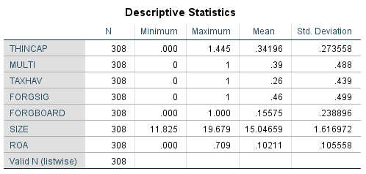

Lampiran 3. Uji Normalitas sebelum Transformasi Data
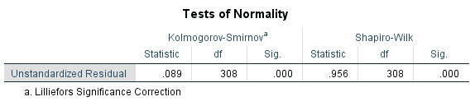

Lampiran 4. Uji Multikolinearitas sebelum Transformasi Data
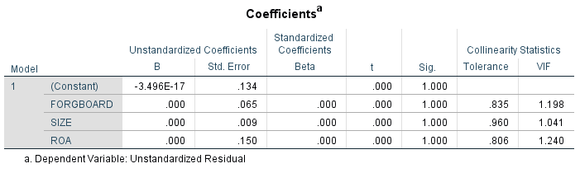

Lampiran 5. Uji Heteroskedastistas sebelum Transformasi Data
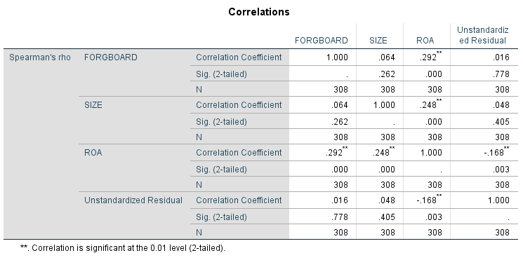

Lampiran 6. Uji Normalitas setelah Transformasi Data
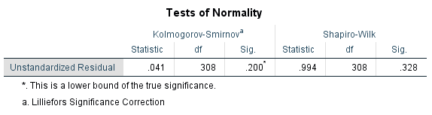

Lampiran 7. Uji Multikolinearitas setelah Transformasi Data
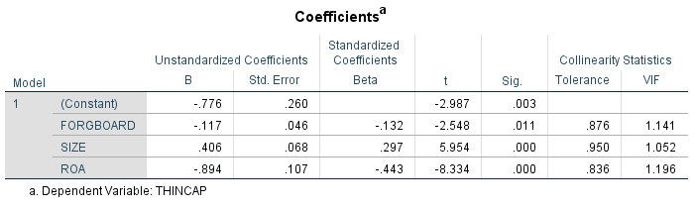

Lampiran 8. Uji Heteroskedastistas setelah Transformasi Data
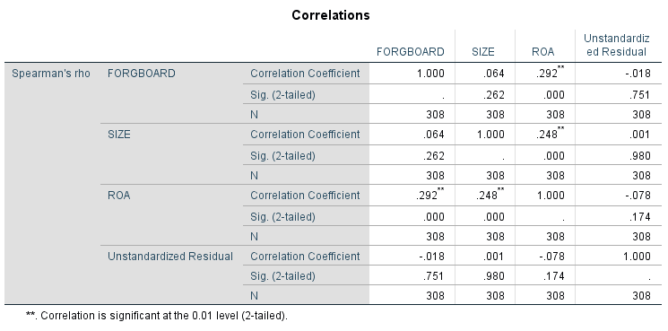

Lampiran 9. Uji Koefisien Determinasi (Adjusted R²)
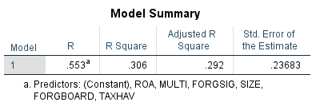

Lampiran 10. Uji Signifikansi Simultan (Uji F)
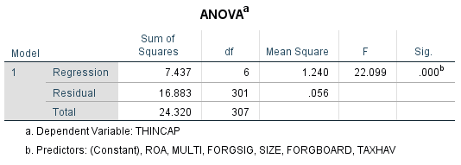

Lampiran 11. Uji Signifikansi Parameter Individual (Uji t)
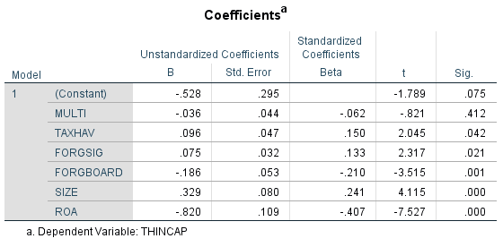

Lampiran 12. Daftar Negara Tax Haven
Caribbean/West Indies | Anguilla, Antigua and Barbuda, Aruba, Bahamas, Barbados, British Virgin Islands, Cayman Islands, Dominica, Grenada, Montserrat, Netherlands Antilles, St. Kitts and Nevis, St. Vincent and Grenadines, Turks and Caicos, U.S Virgin Islands
Central America | Belize, Costa Rica, Panama
Coast of East Asia | Hong Kong, Macau, Singapore
Europe/Mediterranean | Andorra, Channel Islands (Guernsey and Jersey), Cyprus, Gibraltar, Isle of Man, Ireland, Liechtenstein, Luxembourg, Malta, Monaco, San Marino, Switzerland
Indian Ocean | Maldives, Mauritius, Seychelles
Middle East | Bahrain, Jordan, Lebanon
North Atlantic | Bermuda
Pacific, South Pacific | Cook Islands, Marshal Islands, Samoa, Nauru, Niue, Tonga, Vanuatu
West Africa | Liberia
Sumber: Gravelle, J. G. (2015)

